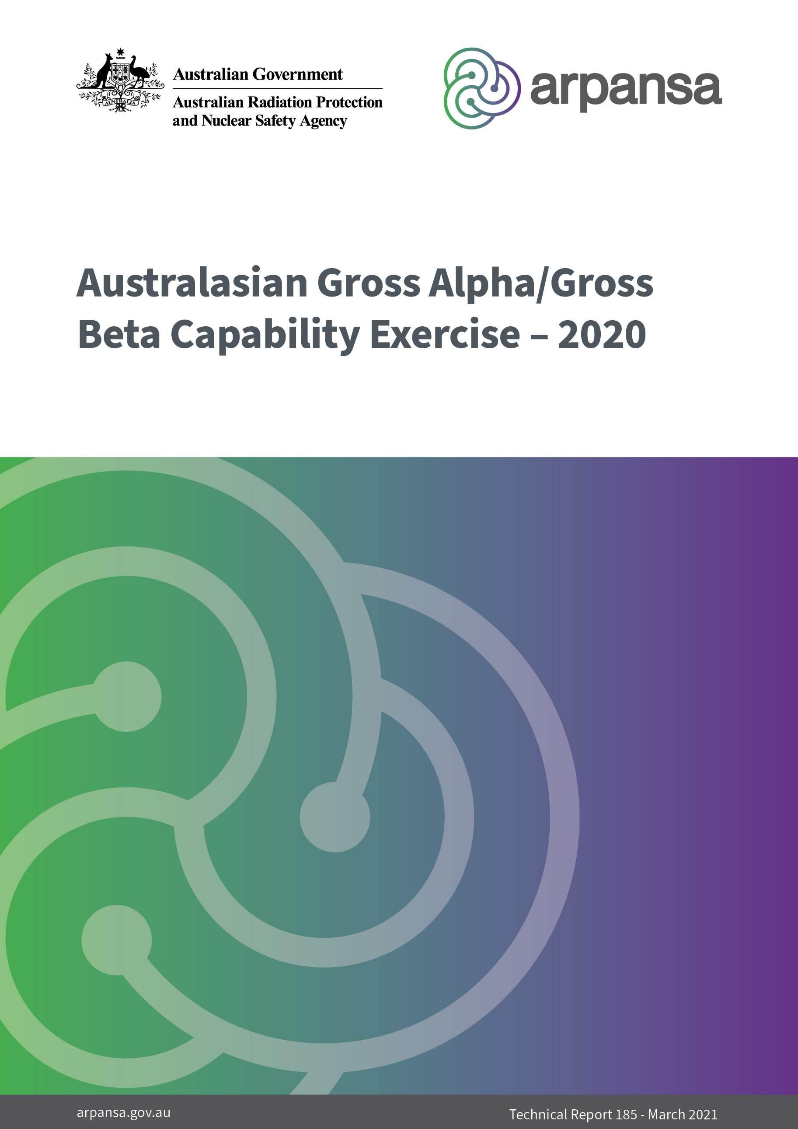
111

Australasian Gross Alpha/Gross Beta

Capability Exercise – 2020

Technical Report 185

E. Barnes

© Commonwealth of Australia 2021
This publication is protected by copyright. Copyright (and any other intellectual property rights, if any) in this publication is owned by the Commonwealth of Australia as represented by the Australian Radiation Protection and Nuclear Safety Agency (ARPANSA).

ISSN 0157-1400



Creative Commons

With the exception of the Commonwealth Coat of Arms, any ARPANSA logos and any content that is marked as being third party material, this publication, Australasian Gross Alpha/Gross Beta Capability Exercise – 2020, by the Australian Radiation Protection and Nuclear Safety Agency is licensed under a Creative Commons Attribution 3.0 Australia licence (to view a copy of the licence, visit http://creativecommons.org/licenses/by/3.0/au). It is a further condition of the licence that any numerical data referred to in this publication may not be changed. To the extent that copyright subsists in a third party, permission will be required from the third party to reuse the material.

In essence, you are free to copy, communicate and adapt the material as long as you attribute the work to ARPANSA and abide by the other licence terms. The works are to be attributed to the Commonwealth as follows:-

‘© Commonwealth of Australia 2021, as represented by the Australian Radiation Protection and Nuclear Safety Agency (ARPANSA)’

The publication should be attributed as: Australasian Gross Alpha/Gross Beta Capability Exercise – 2020.

Use of the Coat of Arms

The terms under which the Coat of Arms can be used are detailed on the Department of the Prime Minister and Cabinet website (www.dpmc.gov.au/government/commonwealth-coat-arms).

Enquiries regarding the licence and any use of this report are welcome.

ARPANSA
619 Lower Plenty Road
YALLAMBIE VIC 3085
Tel: 1800 022 333 (Freecall) or +61 3 9433 2211
Email: info@arpansa.gov.au
Website: www.arpansa.gov.au

Acknowledgement of Country
ARPANSA respectfully acknowledges Australia’s Aboriginal and Torres Strait Islander communities and their rich culture and pays respect to their Elders past and present. We acknowledge Aboriginal and Torres Strait Islander peoples as Australia’s first peoples and as the Traditional Owners and custodians of the land and water on which we rely.
We recognise and value the ongoing contribution of Aboriginal and Torres Strait Islander peoples and communities to Australian life and how this enriches us. We embrace the spirit of reconciliation, working towards the equality of outcomes and ensuring an equal voice.
Contents
Acknowledgements 5
Executive summary 6
1. Introduction 7
2. Methods 7
2.1 Sample preparation and measurement 8
3. Analysis of results 8
4. Results and discussion 9
4.1 Performance relative to acceptance limits 9
4.2 Performance relative to the certified activity 9
4.3 Gross alpha 10
4.4 Gross beta 11
4.5 Variations in analysis techniques and sample matrices 12
4.6 Variations in calibration sources used 12
5. Conclusion 13
6. References 14

Acknowledgements
The author wishes to thank all the laboratories that participated in the exercise.

Executive summary
International experience with significant radiological incidents has shown that extensive measurement of environmental samples is required (Japanese Ministry of Health, Labour and Welfare, 2015) (IAEA, 1988). Initial screening of samples via gross alpha and gross beta measurements can reduce the number of samples that require more accurate analyses. This approach improves the throughput of laboratories following an incident. ARPANSA’s capacity to analyse samples could be overwhelmed by the response required by a significant radiological incident. Therefore, assistance from other laboratories might be required to respond to a significant radiological incident.
This exercise was conducted to ascertain the capability of participating laboratories with respect to the measurement of total alpha and beta activity by gross alpha/gross beta analysis. The main purpose for this exercise was to establish how different laboratories perform gross alpha/beta measurements (i.e. gas-flow proportional counting or Liquid Scintillation Counting (LSC)), what sources they use for calibration and whether the diverse procedures used by the laboratories produce acceptable results.
Five of the radioanalytical laboratories identified as having gross alpha/gross beta capabilities participated in this exercise. These laboratories form part of the Australasian Radionuclide Laboratory Network (ARLN). Participants were asked to analyse 500 ml of water, containing known amounts of alpha and beta activity, obtained from an accredited supplier of Certified Reference Materials and proficiency testing products. The sample required preparation by the participating laboratories prior to analysis, as described in the Instruction to Participants letter, and noted further on in this report.
Apart from one laboratory, the participants reported gross alpha results that would be considered acceptable by the supplier of the samples. That is, 4 of the 5 reported gross alpha results were within the performance acceptance limits defined by the supplier. With regards to the gross beta results, the reported results were a lot more variable with only 3 of the 5 reported gross beta results being considered acceptable as defined by the supplier.
This exercise showed there is a lot of variability in both the procedures used by the laboratories and the sources used to calibrate for gross alpha/beta measurements. Work will now be undertaken to establish a standard procedure for gross alpha/beta measurement that all ARLN laboratories can undertake to improve the reliability of determining gross alpha/beta activities. A future capability exercise will be undertaken once this procedure has been implemented to see how the newly implemented procedure has improved gross alpha/beta measurement.

Introduction
ARPANSA maintains a radioanalytical laboratory, in part, to respond to radiological incidents. Theoretically, this laboratory has the capacity to measure about 48 samples over a week for gross alpha/beta measurements. However, this capacity could be overwhelmed by the response required by a significant radiological incident. Therefore, assistance from other laboratories might be required to respond to such an incident.
ARPANSA has identified 9 radioanalytical laboratories in Australia and New Zealand. This includes 3 laboratories run by the Australian Nuclear Science and Technology Organisation (ANSTO), ARPANSA’s own laboratory, 2 university laboratories as well as 3 other state or national laboratories. However, there is considerable specialisation in the radionuclides analysed by these laboratories. This is because many of these laboratories exist to fulfil specific needs and are not funded or specifically tasked with providing analyses in the event of general radiological incident. Therefore, some laboratories may not be able to provide assistance for certain radiological incidents.
This exercise was conducted to ascertain the capability of participating laboratories with respect to the measurement of gross alpha/beta activity in water and was the first capability study to ascertain the performance of the participating laboratories’ procedures for accuracy in determining gross alpha/beta activities.
It should be noted that this was not a proficiency test exercise because participants were not judged as to the acceptability of their procedures. The procedures used by each laboratory are appropriate to their particular objectives. Rather, the purpose of the exercise was simply to determine whether the methods currently used by each participating laboratory produced acceptable results when used for another purpose.

Methods
Five of the Australasian radioanalytical laboratories (including ARPANSA) agreed to participate in the exercise.
ARPANSA distributed screw-top glass vials containing at least 10 ml of standard concentrate to all 5 participating laboratories. The concentrate was preserved with nitric acid to pH < 2. The sample also contained added dissolved nitrates of magnesium, calcium, manganese, and iron. The remaining nitrate residues of the diluted standard, after evaporation, should range between 5 and 70 mg per 100 ml aliquot.
The sample was supplied as a concentrate and was diluted at the participating laboratories before use and represented the minimum suggested sample size for the sample. The diluted standard contained the following analytes in the activity ranges shown:
- Gross alpha (as thorium-230) – 0.25 – 2.8 Bq/L
- Gross beta (as caesium-137) – 0.25 – 2.8 Bq/L
The supplier also provided a certificate of analysis stating the certified values of the gross alpha and beta activity in the vials. The certificate of analysis also included performance acceptance limits (PALs) approximating 95% confidence intervals of the performance that an experienced laboratory should achieve.
The dilution instructions provided to all participants are detailed at 2.1 below.

Sample preparation and measurement
- Shake the jar well prior to opening.
- Using clean, dry, class A volumetric glassware, transfer 5.0 mL of the concentrate and dilute to a final volume of 500 mL with 0.1 M nitric acid solution
- If necessary, prepare a second 500 mL portion by following steps 1 and 2 above
- Mix or shake the diluted sample well prior to analysis
- Use your regular preparation and analytical procedures
- There is no decay correction performed for the measured results
- There is no correction for potassium-40 for the measured results
The diluent should have an acidic composition comparable to that of the concentrate to ensure analyte stability and should be analysed as soon as possible after dilution.
All participating laboratories confirmed the samples were prepared in accordance with the instructions supplied above, prior to analysis.

Analysis of results
For each radionuclide, ARPANSA calculated the relative bias (R) of the measured activity concentration (M), relative to the certified activity concentration supplied by the manufacturer (C):
Equation 1: $R= \frac{M-C}{C} ×100$
Due to the uncertainties in both the certified value (u_{c}) and the measured value (u_{m}), the relative bias for an individual radionuclide may not be statistically significant. Therefore, ARPANSA also calculated the U-test value (U):
Equation 2: $U= \frac{\sqrt{{(M-C)}^{2}}}{\sqrt{u_{m}^{2}+ u_{c}^{2}}}$
The relative bias for an individual radionuclide is statistically significant if U > 2.58 and may be statistically significant if U > 1.64.
If a participant under- or over-estimated the uncertainty associated with a measurement, the U-test value will over- or underestimate the statistical significance of the relative bias. Therefore, ARPANSA also compared the measured value to the PALs provided by the supplier of the sample.
Each participant was provided with an individual report detailing the relative bias, U-test value and comparison with the PALs for each radionuclide. This report also indicated if there appeared to be systematic errors in the laboratory’s measured values and indicated the potential sources of these errors, based on the results and responses from the report form.
The laboratories were randomly designated a number to be used throughout this report. Laboratory 3 returned 2 results, based on different analysis techniques and these results are displayed in the following report as laboratory 3 and 3.1.

Results and discussion

Performance relative to acceptance limits
As noted in section 2, the certificate of analysis for each sample also included PALs approximating 95% confidence intervals of the performance that an experienced laboratory should achieve. The reported activity concentration for each radionuclide, for each laboratory, was compared to these acceptance limits. Table 1 details the number of laboratories taking part in the exercise, reporting results within these limits.

Table 1: Laboratories reporting acceptable results
Analyte | Number of laboratories with results  within acceptance limits
Gross alpha | 5
Gross beta | 3
Most laboratories reported acceptable results for gross alpha, however the results for gross beta were less accurate. This indicates that further work is required to investigate a more reliable procedure for analysing samples for gross alpha/beta determinations than what is currently used by each participating laboratory.

Performance relative to the certified activity
Highly capable laboratories should produce a result that is commensurate with the certified value. The usual method to test whether a reported result is not significantly different to a certified value is the U-test (see equation 2). This test compares the measured result with the certified result in a way that accounts for the uncertainty in both values.
The U-test values for each radionuclide and each laboratory are shown in Figure 2. In the figure, the blue line indicates a U-test value of 1.64. Results with a U-test value below 1.64 are not statistically different from the certified value and are, therefore, consistent. The purple line in the figure indicates a U-test value of 2.58. Results with a U-test value greater than 2.58 are statistically different from the certified value. That is, those results with a U-test value greater than 2.58 are discrepant and indicate a significant error in the analysis.

Figure 1: U-test values for gross alpha and gross beta results for each laboratory.
Figure 1 indicates that laboratories 1, 3, 3.1 and 4 provided good results for gross beta as their reported values were consistent with the reference value. Laboratory 1 showed excellent results for their gross alpha result as it was almost the same result as the certified activity provided on the Certificate of Analysis. Laboratory 4 also returned good results for gross alpha.
Figure 1 does show that laboratories 2, 3, 3.1 and 5 each produced a result with U-test values greater than 2.58 for gross alpha. This indicates that significant errors were made by each of these laboratories when analysing the sample for this analyte. Additionally, Laboratories 2 and 5 also produced discrepant results for gross beta.
Where results reported are above the 1.64 U-test value, this may indicate that an error in the analysis might have been made but could also be due to simple statistical variation.

Gross alpha
Figure 2 shows some discrepancy with results achieved by the participating laboratories, it also indicates a large negative bias for the majority of laboratories when compared to the certified activity.
Another notable artefact is the very large uncertainty returned with the second analysis from laboratory 3.

Figure 2: Gross alpha activity concentration

Gross beta
Figure 3 shows a large discrepancy with results achieved by the participating laboratories, it also indicates a large result uncertainty for the majority of laboratories.
The only laboratories to report acceptable results were 1, 2 and 4, although the gross beta result for laboratory 4 is borderline acceptable.
Again, there is a noticeable difference in the uncertainties reported for each result, with the biggest uncertainties being reported by laboratories 3, 4 and 5.

Figure 3: Gross beta activity concentration

In attempting to understand the variability of the results received, further information was requested from the laboratories, including the:
- analysis techniques/procedures and sample matrices used
- calibration sources used.
Further discussion on these topics is shown below

Variations in analysis techniques and sample matrices
The results received from the participating laboratories were achieved using various techniques including liquid scintillation counting (LSC), gas-flow proportional counting (GFPC), and the use of solid-state detectors (SSD) and different sample matrices.
The matrices included suspension of sample within scintillant (LSC), evaporation of a sample aliquot on stainless steel/aluminium planchets and evaporation on filter paper (GFPC and SSD).
Table 2 shows the analysis techniques used by each participating laboratory:
Table 2 – analysis techniques/matrices used by each laboratory.
Laboratory | Analysis technique | Sample matrix | Instrumentation
1 | Evaporation and low-level LSC | Suspension in scintillant | Quantalus
2 | Evaporation and deposition on 50mm stainless steel planchet - GFPC | Stainless steel planchet | Tennelec 5XLB
3 | Evaporation on filter paper - SSD | Filter paper | Ludlum 3030P
3.1 | Evaporation on aluminium planchet - SSD | Aluminium planchet | Ludlum 3030P
4 | Evaporation and low-level LSC | Suspension in scintillant | Quantalus
5 | Evaporation and low-level LSC | Suspension in scintillant | Quantalus
Unfortunately, understanding the analysis techniques/matrices used by the laboratories does not provide a reliable insight into the variations in results provided for this capability exercise. As such, information on calibration sources used was also investigated.

Variations in calibration sources used
Table 3 shows the sources laboratories used for calibration of their instrumentation for gross alpha and gross beta determinations.
Table 3 – calibration sources used by each laboratory.
Laboratory | Gross alpha calibration source | Gross beta calibration source
1 | Pu-242 | Sr-90
2 | Am-241 | K-40
3 | Po-209 | Cs-137
4 | Am-241 | Sr-90
5 | Am-241 | Sr-90
Am-241, Sr-90, Cs-137 and K-40 are the sources most regularly used for calibration for gross alpha/beta measurements and are also the most readily available and cost effective to purchase.
For laboratories that utilised difference calibration sources, the choice to do so was based on the types of sources they had available to use at the time of this exercise and were also the sources usually used within their established procedures for gross alpha/beta.
Again, no direct correlation could be made between the calibration sources used and the inconsistent results reported.

Conclusion
This exercise was conducted to ascertain the capability of participating laboratories with respect to the measurement of gross alpha and gross beta. It should be noted the purpose of the exercise was to determine whether the methods currently used by each participating laboratory produced acceptable results when applied to a sample which may be received in a radiological emergency.
Five of radioanalytical laboratories in the Australasian Radionuclide Laboratory Network participated in this exercise. All laboratories undertook the gross alpha/beta measurements in accordance with their standard procedures, established for their core business requirements.
In almost all cases, the participants reported gross alpha results that would be considered acceptable by the supplier of the samples. That is, 4 of the 5 reported results were within the performance acceptance limits (PALs) defined by the supplier.
However, the results for gross beta showed that approximately half of the results returned would not be considered acceptable by the supplier of the samples.
With the vastly varying results returned for this exercise, it is evident that a standard method for the determination of gross alpha/beta is required for use by the Australasian Radionuclide Laboratory Network.
As such, work with all the participating laboratories will be undertaken to develop a standard method for the determination of gross alpha/beta measurements. Once a standard method has been implemented, a repeat of this ARLN capability study will be undertaken to determine if an improvement in results can be achieved using the standard method chosen.

References
IAEA The Radiological Incident in Goiania [Report]. Vienna : International Atomic Energy Agency, 1988.
Japanese Ministry of Health, Labour and Welfare Levels of Radioactive Contaminants in Foods Tested in Respective Prefectures [Online]. 2015. 14 August 2015.
http://www.mhlw.go.jp/english/topics/2011eq/index_food_radioactive.

