Analysis of the ANRDR Medical Sector Survey

Ben Paritsky and Cameron Lawrence

March 2017

# 1. Executive summary

This report presents the findings of a survey undertaken by the Australian Radiation Protection and Nuclear Safety Agency (ARPANSA) to assess the current status of radiation dose record management practices in the Australian medical sector and other issues relating to the disclosure of workers’ dose records to the Australian National Radiation Dose Register (ANRDR). The purpose of this report is to provide information and recommendations that will assist ARPANSA, regulatory authorities and employers in establishing the legal and practical requirements for the expansion of the ANRDR to cover occupationally exposed workers in the medical sector.

Based on the findings of this report, ARPANSA has assessed that existing practices for the management of radiation dose records in the medical sector could be improved to ensure record keeping practices meet **international best practice**. A best practice approach for recording and maintaining radiation dose records for workers in the medical sector involves the long-term storage of dose records in a centralised (national) database, such as the ANRDR. When adopted and implemented, the ANRDR will allow for a nationally uniform approach for the long-term maintenance of radiation dose records for the medical sector in a central location and will ensure that records remain available to workers as per the requirements in GSR Part 3 (IAEA, 2014).

In order to assist the medical sector to improve the existing practice for maintaining radiation dose records and facilitate implementation of the ANRDR, ARPANSA makes the following three key recommendations:

**Recommendation 1**

**That ARPANSA works cooperatively with industry and regulatory authorities to establish processes and working arrangements for obtaining dose data directly from medical organisations to ensure that all exposure pathways are included in the dose assessment records reported to the ANRDR.**

**Recommendation 2**

**That all employers currently maintaining dose records using only paper-based systems work towards the development of digital record management systems. This would ensure that dose record management practices are in-line with international best practice and would facilitate national uniformity in record keeping practices through the implementation of the ANRDR.**

**Recommendation 3**

**That ARPANSA, relevant regulatory authorities and the medical industry work cooperatively to develop dose record reporting frameworks, processes and working arrangements to ensure that industry reporting requirements are effective and efficient in facilitating worker dose optimisation efforts and inclusion of national dose records in the ANRDR for long-term maintenance.**

ARPANSA may form a coordinating body of and/or host a workshop for relevant medical industry and regulatory representatives to strengthen support for the ANRDR and guide implementation activities to ensure that future decisions for expansion of the ANRDR are in-line with industry practice and the regulatory framework for radiation protection in the medical sector.

**Contents**

1. Executive summary 2

2. Background 4

3. Purpose of the medical sector survey 4

4. Methodology for conducting the medical sector survey 4

5. Results of the medical industry survey 5

5.1. Personal radiation monitoring services 5

5.2. Types of radiation and exposure pathways 5

5.3. Personal information collection 6

5.4. Dose record management practices 7

5.5. Historical data collection 8

5.6. Record keeping for multiple sites 10

5.7. Provision of dose records to regulatory authorities 11

5.8. Classification of data and privacy considerations 11

5.9. Dose record management software 12

5.10. Implementation of the ANRDR 12

6. Appendix 14

7. References 18

# 2. Background

All medical facilities in which workers may be potentially exposed to ionising radiation throughout the course of their work are required to maintain a suitable personal monitoring program to ensure occupational exposures are kept optimised. Occupational dose reporting to a regulatory authority is governed by the relevant state/territory jurisdiction in which the facility lies. Different radiation dose recording and reporting practices exist across medical facilities and jurisdictions.

To address existing limitations in dose record management, ARPANSA has developed a national dose register, in-line with international best practice.

Paragraph 4.63 of GSR Part 1 (IAEA, 2016) states that:

*“The regulatory body shall make provision for establishing and maintaining the following main registers and inventories:*

*• Records of doses from occupational exposure”*

Clause 3.1.24 (c) of the Planned Exposure Code (ARPANSA, 2016) states that the Responsible Person must:

*“Provide details of the doses estimated to have been received by an occupationally exposed person to the relevant regulatory authority or its approved central record keeping agency”*

ARPANSA will work with the Radiation Health Committee (RHC) to define the criteria for approval of a central record keeping agency. The role of the RHC is to advise ARPANSA’s CEO and the Radiation Health and Safety Advisory Council on matters relating to radiation protection, including formulating draft national policies, codes and standards for consideration by the Commonwealth, states and territories.

# 3. Purpose of the medical sector survey

The purpose of the medical survey was to gather information on how occupational radiation dose record management is managed across different facilities and jurisdictions. It is intended that the medical industry and relevant regulators will use this report to assist in implementing the ANRDR. The survey results are presented in this report.

# 4. Methodology for conducting the medical sector survey

The survey commenced with the identification of key industry stakeholders in the medical sector such as medical physicists and radiation safety officers who are responsible for maintaining radiation safety programs for their site(s). A range of sources were used to identify relevant stakeholders, such as the Engineering in Physical Sciences and Medicine (EPSM) 2016 Conference, ARPANSA stakeholder lists and desktop research.

The ANRDR team conducted an online survey of the medical sector that formed the basis of this analysis. All relevant identified stakeholders were circulated a link to the survey and requested to complete all questions. The survey consisted of a range of multiple choice and short answer questions concerning radiation exposure to workers, data management and record keeping practices.

# 5. Results of the medical industry survey

The survey was circulated to 124 stakeholders from a range of medical facilities and networks across Australia that monitor their workers for occupational radiation exposure. Of those, 42 responses were received; however, not all respondents provided responses to all questions.

The main types of services offered by medical facilities are nuclear medicine, radiology and radiotherapy. In addition, 19% of respondents undertake additional services such as blood irradiation, research and molecular imaging. The survey questions are provided in the Appendix. The results of the survey showing the current status of dose record management practices in Australia are discussed below.

## 5.1. Personal radiation monitoring services

The three main personal radiation services used by medical facilities to monitor external exposures are listed below alphabetically:

* ARS-SGS (26%)
* Landauer Australasia (62%)
* PRMS (ARPANSA’s Personal Radiation Monitoring Service) (35%)

A small number of facilities also use the National Radiation Laboratory (New Zealand) and Mirion, while one facility operates an in-house dosimetry service. The percentage of market share does not equal 100% as some organisations use more than one monitoring service.

## 5.2. Types of radiation and exposure pathways

Although medical radiation workers may be potentially exposed to a variety of radiation types and exposure pathways, external gamma/x-ray exposure is the prevalent exposure type in the medical industry.

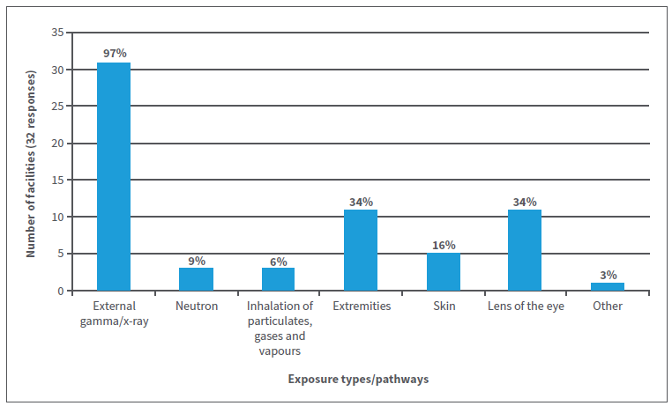

Figure 1: Radiation types and exposure pathways to which medical workers may be occupationally exposed

Figure 1 represents the wide range of radiation types and exposure scenarios for which workers in the surveyed organisations are monitored, including external exposure from gamma/x-ray emitting sources, internal exposure from inhalation of radioactive material and exposure to specific organs.

As expected, the exposure to external gamma/x-ray radiation is the principle exposure scenario for most medical facilities. External monitoring is performed using personal dosimeters issued by one of the providers discussed in section 5.1.

One third of the respondents also monitor their workers for exposures to extremities and the lens of the eye. Extremity monitoring is usually undertaken for workers handling radioisotopes such as nuclear medicine technologists and those involved in radioisotope production or research. In 2011, ICRP recommended the reduction of the dose limit for equivalent dose to the lens of the eye to 20 mSv per year (averaged over 5 years), with a maximum of 50 mSv in any one year (ICRP, 2011). Previously, the dose limit had been 150 mSv per year (IAEA, 2014). Workers who have the potential to be affected by the reduction in the dose limit for the lens of the eye include interventional radiologists and cardiologists (ARPANSA, 2011).

Furthermore, 25% of organisations calculate or estimate doses that are not captured by their radiation monitoring service. This demonstrates the need for a uniform approach to dose record management to ensure all exposure pathways are captured and recorded in a central location.

**Recommendation 1**

**That ARPANSA works cooperatively with industry and regulatory authorities to establish processes and working arrangements for obtaining dose data directly from medical organisations to ensure that all exposure pathways are included in the dose assessment records reported to the ANRDR.**

## 5.3. Personal information collection

Accurate personal information collection and maintenance is an important aspect of any radiation protection program. In the case of the ANRDR, personal information helps to conclusively match a dose record with the correct worker. This becomes especially important when workers change employers, move between jurisdictions or are employed by more than employer at a time, all of which are common occurrences in the medical sector.

The personal identifiers that are required for data submission to the ANRDR are listed in Figure 2. Full name was the only identifier stored with dose records at all facilities, while many facilities also recorded workers’ dates of birth, genders and work classifications. Although the employee number is only recorded at 28% of facilities, it is likely that this identifier could be retrieved from human resources and supplied to the ANRDR. The employee number is essential for the ANRDR as it is the only parameter that is unique and is used to differentiate workers with the same name and date of birth.

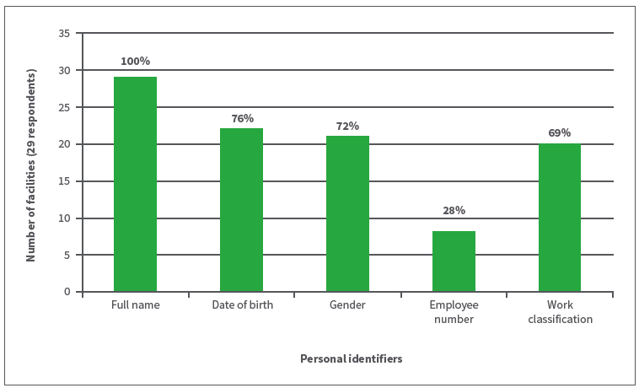

Figure 2: Personal identifiers stored with dose records by employers

## 5.4. Dose record management practices

Most employers use a combination of different digital formats (Database, CSV, PDF, XML and Excel) or a combination of digital and paper records as demonstrated in Figure 3. The ANRDR accepts data in CSV (comma separated variables) format according to predefined specifications.

Nine (31%) employers use paper records only. Transitioning to digital record keeping will ensure the long-term survival of historical data attributed to workers past, present and future, as well as provide the opportunity to observe trends across the industry.

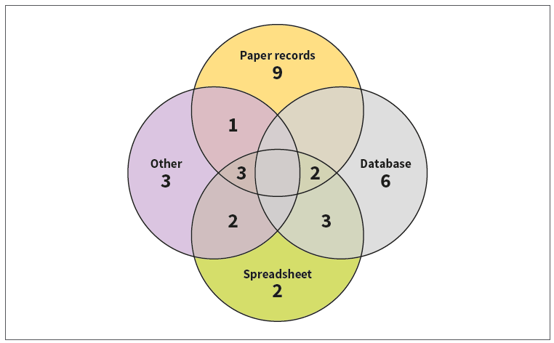

Figure 3: Dose record formats

**Recommendation 2**

**That all employers currently maintaining dose records using only paper-based systems work towards the development of digital record management systems. This would ensure that dose record management practices are in-line with international best practice and would facilitate national uniformity in record keeping practices through the implementation of the ANRDR.**

## 5.5. Historical data collection

The ANRDR survey has revealed that a significant number of employers maintain a large amount of historical dose data, as shown in Figure 4. In fact, 21% of employers maintain over 25 years’ worth of dose records.

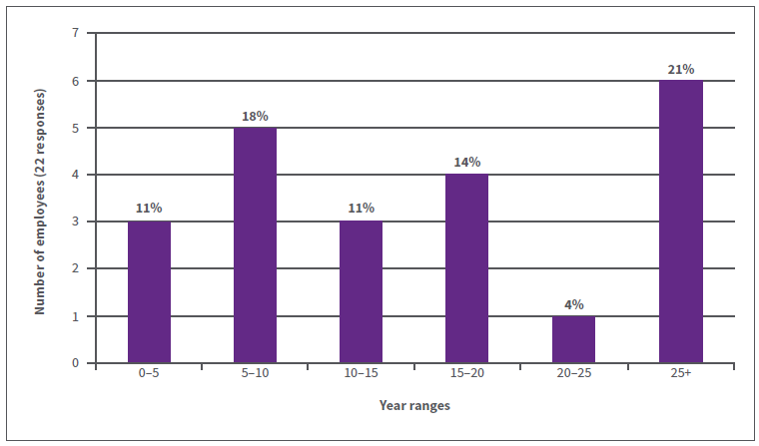

Figure 4: Years’ worth of paper records

As shown in Figure 5, a significant number of employers have digitised their current and historical dose records. Although the ANRDR only requires registered organisations to submit current data (from the date that they join onwards), the submission of historical data offers valuable benefits, such as the ability to provide comprehensive personal dose history reports and the ability to analyse dose trends within the industry across an extensive period of time, demonstrating the effectiveness of dose optimisation efforts.

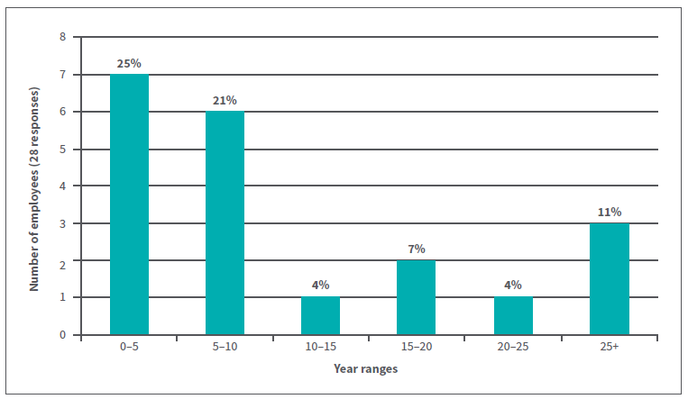

Figure 5: Years’ worth of digital records

The total number of workers monitored by each employer over the past year and since monitoring began varies considerably. Figure 6 shows that 70% of employers monitor over 50 workers with a significant number monitoring workers in the hundreds, while 7% of employers monitor over one thousand workers at one time. Figure 7 demonstrates that there are historical records for thousands of workers who have been monitored by employers in the past. It is well known that the medical sector has a dynamic workforce with workers commonly changing employers or working for multiple employers at one time. In most cases, individuals’ dose histories would not accompany them to their new employer, especially if there was movement between jurisdictions. The consolidation of these dose records in a central location would be desirable and would promote longevity of personal dose records as well as enhancing dose optimisation efforts.

ARPANSA estimates that there are approximately 26,000 medical sector workers monitored for occupational radiation exposure in Australia.[1]

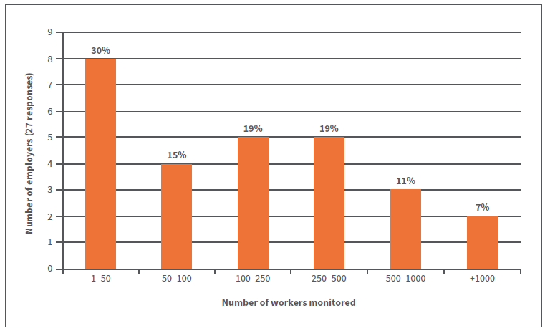

Figure 6: Number of workers monitored over the past year

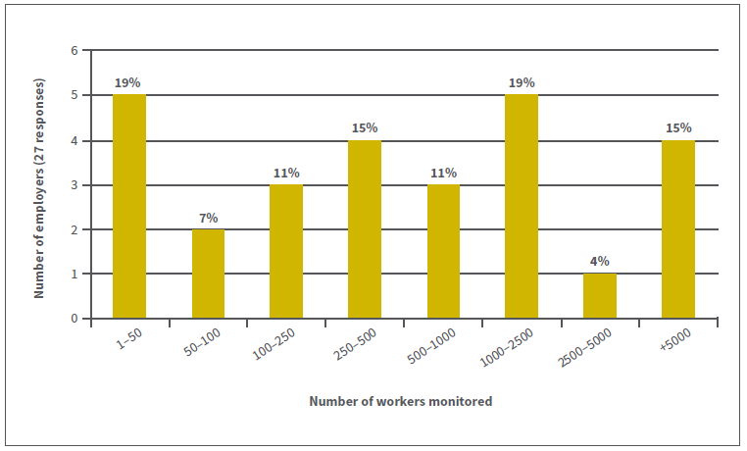

Figure 7: Number of workers monitored since monitoring commenced

## 5.6. Record keeping for multiple sites

According to the survey results, approximately 60% of organisations operate multiple sites. Of those, 36% are responsible for five or more sites. In terms of how dose records are managed, there is a roughly even split between managing dose records centrally (56%) and independently (44%). The same is true for the responsibility of dose records management, with 48% managing dose records centrally, while 52% have a radiation safety officer or radiation safety group responsible for dose records at each worksite.

## 5.7. Provision of dose records to regulatory authorities

Of the employers surveyed, only 12% provide dose record information to an external stakeholder (regulatory authority), and there is little consistency in the specific requirements and formats of such provisions across different jurisdictions. It is unknown whether individual dose records or statistical information is reported to regulatory authorities.

As the medical workforce is well-known to be dynamic, this is a concern for occupationally exposed medical workers. Workers who change employers, move between jurisdictions (common with locum workers) or work for multiple employers concurrently are at risk of receiving elevated doses as their doses are currently not being consolidated and monitored accordingly.

**Recommendation 3**

**That ARPANSA, relevant regulatory authorities and the medical industry work cooperatively to develop dose record reporting frameworks, processes and working arrangements to ensure that industry reporting requirements are effective and efficient in facilitating worker dose optimisation efforts and inclusion of national dose records in the ANRDR for long-term maintenance.**

## 5.8. Classification of data and privacy considerations

The ANRDR was established with the purpose of being a central repository for the long term storage and maintenance of dose records allowing individuals to obtain their dose records regardless of where in Australia they have worked throughout the course of their career, including when an employer has ceased to operate. As such, the disclosure of dose records to the ANRDR forms part of the primary purpose for which this information was collected by the employer and is also directly related to ARPANSA’s function of protecting the health and safety of people and the environment from the harmful effects of radiation.

Dose records with accompanying personal identifiers can be classified as either personal information or sensitive information (health information). As shown in Figure 8, 13% of respondents classify dose records as sensitive information (health information). Dose records that are ‘not classified’ are generally treated as personal information.

Regardless of the classification type, the disclosure of radiation dose records to the ANRDR is permitted as part of the primary purpose for which this information was collected by the employer. To establish the relationship of disclosure to the ANRDR as part of the primary purpose, an employer will need to update their privacy policy and communicate the disclosure to their employees. Although only 6% of organisations employ a privacy officer, ARPANSA will work with each organisation to determine the most suitable means of meeting their privacy requirements for the disclosure of dose records to the ANRDR.

The survey respondents consist of a combination of private sector (29%) and public sector (71%) entities. With regards to privacy, public sector entities are required to abide by their jurisdictional privacy legislation, while private sector entities and jurisdictions that do not have their own privacy legislation are expected to abide by the Australian Privacy Principles (APPs).

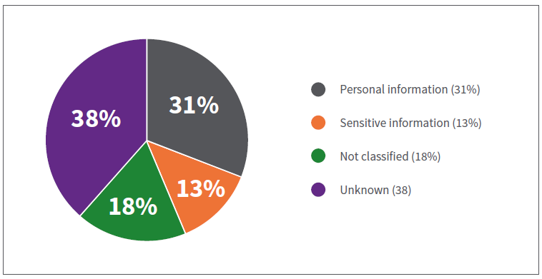

Figure 8: Classification of dose records (39 responses)

ARPANSA recommends that employers wishing to participate in the ANRDR complete a privacy impact assessment (PIA) to ensure their privacy requirements are met. ARPANSA has developed a PIA template to facilitate this process and completed its own PIA to demonstrate compliance with the APPs. The completed ANRDR PIA is available from the ARPANSA website and can be used as a guide for employers completing their own PIA. Employers are encouraged to seek independent legal advice regarding their privacy obligations.

## 5.9. Dose record management software

Data management software facilitates dose optimisation in the workplace by enhancing an employer’s ability to effectively and efficiently manage workers’ exposures and other aspects of a radiation protection program. Recently, ARPANSA worked with the developers of Historion (a dose record management system) to develop an integrated ANRDR tool which is able to generate a submission file in the correct format using the data and parameters defined by users within Historion.

Around 15% of respondents currently use Historion for their dose management needs, with others set to follow suit in the near future. At the time this report was written, ARPANSA was not aware of any other dose record management systems with ANRDR export capability.

## 5.10. Implementation of the ANRDR

ARPANSA has previously hosted workshops for the uranium and mineral sands industries, and Commonwealth Government organisations to assist with the implementation of the ANRDR and to facilitate engagement between industry and ARPANSA. Typically, these workshops were hosted on the sidelines of a relevant industry conference to allow attendance without the need for additional travel. Stakeholders provided positive feedback on past workshops which were found to be useful and informative. As the majority (58%) of respondents expressed interest in attending an ANRDR workshop, it is likely that ARPANSA would host a similar workshop for the medical sector in the near future. The purpose of such a workshop would be to provide an overview of the ANRDR, to discuss technical and legal considerations and to provide a platform for industry feedback and sharing of information that will contribute to improving national uniformity for recording and maintaining occupational exposure records in a national database.

Eighty-eight per cent of respondents agreed that to further support implementation of the ANRDR, the establishment of a coordinating body consisting of industry, regulatory and ARPANSA representatives would be useful. Consideration will be given to the formation of such a coordinating body at a later time. In the interim, ARPANSA will be presenting further information at relevant medical conferences throughout 2017.

# 6. Appendix

Survey questions relating to dose record management are provided below:

1. Which service(s) are you responsible for?

a. Nuclear Medicine

b. Radiology

c. Radiotherapy

d. Other (please specify)

2. Is your organisation classified as a:

a. Private sector entity

b. Public sector entity

3. With reference to the definitions provided in the Privacy Act 1988 (Cth), does your department/organisation classify dose records with accompanying personal identifiers as:

a. Personal information

b. Sensitive information (i.e. health information)

c. Not classified

d. Unknown

4. Does your department/organisation use Historion (dose record management software)?

a. Yes

b. No

5. Does your department/organisation have a privacy officer?

a. Yes

b. No

6. Please provide the contact details of your privacy officer.

7. Does your department/organisation monitor workers across multiple sites?

a. Yes

b. No

8. If monitoring across multiple sites, how many sites are monitored?

a. 2

b. 3

c. 4

d. 5 or more

9. If monitoring across multiple sites, are any sites located in different state/territory jurisdictions?

a. Yes

b. No

10. In which state/territory jurisdictions are the sites located?

a. ACT

b. NT

c. NSW

d. QLD

e. SA

f. TAS

g. VIC

h. WA

11. Which radiation monitoring service does you department/organisation use?

a. ARPANSA Personal Radiation Monitoring Service (PRMS)

b. SGS

c. Landauer Australasia

d. Global Dosimetry Solutions

e. Global Medical Solutions Australia

f. National Radiation Laboratory (New Zealand)

g. Mirion

h. In-house dosimetry service

i. None

j. Other

12. What types of radiation exposures are your workers monitored for?

a. External gamma/x-ray doses

b. External neutron doses

c. Inhalation of radioactive particulates

d. Inhalation of radioactive gas and vapour

e. Ingestion of radioactive material

f. Doses to the extremities (hands and feet)

g. Internal doses from intakes of radioactive material via a wound

h. Doses to the skin

i. Doses to the lens of the eye

j. Other (please specify)

13. Does your department/organisation estimate or calculate doses to workers that are not captured by your radiation monitoring service (e.g. lens of the eye)?

a. Yes

b. No

14. Which doses are calculated or estimated?

a. External gamma/x-ray doses

b. External neutron doses

c. Inhalation of radioactive particulates

d. Inhalation of radioactive gas and vapour

e. Ingestion of radioactive material

f. Doses to the extremities (hands and feet)

g. Internal doses from intakes of radioactive material via a wound

h. Doses to the skin

i. Doses to the lens of the eye

j. Other (please specify)

15. What personal identifiers are collected and stored with radiation dose records for workers?

a. Full name

b. Date of birth

c. Gender

d. Employee number (unique identifier)

e. Employee work classification

f. Other (please specify)

16. How does your department/organisation manage radiation dose records (select more than one option if applicable)?

a. Database

b. Spreadsheet

c. Paper records

d. Other (please specify)

17. How many years of PAPER dose records does your department/organisation hold?

a. 0–5 years

b. 5–10 years

c. 10–15 years

d. 15–20 years

e. 20–25 years

f. 25 plus years

g. N/A

18. How many years of DIGITAL dose records does your department/organisation hold?

a. 0–5 years

b. 5–10 years

c. 10–15 years

d. 15–20 years

e. 20–25 years

f. 25 plus years

g. N/A

19. If your records are held in a digital format, in what file format is the data maintained?

a. CSV

b. XML

c. PDF

d. Excel

e. Word

f. Other (please specify)

20. How are the records for radiation exposure to workers managed (e.g. centrally or independently at each site)?

a. All workers’ records are managed in a central location within the organisation

b. Workers’ records are managed separately depending on which location the worker is employed (i.e. separate databases or spread sheets per worksite)

21. The responsibility of radiation record management sits with (e.g. centrally or independently at each site):

a. A central radiation safety officer, or radiation safety group for the entire organisation

b. One radiation safety officer, or radiation safety group for each worksite

22. Over the past year, approximately how many workers were monitored for radiation exposure by your department/organisation?

a. 1–50

b. 50–100

c. 100–250

d. 250–500

e. 500–1000

f. 1000 plus

23. Including historical data, approximately how many workers in total have been monitored for radiation exposure by your department/organisation since personal monitoring of workers commenced?

a. 1–50

b. 50–100

c. 100–250

d. 250–500

e. 500–1000

f. 1000–2500

g. 2500–5000

h. 5000 plus

24. In terms of maintaining radiation dose records, how are workers categorised (i.e. exposure groups)? Please provide a list of categories below. This list may include categories as defined by your radiation monitoring service. Examples may include: Radiation Safety Officer (RSO), Maintenance, Research, Radiographer, Radiotherapist, Nuclear Medicine Technologist, Radiologist, Assistant, etc.

25. Do you currently provide dose record information to internal or external stakeholders (e.g. Company CEO, industry group or state/territory regulator)?

a. Yes

b. No

26. Please provide details of the stakeholder(s) to which you provide dose record information.

27. In what format is the data reported to internal or external stakeholders?

a. CSV

b. XML

c. PDF

d. Excel

e. Word

f. Quarterly report

g. Annual report

h. Other (please specify)

28. Do you perceive any barriers to expansion of the ANRDR to include the medical sector?

a. No

b. Yes

29. Would you be interested in attending a workshop to discuss the expansion of the ANRDR to include the medical sector?

a. Yes

b. No

30. Do you think it would be beneficial for ARPANSA to form a coordinating body to guide implementation of the ANRDR?

a. Yes

b. No

31. Do you have any additional comments?

# 7. References

• Australian Radiation Protection and Nuclear Safety Agency (ARPANSA) 2011.  
***Statement on Changes to Occupational Dose Limit for Lens of the Eye***.  
Accessed 9 February 2017

• Australian Radiation Protection and Nuclear Safety Agency (ARPANSA) 2016.   
***Code for Radiation Protection in Planned Exposure Situations. Radiation Protection Series C-1***.

• International Commission on Radiological Protection (ICRP) 2011.   
***Statement on Tissue Reactions***.  
Accessed 9 February 2017

• International Atomic Energy Agency (IAEA) 2014.   
***Radiation Protection and Safety of Radiation Sources: International Basic Safety Standards. General Safety Requirements Part 3, No. GSR Part 3***.

• International Atomic Energy Agency (IAEA) 2016.   
***Governmental, Legal and Regulatory Framework for Safety. General Safety Requirements Part 1, No. GSR Part 1 (Rev. 1)***.

1. Estimate based on approximately 9000 medical workers monitored by PRMS (from PRMS data) and 35% market share (from survey responses).