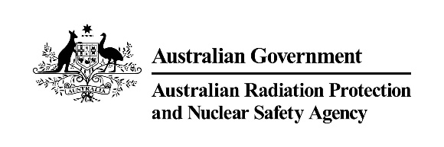 |  | 

AMTA–ARPANSA Liaison Forum Meeting Summary
4 April 2023
10:00am – 12.00pm

Meeting summary
The Chief Executive Officers (CEOs) of the Australian Mobile Telecommunications Association (AMTA) and the Australian Radiation Protection and Nuclear Safety Agency (ARPANSA) and accompanying staff met at the ARPANSA offices in Yallambie. The objective of the AMTA-ARPANSA Liaison Forum is to provide an open, frank, and transparent exchange of information and views on radiation safety and radiation protection issues in the area of Electromagnetic Energy (EME), with due regard to the different roles the organisations play.
EME Program Update
ARPANSA provided a general update on its activities as part of the EME Program. This included an update of key activities that have been completed, and future activities that are planned, for EME measurements in Melbourne and across Australia. An update was provided on a review of the effects of EME on animals and plants in the environment. The completion of the new world-class anechoic chamber was also discussed. An update was also provided on national and international engagement, including the significant contributions that members of the EME team at ARPANSA are making to the World Health Organisation’s systematic reviews and update of their Environmental Health Criterion Monograph on RF.

Research update
ARPANSA provided an update on both internal and external research activities. The current structure of the EME Program Research Framework was discussed, including some of the ongoing problems that the program has faced. A proposal was made for the funding to be allocated in different ways to improve research quality and adopt a more agile approach.

Industry trends update – 5G and small cell rollout
AMTA provided a general update on industry rollout of 5G infrastructure and noted the future plans for the closure of 3G mobile telecommunications in 2024. AMTA also provided an update from the recent Mobile World Congress.

Worker safety initiatives
AMTA noted the RF Safety Program for occupational exposures and discussed ARPANSA supporting an initiative to approach SafeWork Australia to produce guidance on EME exposure for workers.

International base station assessment standards update
AMTA noted that Australian industry has high levels of international engagement in workshops to look at the issues of exposure measurement methods for new technologies such as 5G. The new IEC measurement standard for determination of exposure from base stations has recently been published.

