2023 Safety Culture Assessment Summary Report

*Australian Radiation Protection and Nuclear Safety Agency*

January 2025

John Ward and Prachi Batra

|  |
| --- |
| © Commonwealth of Australia 2017  This publication is protected by copyright. Copyright (and any other intellectual property rights, if any) in this publication is owned by the Commonwealth of Australia as represented by the Australian Radiation Protection and Nuclear Safety Agency (ARPANSA).  ISSN 0157-1400    **Creative Commons**  With the exception of the Commonwealth Coat of Arms, any ARPANSA logos and any content that is marked as being third party material, this publication, *2023 Safety Culture Assessment Summary Report*, by the Australian Radiation Protection and Nuclear Safety Agency is licensed under a Creative Commons Attribution 3.0 Australia licence (to view a copy of the licence, visit [*http://creativecommons.org/licenses/by/3.0/au*](http://creativecommons.org/licenses/by/3.0/au)). It is a further condition of the licence that any numerical data referred to in this publication may not be changed. To the extent that copyright subsists in a third party, permission will be required from the third party to reuse the material.  In essence, you are free to copy, communicate and adapt the material as long as you attribute the work to ARPANSA and abide by the other licence terms. The works are to be attributed to the Commonwealth as follows:-  ‘© Commonwealth of Australia 2017, as represented by the Australian Radiation Protection and Nuclear Safety Agency (ARPANSA)’  The publication should be attributed as: *Radiofrequency Electromagnetic Energy and Health: Research Needs*.  **Use of the Coat of Arms**  The terms under which the Coat of Arms can be used are detailed on the Department of the Prime Minister and Cabinet website ([www.dpmc.gov.au/government/commonwealth-coat-arms](http://www.dpmc.gov.au/government/commonwealth-coat-arms)).  Enquiries regarding the licence and any use of this report are welcome.  ARPANSA  619 Lower Plenty Road  YALLAMBIE VIC 3085  Tel: 1800 022 333 (Freecall) or +61 3 9433 2211   Email: [info@arpansa.gov.au](mailto:info@arpansa.gov.au)  Website: [www.arpansa.gov.au](http://www.arpansa.gov.au) |

**Contents**

1. Introduction 1

1.1 Purpose 1

2. Methodology 1

2.1 Safety Culture Model 1

2.2 Maturity rating 2

3. Data Collection Methods 3

3.1 Perception survey 3

3.2 Interviews 4

3.3 Focus Groups 4

3.4 Document Review 4

3.5 Workplace behavioural interaction observations 5

4. Results 5

4.1 Overall results 5

4.2 Comparisons with past assessments 6

# Introduction

The Australian Radiation Protection and Nuclear Safety Agency (ARPANSA) is the Australian Government’s primary authority on radiation protection and nuclear safety. ARPANSA undertakes research, provides services, regulates Commonwealth users of radiation, and promotes national uniformity and the implementation of international best practice.

ARPANSA conducted an internal safety culture assessment (SCA) in 2023. A good safety culture is where everyone, from operators to managers, take safety seriously. This attitude can significantly reduce the risks of accidents occurring. Auditing our performance in safety culture is consistent with the International Atomic Energy Agency (IAEA) General Safety Requirements Part 2: Leadership and Management for Safety (GSR Part 2) Requirement 14, which states ‘senior management shall regularly commission assessments of leadership for safety and of safety culture in its own organisation’. This requirement applies to all users and regulators of radiation. ARPANSA’s approach is also consistent with the guidance given in the IAEA’s Safety Standard GS-G-3.5 ‘The Management System for Nuclear Installations’ and is informed by the practices outlined in the IAEA’s Safety Reports Series No. 83 ‘Performing Safety Culture Self-assessments’ and the IAEA’s Services Series No. 32 ‘OSART Independent Safety Culture Assessment (ISCA) Guidelines’.

This is ARPANSA’s second formal assessment of its whole of agency safety culture, with the first assessment completed in late 2019, following a pilot study that was undertaken of the agency’s regulatory function in early 2019. A project team was established to deliver this project:

* John Ward, ARPANSA’s Safety Systems Director
* Joy Ho, ARPANSA’s Organisational Psychologist
* Lachlan Whittle, ARPANSA Regulatory Officer
* Chris Nickel, ARPANSA Senior Regulatory Officer
* Dr. Ben Searle, an independent consultant.

## Purpose

The SCA was designed with the following objectives:

* To provide ARPANSA with insights on its current safety culture
* To help develop a vision of where the organisation wants to be in the next 2-3 years in its safety culture performance
* To assist in identifying practical steps to maintain and improve safety performance.

# Methodology

## Safety Culture Model

The safety culture model used in this assessment is based on the Organisation for Economic Co-operation and Development’s (OECD) Nuclear Energy Agency (NEA) publication ‘Safety Culture of an Effective Nuclear Regulatory Body’ and was adapted from the ‘Safety Culture Maturity Matrix’ and framework developed by Bel V, a subsidiary of the Belgian Federal Agency for Nuclear Control, in 2018. Drawing on international safety culture models, this model was developed to cover a large set of relevant safety culture attributes. This was designed to help ARPANSA to understand its current safety culture as well as to help identify areas where work should be carried out to maintain and improve the organisation’s culture in the future.

ARPANSA made minor adjustments to the model for its use in the 2023 SCA in response to advice provided by Dr. Ben Searle. These changes impact upon the comparability of outcomes from the 2019 and 2023 SCA (see here for more information).

## Maturity rating

Safety culture is assessed against a maturity rating scale. The maturity model is anchored to five maturity levels as described below:

Figure 1: ARPANSA’s safety culture maturity model.

While the rating levels are in order of maturity, with the more desirable states being to the right, the model is not linear in that each state represents a discrete cultural trait. And, whilst organisations should strive for a mature safety culture, having a *holistic* safety culture across all elements of an organisation is not necessarily achievable. For example, where work is repetitive, routine and where risks remain mostly constant, a *bureaucratic* mode of working may be appropriate and is not a sign of an unsafe work environment. Alternatively, where work is diverse, novel and often involving novel risks, a *cooperative* maturity level may be appropriate.

# Data Collection Methods

A comprehensive five-point data collection process was followed to provide a holistic, well-rounded understanding of ARPANSA’s safety culture. This process involved:

1. perception survey
2. interviews
3. focus groups
4. documentation review
5. work observations.

All data from participants was de-identified and made confidential to allow staff and leaders to speak openly and thus protect the integrity and validity of the data.

All five sources of data were collated and reviewed against the ARPANSA’s safety culture maturity model, Figure 1 above, to understand ARPANSA’s culture for safety. Final ratings were decided via a group consensus of all SCA project members. This represents a key difference in approach to the 2019 SCA, in which only the perception survey was used to derive the maturity ratings for each sub-topic. This change in 2023 was done to make sure that the data collected was more representative of ARPANSA’s holistic safety culture.

## Perception survey

This survey was designed to obtain information about staff perceptions of ARPANSA’s culture with regards to factors including leadership, risk, rule following, speaking up, and team and divisional dynamics. Further, it was designed to align with the safety culture maturity model topics. Changes were made to 2019 survey items to improve the survey design for the 2023 SCA. This included content changes and randomisation of response options. Both changes were designed to improve the veracity of survey data, where participants engaged with response options rather than selecting a maturity rating before reading the options.

Respondents were asked to select a ‘statement’ that corresponds to a maturity level that, in their opinion, best represented how they viewed the safety culture within their work area and at ARPANSA. It is worth noting that there are sometimes situations in which perceptions may be incongruent with the reality presented by other evidence.

The SCA project team took several steps to ensure the privacy and confidentiality of survey respondents by conducting the survey as a voluntary, anonymous online survey and not tracking employee participation.

The most commonly selected response (i.e., the mode) determined the survey culture score for both the topics and sub-topics of the maturity model. This method, rather than averages, was chosen as it is more representative of the responses individuals actually gave, and more mathematically appropriate when considering the categorical, discrete nature of maturity levels. The full range of responses were also examined to identify where response distributions had multiple peaks. This was especially important when the second most common response represented a similar proportion of participants as the mode (e.g. 24% vs. 27%).

## Interviews

The project team facilitated interviews and focus groups with a sample population of approximately one third of the ARPANSA workforce from a variety of business areas, functions and levels. This was done to confirm, challenge, or extend existing data by asking about the things ARPANSA is doing well (in terms of safety) as well as things that could be improved.

A standardised set of instructions for all focus groups and interviews was generated by the project team using the safety assessment model topics and the survey responses as points of reference. Open-ended questions were used, with topics including what is working well, not so well, and opportunities for improvement.

Eight interviews were conducted for this assessment with:

* + ARPANSA’s Chief Executive Officer
  + All six ARPANSA branch and office heads
  + A Safety Representative.

## Focus Groups

Focus groups were held with staff chosen by the consultant based on an organisational chart to ensure a representative mix of work areas and levels. Employees were grouped according to branch/office with separate groups for managers.

Participants were asked to write their answers to open-ended questions on sticky notes which were then categorised into 5 topics, or an ‘other’ category if they were unsure or believed it did not fit any one category. This was intended to prompt discussion in the session.

Focus groups provide the opportunity to contextualise observations from other data collection methods and provide people the freedom to express issues that may not have been covered elsewhere. Focus group dynamics and language (verbal and body) are examples of observations that can also support an understanding of culture.

## Document Review

The document review involved collecting documentation/data, including systems documents (Human Resources; Work Health and Safety), strategy documents, values documents, policies and procedures, previous reviews and assessments, and communications that contain relevant information to the maturity profiling process.

In reviewing documents, consideration was given to the degree to which:

* they align with the topics and sub-topics
* they provide insights into the organisation’s maturity, e.g. inclusiveness, holistic approach
* documentation is consistent
* documentation is available.

The documentation review was not intended to be a comprehensive assessment of all documentation but rather intended to provide insight and areas for discussion, comparison, and consideration alongside the other data collection methods.

## Workplace behavioural interaction observations

Observations were taken across multiple work groups and work modes, including team meetings, lab work, and other operations. Targeted observations of interaction forums (e.g. meetings, start-up talks) allowed the project team to observe people at work. This provided rich, qualitative data to tell a story about the maturity profile and allowed staff to raise issues in their normal workplace.

# Results

## Overall results

Ratings for each safety culture topic were reached through careful consideration and evaluation of each source of data, collected throughout the assessment. Consensus was reached by all members of the project team to assign the final rating for each component. A high-level overview of findings relating to each topic is provided in Figure 2.

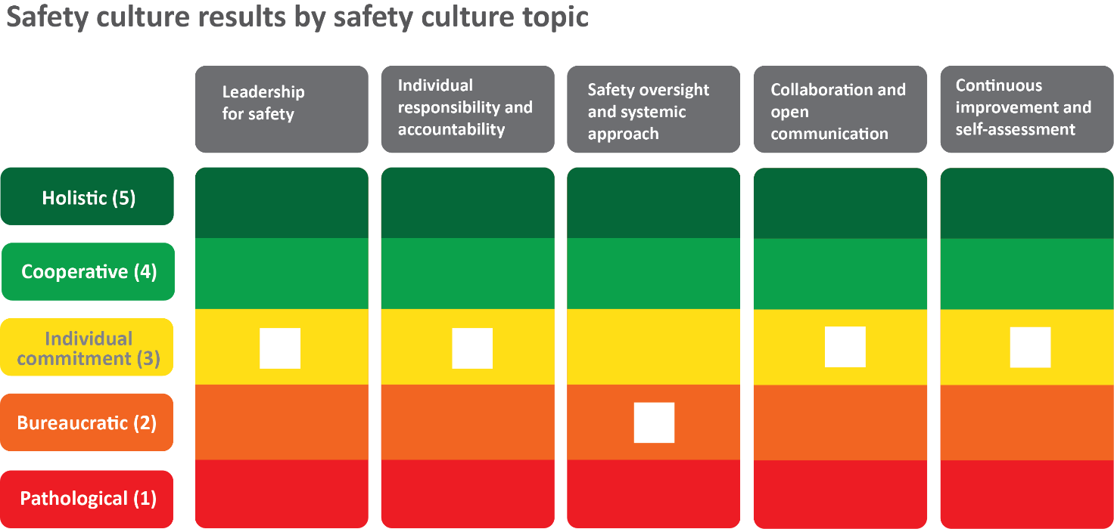

Figure 2: Overall maturity level ratings broken down by safety culture topic.

Overall, results show that across the five topics, safety culture in ARPANSA sits mostly at a middling level of maturity, with 4 out of 5 topics being given a rating of *individual*. *Individual* maturity reflects where staff are involved and take personal responsibility for safety of their own work, but where organisation wide systems are not ensuring collaboration across areas and levels. This does not necessarily imply that work is being done in an unsafe manner. For example, in roles where work is repetitive, routine and where risks remain mostly constant, a *bureaucratic* mode of working may be appropriate.

The assessment identified areas of good practice and areas of improvement.

Area of good practice:

* **External communication and collaboration -** This is a point of good practice at ARPANSA. Throughout the agency, staff report the positive impacts of their work, and of the agency’s work in general with external stakeholders. Staff highly value these relationships, and they are seen to be managed well. ARPANSA has seen benefits from collaborating with external groups.

Areas for improvement:

* **Workload management and support** – A need to address resourcing and workload, including their implications on safety and wellbeing, was identified. This includes sufficiency in time to analyse mistakes, maintain procedures, or develop new procedures.
* **Leadership for safety** – A need for leaders to do more in holding staff accountable for safety was identified. This includes clarifying when and how individuals should be held accountable.
* **Individual responsibility and accountability** – Whilst staff value safety and take safety responsibilities of their role seriously, a need to take ownership for safety issues outside of one’s role or when ownership is ambiguous was identified.
* **Safety oversight and systemic approach** – A need to optimise safety tools was identified. This includes making tools fit for purpose, streamlined, and available to all.
* **Knowledge sharing and communication** – A need for greater collaboration across, and sometimes within, teams was identified. Indeed, improved collaboration and knowledge sharing are key characteristics needed to transition to a higher maturity level.

## Comparisons with past assessments

Direct comparisons between maturity ratings from the 2019 and 2023 SCA are not appropriate for several reasons. Firstly, the 2019 SCA used perception survey outcomes to assign maturity ratings, and did not use findings from focus groups, interviews, document reviews or work observations in determining ratings. The 2023 SCA considered all evidence to assign more informed maturity ratings. Additionally, perception survey items were updated in 2023, meaning some response options are considerably different when compared to the 2019 SCA. These changes create significant variance in the two assessments, deeming comparisons unsuitable. Future SCAs are likely to adopt the 2023 methodology, thereby enabling comparisons moving forward.