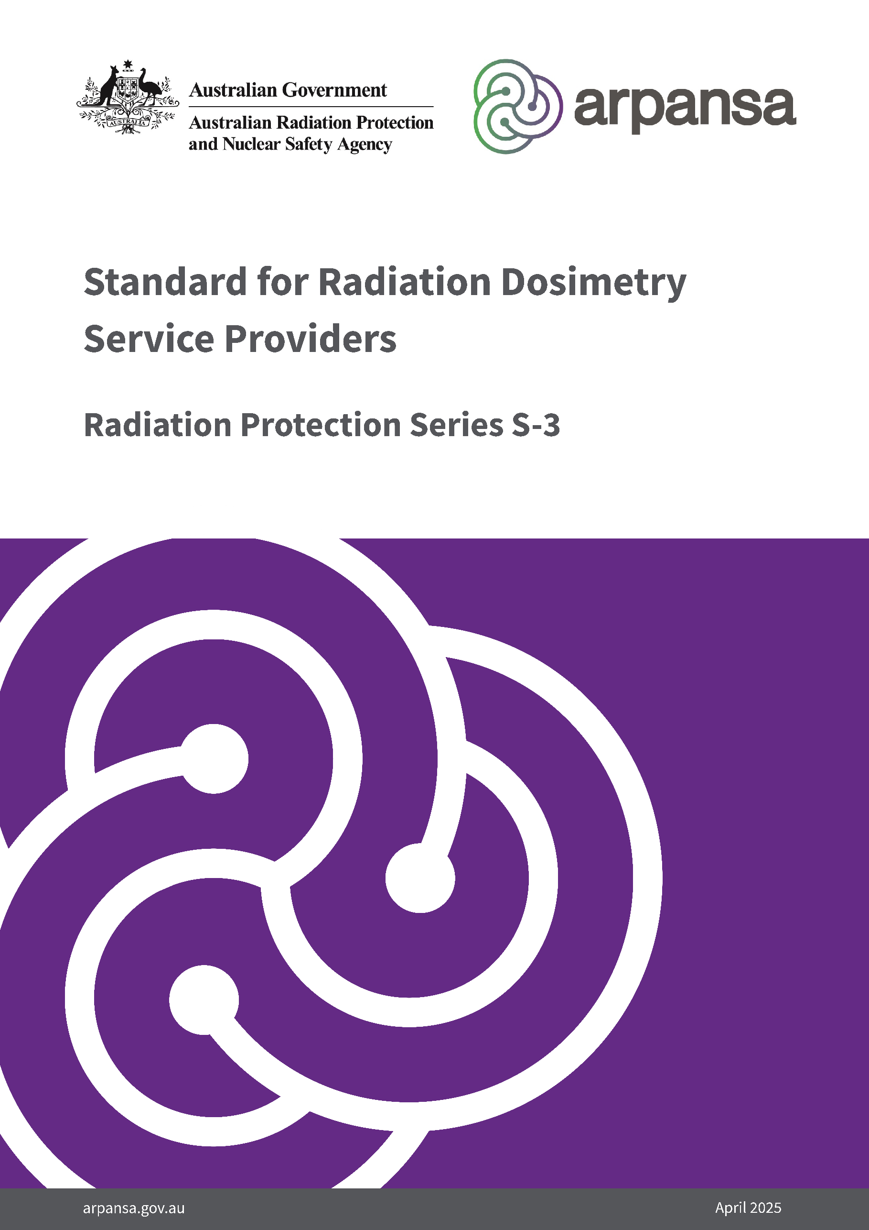

**Radiation Protection Series**

The Australian Radiation Protection and Nuclear Safety Agency (ARPANSA) publishes Fundamentals, Codes and Guides in the Radiation Protection Series (RPS), which promote national policies and practices that protect human health and the environment from harmful effects of radiation. ARPANSA develops these publications jointly with state and territory regulators through the Radiation Health Committee (RHC), which oversees the preparation of draft policies and standards with the view of their uniform implementation in all Australian jurisdictions. Following agreement and, as relevant, approvals at the Ministerial level, the RHC recommends publication to the Radiation Health and Safety Advisory Council, which endorses documents and recommends their publication by the CEO of ARPANSA.

To the extent possible and relevant for Australian circumstances, the RPS publications give effect in Australia to international standards and guidance. The sources of such standards and guidance are varied and include the International Commission on Radiological Protection (ICRP); the International Commission on Non-Ionizing Radiation Protection (ICNIRP); the International Atomic Energy Agency (IAEA); and the World Health Organization (WHO).

***Fundamentals*** set the fundamental principles for radiation protection and describe the fundamental radiation protection, safety and security objectives. They are written in an explanatory and non-regulatory style and describe the basic concepts and objectives of international best practice.

***Codes*** are regulatory in style and may be referenced by regulations or conditions of licence. They contain either general safety or security requirements which may be applicable for all dealings with radiation, or practice-specific requirements. They provide overarching requirements and are expressed as ‘must’ statements which are to be satisfied to ensure an acceptable level of safety and/or security.

***Standards*** provide a national reference point for radiation protection and safety. They mainly provide quantitative requirements, such as exposure limits and key procedural guidance regarded as essential for best practice in radiation protection. They may be referenced by regulators, authorities, industry and other stakeholders in State, Territory or Commonwealth jurisdictions.

***Guides*** provide recommendations and guidance on how to comply with the Codes or apply the principles of the Fundamentals. They are written in an explanatory and non-regulatory style and indicate the measures recommended to provide good practice. They are generally expressed as ‘should’ statements.

These four categories of publications are informed by public comment during drafting and are subject to a process of assessment of regulatory impact.

All ARPANSA publications (including earlier editions of codes and guides for which ARPANSA is now responsible) are available in electronic format, and can be downloaded free of charge by visiting ARPANSA’s website at <https://www.arpansa.gov.au/regulation-and-licensing/regulatory-publications/radiation-protection-series>.

Further information can be obtained by telephoning ARPANSA on 1800 022 333 (free call within Australia) or +61 (03) 9433 2211.

**Standard for Radiation Dosimetry Service Providers**

***Radiation Protection Series S-3***

**April 2025**

**This publication was prepared jointly with the *Radiation Health Committee*. The *Radiation Health and Safety Advisory Council* advised the CEO to adopt the Standard.**

The mission of ARPANSA is to protect people and the environment from the harmful effects of radiation.

© Commonwealth of Australia 2025.

This publication is protected by copyright. Copyright (and any other intellectual property rights, if any) in this publication is owned by the Commonwealth of Australia as represented by the Australian Radiation Protection and Nuclear Safety Agency (ARPANSA).



**Creative Commons**

With the exception of the Commonwealth Coat of Arms, any ARPANSA logos and any content that is marked as being third party material, this publication, *the* *Standard for Radiation Dosimetry Service Providers*, by the Australian Radiation Protection and Nuclear Safety Agency is licensed under a Creative Commons Attribution 3.0 Australia licence (to view a copy of the licence, visit [*http://creativecommons.org/licenses/by/3.0/au*](http://creativecommons.org/licenses/by/3.0/au)). It is a further condition of the licence that any numerical data referred to in this publication may not be changed. To the extent that copyright subsists in a third party, permission will be required from the third party to reuse the material.

In essence, you are free to copy, communicate and adapt the material as long as you attribute the work to ARPANSA and abide by the other licence terms. The works are to be attributed to the Commonwealth as follows:-

“© Commonwealth of Australia 2025 as represented by the Australian Radiation Protection and Nuclear Safety Agency (ARPANSA)”

The publication should be attributed as: *The Standard for Radiation Dosimetry Service Providers*

**Use of the Coat of Arms**

The terms under which the Coat of Arms can be used are detailed on the Department of the Prime Minister and Cabinet website ([www.dpmc.gov.au/government/commonwealth-coat-arms](http://www.dpmc.gov.au/government/commonwealth-coat-arms)).

Enquiries regarding the licence and any use of this report are welcome.

ARPANSA  
 619 Lower Plenty Road  
 YALLAMBIE VIC 3085

Tel: 1800 022 333 (Freecall) or +61 3 9433 2211  
  
 Email: [info@arpansa.gov.au](mailto:info@arpansa.gov.au)  
 Website: [www.arpansa.gov.au](http://www.arpansa.gov.au)

Published by the Chief Executive Officer of ARPANSA in April 2025.

Acknowledgement of Country

ARPANSA proudly acknowledges Australia's Aboriginal and Torres Strait Islander community and their rich culture and pays respect to their Elders past and present. We acknowledge Aboriginal and Torres Strait Islander people as Australia’s first peoples and as the Traditional Owners and custodians of the land and water on which we rely.

We recognise and value the ongoing contribution of Aboriginal and Torres Strait Islander people and communities to Australian life and how this enriches us. We embrace the spirit of reconciliation, working towards the equality of outcomes and ensuring an equal voice.

Foreword

This Standard for Radiation Dosimetry Service Providers (hereafter referred to as ‘the Standard’) sets requirements for the manufacture, performance, calibration, and testing of dosemeters and the quality management, record keeping, and notification requirements of dosimetry service providers.

The Standard was drafted through the Radiation Health Committee (RHC), a statutory advisory body to ARPANSA. It addresses a recommendation from a 2018 International Atomic Energy Agency (IAEA) Integrated Regulatory Review Service (IRRS) report, which recommended that Australia should revise the current requirements on occupational radiation protection to ensure full compliance with IAEA Safety Standards (General Safety Requirement Part 3), including that regulatory bodies shall be responsible, as appropriate, for authorisation or approval of service providers for individual monitoring and calibration services.

ARPANSA operates a dosimetry service – the Personal Radiation Monitoring Service (PRMS). To manage any real or perceived conflict of interest in developing a standard, external input was sought from industry and expert professionals, including targeted consultation with every dosimetry service provider in Australia. Additionally, representatives of Australia’s State and Territory radiation regulators led the RHC working group. The Standard will be published as a voluntary standard with a view to establishing an independent accreditation mechanism and pathway to support regulatory implementation.

It is recognised that the Standard does not operate in isolation from the legal framework within Australia. Relevant Australian occupational, health, safety, and environmental laws provide obligations on employers, and the designers, manufacturers and suppliers of plant or equipment, to ensure that their activities, or their plant and equipment, do not represent a risk to the health and safety of their employees or third parties who may be affected by them. In effect, such laws require relevant parties to continually assess and improve the safety and health impact of their activities.

This Standard is intended to complement the requirements of the relevant Work Health and Safety legislation in each jurisdiction. The relevant regulatory authority should be contacted should any conflict of interpretation arise. A listing of such authorities is provided at:

<https://www.arpansa.gov.au/regulation-and-licensing/regulation/state-territory-regulators>

I thank the RHC working group, Australian regulators, and all other contributors (listed at the end of this document) for their efforts to create this new standard for service provision to Australian workers.

Gillian Hirth AO  
CEO of ARPANSA

2 April 2025

**Contents**

Foreword i

1. Introduction 3

1.1 Citation 3

1.2 Purpose 3

1.3 Scope 3

2. Dosemeter manufacture requirements 4

2.1 Definition of dosemeter manufacturer 4

2.2 Manufacture of the dosemeter 4

2.3 Testing of performance characteristics of the dosemeter 4

3. Dosemeter analysis laboratory requirements 5

3.1 Definition – Dosemeter analysis laboratory 5

3.2 Accreditation requirements 5

3.3 Calibration records for dosemeter readers and processing instrumentation 5

3.4 Investigation of abnormal results 5

4. Local dosimetry service provider requirements 6

4.1 Definition – local dosimetry service provider 6

4.2 Implementation of a Quality Management System 6

4.3 Uploading of dose results to the national dose repository 6

4.4 Issuing of Dosemeter – Critical Information 7

4.5 Issuing of Dosemeter – Dosemeter approval 7

4.6 Issuing of Dosemeter – Regulatory requirements 7

4.7 Retention of records 7

4.8 Reporting of results 7

4.9 Notification thresholds 7

4.10 Amendment of dose records 8

References 9

Contributors to drafting and review 10

# Introduction

## Citation

This publication may be cited as the *Standard for Radiation Dosimetry Service Providers (2025).*

## Purpose

This document stipulates standards for dosemeters and dosimetry service providers regarding quality, performance, information management, record keeping and reporting to ensure the adequacy of dosimetry services for dose monitoring as part of radiation protection measures in Australian workplaces involving occupational radiation exposure.

This document is intended to serve on an interim basis until such time as an independent standard for radiation dosimetry service providers can be published.

## Scope

The standards in this document apply to dosemeters used for personal and area monitoring and stipulate requirements for:

* Dosemeters with regards to their:
  + Manufacture
  + Performance
* Dosemeter analysis laboratory with regards to their:
  + Accreditation
  + Calibration
  + Investigation
* And local dosimetry service providers, with regards to their:
  + Quality management
  + Information handling
  + Reporting requirements

# Dosemeter manufacture requirements

## Definition of dosemeter manufacturer

The dosemeter manufacturer is the organisation responsible for the assembly of the dosemeter from individual components such as detector elements, badge casing and electronic components. The requirements listed below are intended to ensure any dosemeter elements, and the final assembled product is produced according to a manufacturing process that results in reliability of individual dosemeters and consistency between batches. Dosemeter manufacturers are responsible for type testing and publishing of detection characteristics for the dosemeters they produce.

## Manufacture of the dosemeter

The manufacturer of the dosemeter must be certified to ISO 9001 or an equivalent certification program. The manufacturer’s Quality Management System (QMS) must cover the manufacture of the dosemeter and its components, assembly of the dosemeter and batch testing to ensure the dosemeter can be manufactured within tolerances specified by the manufacturer.

## Testing of performance characteristics of the dosemeter

The manufacturer of the dosemeter must provide the results of performance response testing in accordance with the requirements of ISO 4037-3 *Calibration of area and personal dosemeters and the measurement of their response as a function of energy and angle of incidence,* or equivalent.

The testing must include energy response for each radiation type detected by the dosemeter, the dose and dose rate response, the angular response and the maximum dose that can be accumulated by the dosemeter.  The testing must be undertaken by an ISO 17025 accredited laboratory whose scope of accreditation includes the testing of personal dosemeters under ISO 14146 *Radiological protection – Criteria and performance limits for the periodic evaluation of dosimetry services* or ANSI-HPS N13.11-2009 *Personal Dosimetry Performance – Criteria for Testing*. The dosemeter will only be approved for use in applications where a “Pass” test result has been achieved.

# Dosemeter analysis laboratory requirements

## Definition – Dosemeter analysis laboratory

The dosemeter analysis laboratory is the organisation responsible for analysing the dosemeters and reporting the dose received by the dosemeter following a wearing period by an occupationally exposed worker. In some cases, the dosemeter analysis laboratory and the dosemeter manufacturer may be the same organisation. For example, assembly of the dosemeter prior to distribution to the wearer and analysis after being returned by the wearer may be performed by the same organisation.

## Accreditation requirements

The laboratory must have ISO 17025 accreditation. The scope of accreditation for the facility must include the specific dosemeter under analysis.

## Calibration records for dosemeter readers and processing instrumentation

The supplier must provide records showing that instrumentation used for analysis of dosemeters has been calibrated by an ISO 17025 accredited laboratory at least annually and as required after maintenance and repairs.

## Investigation of abnormal results

The dosimetry laboratory must implement a procedure for investigation of abnormal dose analysis results indicative of faulty or damaged dosemeters or analysis equipment. The procedure must be incorporated into the facility’s QMS and document the investigation process to be undertaken in the event of abnormal dose results.

# Local dosimetry service provider requirements

## Definition – local dosimetry service provider

The local dosimetry service provider (DSP) is the organisation responsible for distributing the dosemeters to end users or their nominated representatives. Typically, manufacturers will supply the local dosimetry service provider with the badges for their wearers. The local service provider will then distribute the badges to the wearers, accept returned badges from wearers and return them to the dosemeter analysis laboratory.

Requirements listed for local dosimetry service providers are intended to ensure the integrity of the dose recorded on the dosemeter as it passes through their distribution points, both inbound and outbound. It is typical for the local service provider to be the sole contact point for the end user with respect to their dosimetry service. For this reason, their requirements are defined separately from the manufacturer and analysis laboratory requirements. Local dosimetry service providers are not required to attain ISO 17025 accreditation, since it is a technical and measurement-based accreditation, and the local service provider does not provide a technical and measurement-based function. The service provider must have ISO 9001 or equivalent certification since it addresses the administrative requirements of a QMS. If a local service provider intends to meet the requirements through ISO 17025 facility accreditation, the dosimetry service must be listed in its scope of accreditation and the requirements listed in these guidelines must be reviewed by the relevant ISO 17025 inspecting authority during routine surveillance visits.

## Implementation of a Quality Management System

The local service provider must provide evidence that a QMS has been implemented. The QMS must have ISO 9001 or equivalent certification and include the following:

1. Procedures for the tracking, preparation, updating, amending and periodic review of QMS documents.
2. A procedure and system for tracking amendments, updates, and non-conformances.
3. Documented training records and a training matrix.
4. A method of requesting and recording customer feedback and tracking actions relating to the feedback.
5. Procedure for complying with local regulatory requirements prior to supplying dosimetry in that jurisdiction.
6. Procedure for providing the wearer with relevant wearing instructions for each unique type of dosemeter supplied by the DSP.

## Uploading of dose results to the national dose repository

The DSP shall be responsible for uploading the dose records of occupationally exposed persons using their service to the recognised national dose repository, as required by the relevant regulatory authority, and subject to other applicable jurisdictional legislative requirements.

## Issuing of Dosemeter – Critical Information

The following critical information about the radiation practice must be obtained prior to supplying a dosemeter to the wearer:

1. The radiation source used.
2. The radiation type to be measured (beta, photon, neutron)
3. The required wearing period
4. The position on the body to be monitored (e.g. torso, eye, extremity)
5. Environmental factors that may affect the performance of the dosemeter (e.g. is a sealed dosemeter required).

The critical information must be used by the DSP, in consultation with the dosemeter manufacturer where necessary, to recommend a suitable dosemeter for the specific radiation practice.

## Issuing of Dosemeter – Dosemeter approval

The DSP must only issue to wearers, dosemeters that have been approved for use by the applicable jurisdiction in which the wearer is based.

## Issuing of Dosemeter – Regulatory requirements

The DSP must comply with the specific requirements of the jurisdiction in which the dosemeters are supplied. These requirements must be recorded in a QMS document and periodically reviewed and updated where necessary. Specific requirements including dose limits, reporting requirements, dose record retention policies and any specific restrictions that apply to a particular type of dosemeter must be documented. Staff who work for the DSP must be trained in the procedures detailed in the QMS.

## Retention of records

Relevant state and territory regulators must be consulted with respect to laws applying to the retention of dose records for occupationally exposed persons.

## Reporting of results

The DSP shall provide dose reports to the wearer or nominated representative within four weeks of receiving the results from the dosimetry laboratory. If an online dose reporting system is available, access to this system must be provided to the wearer or their nominated representative.

## Notification thresholds

Relevant state and territory regulators must be consulted regarding their specific requirements with respect to dose notification thresholds for occupationally exposed persons.

## Amendment of dose records

The dose record of a wearer must not be amended without prior written approval by the relevant regulatory authority. It must be noted on future reporting of the lifetime dose for that wearer that an amendment of the dose record has occurred.

References

American National Standards Institute (ANSI), Health Physics Society (HPS), 2009. *ANSI-HPS N13.11-2009* –*Personal Dosimetry Performance – Criteria for Testing*. <https://store.accuristech.com/standards/hps-ansi-hps-n13-11?product_id=2857315#document>

International Standards Organisation (ISO), 2024. *ISO 14146:2024 – Radiological protection – Criteria and performance limits for the periodic evaluation of dosimetry services*.<https://www.iso.org/standard/85249.html>

International Standards Organisation (ISO), 2017. *ISO/IEC 17025:2017 – General requirements for the competence of testing and calibration laboratories*. <https://www.iso.org/standard/66912.html>

International Standards Organisation (ISO), 2015. *ISO 4037-3:2019 –* *Radiological protection — X and gamma reference radiation for calibrating dosemeters and doserate meters and for determining their response as a function of photon energy. Part 3: Calibration of area and personal dosemeters and the measurement of their response as a function of energy and angle of incidence*. <https://www.iso.org/standard/66874.html>

International Standards Organisation (ISO), 2015. *ISO 9001:2015 –* *Quality management systems — Requirements*. <https://www.iso.org/standard/62085.html>

Contributors to drafting and review

|  |  |
| --- | --- |
| Glenn Riley | *Working Group Chair,* Victorian Department of Health |
| Stephen Carter | *Working Group Member,* Queensland Health |
| Andrew McCormick | *Working Group Member,* Australian Radiation Protection and Nuclear Safety Agency |
| Noel Cleaves | *Specialist Review (Regulatory),* Victorian Department of Health |
| Neil Wain | *Specialist Review (Regulatory),* Victorian Department of Health |
| Martin Butson | *Specialist Review (Regulatory),* New South Wales Environment Protection Authority |
| Mark Carey | *Specialist Review (Regulatory),* New South Wales Environment Protection Authority |
| Cameron Lawrence | *Specialist Review (Australian National Radioactive Dose Register),* Australian Radiation Protection and Nuclear Safety Agency |
| Allister Prosser | *Specialist Review (Standards & Accreditation),* Australian Radiation Protection and Nuclear Safety Agency |
| James Wheaton | *Secretariat and Coordination,* Australian Radiation Protection and Nuclear Safety Agency |
|  |  |

Dosimetry Service Provider Organisations Consulted

SGS Radiation Services (Distributor of Mirion Dosimetry)

Landauer Australia

Global Medical Solutions Australia

ARPANSA Personal Radiation Monitoring Service