Personal Radiation Monitoring Service

|  |
| --- |
| 619 Lower Plenty Road, Yallambie, Victoria 3085 Phone: (03) 9433 2211 FREECALL: 1800 678 112 E-mail: prms@arpansa.gov.au |

**User Guide for Uranium/Mineral Sand Mines and Processing Plants**

Your new BeO OSL Monitor is sealed in a PET blister pack prior to issue. Each monitor must be returned to the Personal Radiation Monitoring Service intact at the end of each wearing period. They are checked for radioactive contamination upon return.

Your new BeO OSL Monitor can be used in uranium and mineral sand mining and processing plant operations where conditions may be dusty and in laboratories where there is a significant risk of radioactive contamination.

In uranium and mineral sand mining and processing plants, it may not be possible to store them in a low radiation background area when they are not in use. Under these circumstances, extra controls are issued to measure the radiation background of the storage sites. Each monitor issued to a wearer must be associated with the particular control with which it is to be stored whilst not in use.

The use of the various controls is as follows:

1. **CONTROL A** is the main Control which **must** be kept in a low background area typical of the everyday **non-work** environment. The dose measured on this Control will be assumed to be the natural background radiation reading and any reading on a monitor which is above this reading will be reported as the occupational radiation dose received by the wearer. Consequently, Control A must be kept well away from sources of radiation and be left in the selected low background area for the full wearing period of the monitors. The sites for the Controls should be chosen with care. It is expected that the regulatory authority will require inspection of the Control sites to be part of the regulatory control process.
2. **CONTROL B** is the subsidiary Control which is placed at the storage site. All monitors issued under this Control **must** be stored with the Control during the wearing period whilst they are not being worn. As the control storage site is likely to be subjected to a higher dose rate than the low background (Control A) site, the pro-rata dose received by the monitors whilst they are not being worn needs to be subtracted from their readings.
3. **CONTROL C, CONTROL D**, etc. have the same use as Control B, but at different control storage sites.

The accuracy of the reported doses is dependent on the accuracy of the information provided by the user on the Monitor Details Forms. If incorrect information is supplied, it is difficult to reassess the reported doses.

It is important that the following information is as accurate as possible:

1. The **INCLUSIVE DATES OF WEARING** of the monitors **must** be the date that the monitors were **first** placed at the control storage site of Control B, etc., and the date that the monitors were **finally** removed from the control storage site and returned to the Control A site. If no inclusive dates of wearing are listed, it will be assumed that the recommended wearing period has been used.

Any unnamed monitor which has been issued against the Control A, but has been used at a different control storage site **must** have a clear indication of control storage site at which it was used. The inclusive dates of wearing are the date that it was first moved to this control storage site and the date that it was finally returned to the Control A. If it is not clear at which control storage site the monitor was used, it will be assumed that it was stored for the full wearing period at the control storage site to which it was issued.

1. The **SHIFT HOURS** is the **TOTAL HOURS MONITORED** in the wearing period. This allows for the radiation received by the worn monitor whilst it was stored at the control storage site to be subtracted from the monitor reading.

If no shift hours are recorded against a monitor, a default value will be calculated based on a value of **40 hours** for each week of wearing.

1. The reported dose for a monitor clearly marked as being an **ENVIRONMENTAL** monitor will be the total dose received minus a component which takes into account the transit dose received whilst the monitor was not at the monitoring position. It is therefore important that the inclusive dates for which the monitor was in position are listed. The default period will be the recommended wearing period.

Your BeO OSL monitor should be returned to the Personal Radiation Monitoring Service immediately after the end of the wearing period together with the appropriate Monitor Details Form. There is a **charge** for non-returned or irreparably damaged monitors. This charge is listed on the schedule of charges.

Figure 1: Storage location of controls and monitors

**Natural Background/  
Control A monitor Storage**

**Mine/Ore Body/Stock Pile**

**Change Room/Control B, C, D etc. Monitor Storage**

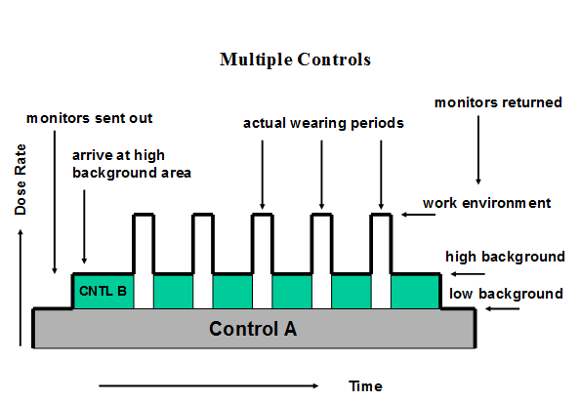

Figure 2: Multiple controls

Figure 2 demonstrates the problem. The grey shaded area is the exposure received by Control A, the green area is the extra exposure received by Control B above the Control A exposure, due to the higher background area in which it is stored. The white area is the occupational dose that the wearer received. The total number of hours worked in the wearing period by the wearer is also required.

The wearer dose is calculated in the following manner:



where: R is the total dose recorded by the worn monitor  
CB is the dose recorded by the Control B monitor  
CA is the dose recorded by the Control A monitor  
WP is the wearing period in weeks (168 hours per week)  
TSH is the total number of hours worked during the wearing period

# Environmental Monitor

Monitor can also be used to measure the environmental dose at a site. The environmental dose is the total photon dose recorded at the site for the period that the monitor is in place and includes the normal background radiation.

The Control A is used to measure the dose received by the environmental monitor during transit.

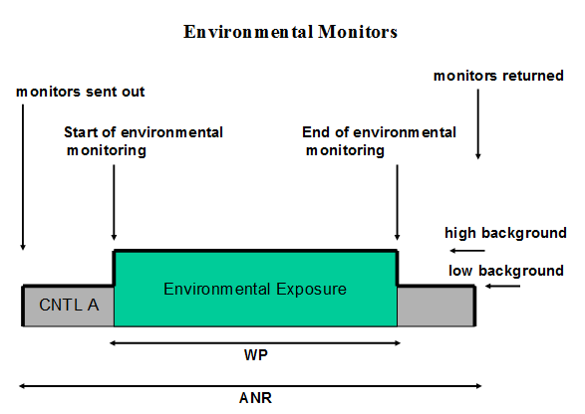

Figure 3: Calculation of environmental dose

Figure 3 demonstrates the calculation of the environmental dose, where the green shaded area is the total environmental exposure measured and the grey area is the exposure received by the Control A during transit.

The environmental dose is calculated in the following manner:



where: R is the total dose recorded by the environmental monitor

CA is the dose recorded by the Control A monitor

WP is the wearing period in weeks

ANR is the period, in weeks, between the date of preparation of the monitor and the date that it is read out.

# Naming Control Monitors

You can rename you control monitors to something that is meaningful. (RECOMMENDED)

For example you may rename Control A to something more useful such as Control Administration Office and Control B to Control Mine Change Room and Control C Processing Plant Change Rooms. However the relationship should remain the same as control A and Control B as described above.

If you have any questions relating to the use of multiple control monitors please do not hesitate to contact the PRMS at [prms@arpansa.gov.au](mailto:prms@arpansa.gov.au).