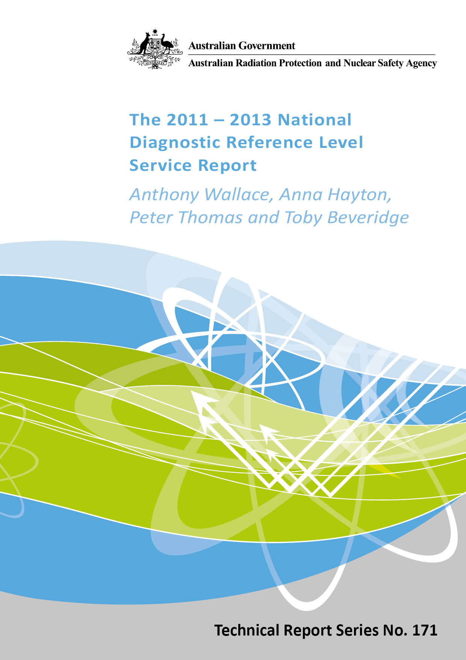

The 2011 – 2013 National Diagnostic Reference Level Service Report

By

Anthony Wallace, Anna Hayton, Peter Thomas and Toby Beveridge

Notice

© Commonwealth of Australia 2015

ISSN: 0157-1400

Creative Commons

With the exception of the Commonwealth Coat of Arms, any ARPANSA logos and any content that is marked as being third party material, this publication, The 2011 – 2013 National Diagnostic Reference Level Service Report, by the Australian Radiation Protection and Nuclear Safety Agency is licensed under a Creative Commons Attribution 3.0 Australia licence (http://creativecommons.org/licenses/by/3.0/au/). It is a further condition of the licence that any numerical data referred to in this publication may not be changed. To the extent that copyright subsists in a third party, permission will be required from the third party to reuse the material.

In essence, you are free to copy, communicate and adapt the material as long as you attribute the work to ARPANSA and abide by the other licence terms. The works are to be attributed to the Commonwealth as follows:-

“© Commonwealth of Australia 2015, as represented by the Australian Radiation Protection and Nuclear Safety Agency (ARPANSA)”

Use of the Coat of Arms

The terms under which the Coat of Arms can be used are detailed on the It's an Honour website (www.itsanhonour.gov.au/coat-arms/index.cfm).
Enquiries regarding the licence and any use of this report are welcome.

ARPANSA
619 Lower Plenty Road
YALLAMBIE VIC 3085

Tel: 1800 022 333 (Freecall) or +61 3 9433 2211
Email: info@arpansa.gov.au
Website: www.arpansa.gov.au

Disclaimer
All care has been taken in the preparation of this work and its conclusions. However, where the data or results presented are utilised by third parties the Commonwealth of Australia shall not be liable for any special, indirect, consequential or other damages whatsoever resulting from such use. Nor will the Commonwealth of Australia be liable for any damages arising from or in connection with any errors or omissions that have inadvertently occurred in this work.

Acknowledgements
The authors wish to acknowledge the support and expert advice provided from our principal stakeholders, the Australian Government Department of Health (DoH), the Royal Australian and New Zealand College of Radiologists (RANZCR), the Australasian College of Physical Scientists and Engineers in Medicine (ACPSEM), the Australian Institute of Radiography (AIR), the Australian and New Zealand Society of Nuclear Medicine (ANZSNM) and the various state and territory regulators.

Executive Summary
The ARPANSA National Diagnostic Reference Level Service (NDRLS) was established within the Medical Imaging Section of the Medical Radiation Services Branch to establish Diagnostic Reference Levels (DRLs) for appropriate diagnostic imaging procedures across various imaging modalities that use ionising radiation.
The NDRLS’ main function was to survey and establish national DRLs against which facilities can compare their doses against, as required by section 3.1.8 of RPS 14 Code of Practice for Radiation Protection in the Medical Applications of Ionizing Radiation (ARPANSA, 2008).
In the first three years of the project, the focus was on Multi-Detector Computed Tomography (MDCT), the modality which delivers the largest doses of ionising radiation to the Australian population from diagnostic imaging. It is estimated that there are 1000 MDCT scanners registered/licensed nationally, sited in approximately 850 diagnostic imaging facilities. At the date of this report 30% of facilities had registered with the NDRLS to undertake DRL surveys.
A web based facility registration and survey form were developed based on draft surveys and stakeholder engagement in 2009-2010. Software was developed and tested with the website going live in August 2011. Participating facilities who registered and submitted a compliant survey received a Facility Reference Level (FRL) report which could be accessed and downloaded when logged in to the service.
A sufficiently sized adult dataset was obtained by the end of 2011 for an initial set of MDCT DRLs to be published in early 2012. Submission of paediatric data over this period was not sufficient for paediatric DRLs to be published. However, the Royal Australian and New Zealand College of Radiologists (RANZCR) provided a paediatric dataset that was used to publish paediatric MDCT DRLs in November 2012.
The MDCT survey process is ongoing with facilities encouraged to submit surveys on an annual basis or whenever there is a sufficient change in a scanning situation, e.g. new equipment, new or changed protocols, etc.
The key outcomes of the project, so far, are:
- A free web based registration and survey tool has been posted for diagnostic imaging facilities to assess their patient doses from MDCT.
- ARPANSA provides each facility a confidential written report for each compliant survey submitted.
- ARPANSA facility reports may be used as indicative compliance with section 3.1.8 of RPS 14.
- National DRLs for adult and paediatric MDCT protocols have been published.
- The survey is ongoing with regular review of data and client requirements.
- ARPANSA provides the stakeholder community with survey progress via website updates, registrant newsletters, conference presentations and peer reviewed publications.

Contents
Executive Summary iii
1. Introduction 5
2. Survey and Reporting Tools Development 7
2.1 Draft Surveys 7
2.1.1 Data Collected 8
2.1.2 Draft Survey Facility Reports 8
2.2 Web Survey 9
2.2.1 Structure 9
2.2.2 Facility Reports 11
3. Adult Data – 2011 - 2013 15
3.1 Initial Collected Data 15
3.1.1 The Australian National DRLs for MDCT 16
3.2 Adult MDCT DRL Publication 18
3.3 Facility Registrations 19
3.4 CT Platforms 19
3.5 Submitted Surveys 19
3.6 Inter Year Data Comparison 20
3.7 Iterative Reconstruction 22
4. Paediatric Data - 2011 - 2013 22
4.1 Submitted Surveys 22
4.2 RANZCR Paediatric Data 23
5. Conclusion 25
6. References 26

Introduction
It is well recognised that the greatest source of patient dose in diagnostic imaging is from Multi-Detector Computed Tomography (MDCT) (NCRP, 2009, Mettler et al., 2008). ARPANSA estimates that the growth in MDCT scans, based on Medicare Benefits Schedule data, is approximately 9% per annum with over 2 million MDCT scans being performed in 2009 (Hayton et al., 2009). While the use of MDCT in diagnosis and therapy should always be justified on the basis of benefit outweighing risk, its application does increase the probability of stochastic detriment to the population e.g. expression of cancerous disease (Brenner et al., 2001). Radiobiological and epidemiological research also points to the increased risk of stochastic effects in the paediatric population compared with adults (Hall and Brenner, 2008, Mathews et al., 2013).
While the dose to the individual and the consequent individual risk is relatively low, the population risk is compounded by the increasing number of imaging and therapeutic applications undertaken in current medical practice. As the expression of stochastic detriment may take many decades to appear, with the exception of leukaemia, we may only be at the threshold of an increasing MDCT induced cancer rate (Larson et al., 2007). To address this increasing population health risk ARPANSA has developed a Code of Practice and Safety Guides for the application of ionising radiation in medicine (ARPANSA, 2008). The Code of Practice has been taken up by state and territory regulators and its provisions are now a necessary compliance requirement in radiation safety acts, regulations and conditions of licence.
Diagnostic medical exposures should be optimised to maximise the benefit to risk ratio by ensuring that the desired outcome is achieved with the lowest radiation dose practicable. To identify facilities that could benefit from further optimisation of acquisition protocols, it has become common practice to undertake regional dosimetry surveys to measure the spread of doses that are used for similar radiological investigations across various institutions. Individual site dosimetry is usually established by recording dose metrics for a group of patients undergoing a particular procedure and then calculating the mean or median values of the recorded dose metrics for that procedure. Those doses are then compared with the Diagnostic Reference Levels (DRLs) which are typically derived from the 75th percentile (3rd quartile) of the distribution of doses for similar radiology procedures from all of the participating facilities. The development of DRLs for common radiology procedures has been ongoing for the past 2 decades (Jones and Shrimpton, 1991, Shrimpton et al., 1991, Shrimpton et al., 1991, Roch and Aubert, 2013, Foley et al., 2012, Fukushima et al., 2012). DRLs provide a simple, comparative metric of the dose delivered by common radiological procedures. The process of individual site and regional/national comparison should be undertaken on a regular basis to maintain currency.
It is important to understand that DRLs are not dose limits, they are simply indicators of common practice and are expected to vary over time depending upon changes in technology, acquisition protocols and clinical application. If a facility, after due consideration and optimisation, can justify a local DRL that is higher than the regional or national benchmark then they have met the requirements of the DRL philosophy. By definition, at the time of DRL calculation there will always be 75% of facilities who are at or below the current DRL and 25% who will be using a higher value.
The establishment of DRLs has proven to be a useful tool in the standardisation and optimisation of radiation doses received from common medical imaging protocols (Hart et al., 2009, Wall, 2005, Hauge et al., 2013, Jarvinen et al., 2011, Nfaoui et al., 2010). The International Commission on Radiological Protection (ICRP), in publication 73, first coined the term ‘diagnostic reference level’ (DRL) (ICRP, 1996). They have long enunciated the need to establish diagnostic reference levels in radiology as a key step towards addressing the ALARA principle (ICRP, 2007). Various organisations, regulatory authorities and individual facilities in Australia have carried out limited CT dose surveys (Boal et al., 1999, Wallace et al., 2010). In the United Kingdom national surveys of radiographic facilities have been conducted every five years since the mid-eighties (Wall, 2001). Improved optimisation has resulted in an overall lowering of doses with each iteration of the survey (Hart et al., 2009). In 1997 the European Union released directive 97/43 which stated that ‘member states shall promote the establishment and the use of diagnostic reference levels for radiodiagnostic examinations’, with which the member states were obliged to comply with by May 2000.
In an effort to curb the growing radiation dose to the Australian population, the Australian Radiation Protection and Nuclear Safety Agency (ARPANSA), is conducting an ongoing national dosimetry survey of common MDCT protocols. The survey is a collaborative project being conducted in partnership with a liaison panel consisting of members from the Australian Government Department of Health (DoH), the Royal Australian and New Zealand College of Radiologists (RANZCR), the Australasian College of Physical Scientists and Engineers in Medicine (ACPSEM), the Australian and New Zealand Society of Nuclear Medicine (ANZSNM) and the Australian Institute of Radiography (AIR).
For medical imaging facilities, participation in the survey and attainment of resultant facility dose reports may be submitted as an indication of compliance with Radiation Protection Series No. 14, ‘Radiation Protection in the Medical Applications of Ionising Radiation’ (ARPANSA, 2008). In particular section 3.1.8(a) states that:
‘the responsible person must establish a program to ensure that radiation doses administered to a patient for diagnostic purposes are: periodically compared with diagnostic reference levels (DRLs) for diagnostic procedures for which DRLs have been established in Australia’.

Survey and Reporting Tools Development

Draft Surveys
During 2009 and 2010 ARPANSA conducted two draft surveys in preparation for the web survey development. Selected facilities were invited to participate via the CT DRL liaison panel. The format of both surveys was a Microsoft Excel workbook which was emailed to the participating facilities. Both draft surveys required basic registration information which included:
- Facility Name
- Facility Address
- Location Specific Practice Number (LSPN)
- Facility Type
- Radiologist in Charge details
- Contact Person details
- Number of CT scanners at the facility
- Make and model of CT scanner with the highest throughput
- Number of slices/detectors on CT scanner with the highest throughput.
Survey 1 involved data collection for seven protocols:
- Head
- Neck
- Chest
- Chest-Abdomen
- Abdomen-Pelvis
- Lumbar Spine
- Chest-Abdomen-Pelvis.
Survey 2 involved data collection for six protocols, similar to Survey 1 but excluding Chest-Abdomen and Cervical Spine replaced Neck.
For Survey 1 a brief description of the scan margins and indications was given for each protocol and for Survey 2 this was extended to include a diagram with superior and inferior scan margins marked.
The data entry page for Survey 1 recorded the Dose Length Product (DLP) and weight (kg) for 20 patients, and also required the patient height and width for some protocols. A tick box was also included for each patient to indicate if automatic dose modulation was used. For Survey 2 this data entry page was adjusted to record the DLP, patient weight and patient height only for twenty patients as well as recording the following protocol parameters:
- kVp
- mAs
- Pitch
- Contrast
- Rotation Time
- Dose Modulation
- No. of Phases
- Scan Field of View
- Helical or Axial
- Reconstruction Slice Width
- Noise Index
- CTDI_{vol}
- Detector Configuration
- Beam Shaping Filter
- Reconstruction Algorithm/Kernel.
Survey 2 also included a height conversion chart which specified a range of heights in imperial feet and inches and the corresponding heights in cm.

Data Collected
Twelve and thirty-two facilities participated in Survey 1 and Survey 2 respectively. Each survey specified a due date by which the completed survey forms should be returned via email.
The analysis of data collected involved calculating a Practice Reference Level (PRL), subsequently changed in 2013 to Facility Reference level (FRL), for each facility for each protocol. The FRL was defined as the median of the DLP values for the individual protocol. The DRL value for each protocol for the survey was then calculated by taking the 75th percentile of the spread of all FRL values for that protocol. The DRL values for Survey 1 and Survey 2 are shown in Table 1. A lack of data submitted in Survey 1 for the Chest-Abdomen protocol lead to no DRL being calculated and the exclusion of the protocol from Survey 2.

Draft Survey Facility Reports
At the completion of each survey the FRL values calculated for each facility were compared with the DRL values calculated for each protocol and a brief report describing this comparison was sent to each participating facility. These reports included a description of the DRLs provided in the European Guidelines (Tsapaki et al., 2006) followed by a summary of the draft survey results. This included the resultant FRLs for each protocol, the DRLs calculated from the survey data and a graph showing the 95% confidence intervals around these DRLs. They also included histograms showing the spread of all data collected for each protocol compared with the spread of individual facility data for that protocol.
The graph showing the DRL values with 95% confidence intervals was excluded from the Survey 2 facility reports as it was believed it added little in addition to the graph showing minimum and maximum FRL values. The table of FRLs and DRLs was added to the Survey 2 facility reports to provide a quick summary and comparison in an alternative format to the graph on the same page.
Feedback from participating facilities indicated that the addition of vertical lines indicating the FRL and DRL to the histograms was helpful.
DLP DRL values calculated from both surveys are shown in Table 1.

Protocol | DRL Survey 1 (DLP, mGy.cm) | DRL Survey 2 (DLP, mGy.cm)
Head | 1022 | 1246
Neck/Cervical Spine | 815 | 958
Chest | 784 | 613
Abdomen-Pelvis | 837 | 791
Lumbar Spine | 1031 | 1274
Chest-Abdomen-Pelvis | 1338 | 1306
Table 1: DRL values calculated from the data collected in Survey 1 and Survey 2.

Web Survey
The web portal format of the survey was chosen to allow facilities nationwide to participate in the survey without the constraints of paper forms, both for the convenience of the participating facilities and for the administration of the survey. The web portal also enabled a degree of participant security to be applied at registration and log on as the data and FRL reports were deemed to be potentially ‘commercial in confidence’ information.

Structure

Registration
A registration process was designed which facilities were required to complete before they were issued with login details. This registration process involved three separate pages which had to be completed in the specified order. The data collected consisted of:
- Registration Process – Step 1 page
Facility Details:
- Facility Name*
- Facility LSPN*
- Type of Facility *
Address:
- Address Line 1*
- Address Line 2
- Address Line 3
- Town/Suburb*
- State*
- Postcode*
Radiologist’s Details:
- Title*
- Family Name*
- First Name*
- Middle Name
- Phone (Office)*
- Phone (Mobile)
- Fax
- Email*
- Registration Process – Step 2 page
MDCT Scanners:
- Scanner Make (for each scanner)*
- Scanner Model (for each scanner)*
- Scanner Additional Identifier (for each scanner)*
- Registration Process – Step 3 page
Contact’s Details:
- Title*
- Family Name*
- First Name*
- Middle Name
- Occupation
- Phone (Office)*
- Phone (Mobile)
- Fax
- Email*
* indicates a mandatory field

Surveys
Each survey was defined by the protocol/anatomical region, the age group and CT machine (platform) from which the data was collected. The six protocols were as follows:
- Head
- Neck
- Chest
- Abdomen Pelvis
- Chest Abdomen Pelvis
- Lumbar Spine
The three age groups were as follows:
- Adult (15+ years)
- Child (5-14 years)
- Baby/Infant (0-4 years)
A list of CT machines was provided based on the information given in the registration process. New makes and models could be added by ARPANSA staff as requested by the facility.
Each survey data entry page involved the collection of data for fourteen scan parameters, there were:
- kVp*
- mAs*
- Pitch*
- Contrast*
- Dose Modulation*
- Rotation Time*
- No. of Phases*
- Helical or Axial*
- Detector Configuration*
- Reconstruction Slice Width*
- Reconstruction Algorithm/Kernel*
- Scan Field of View
- Beam Shaping Filter
- Noise Index
* indicates a mandatory field.
All mandatory fields had to be filled in and the scan settings saved before the data entry table below could be accessed. As the survey was not based on specific protocols but scanned regions, it was decided that the participant should fully record the protocol for future reference and possible optimisation modification.
The data entry table consisted of three columns in which the DLP (mGy.cm), CTDI_{vol} (mGy) and patient weight (kg) could be recorded for twenty patients. Successful data entry per patient required all three data columns being entered before saving a partially complete survey was possible.

Facility Reports
Once a compliant survey, defined as one with data from at least ten patients, was submitted, a brief facility report in the form of a PDF file was automatically generated. This report was immediately available to the facility for download when a registered participant was logged in to the survey website.

Pre-establishment of Australian National DRLs
Before the establishment of national DRLs, the Facility report consisted of three pages. At the top of the first page a summary of the protocol, age group, CT machine and start and end date of the survey was provided. Below this a Survey Outcome box displayed a comparison between the FRL in terms of DLP and a European Survey DRL taken from the Dose Datamed I study (Commission, 2008). A comment field was also present in this table which stated that “European Data is provided for information only, Australian National DRLs are expected in 2012”.
Below this box a histogram displayed the spread of DLP data for the facility survey along with two vertical lines, one indicating the FRL and the other indicating the European DRL.
Page two of the pre Australian national DRLs report provided more information on the European Survey DRLs. At the top of the page a table showed the low, average and high European Survey DRL value in terms of DLP for the protocol. Below this a graph and table showed the low, average and high European Survey DRL values for each protocol.
Page three of the pre Australian national DRLs report was a copy of the web data entry page for the specific survey. This page was included to provide the facility with a copy of the data submitted, in particular the scan settings parameters, which would be of use if carrying out an optimisation process.

Post establishment of Australian National DRLs
Once MDCT DRLs were established the facility report was modified to consist of four pages. At the top of the first page a summary of the protocol, age group, MDCT machine and start and end date of the survey was provided similar to that of the pre establishment of Australian national DRLs facility report. Below this a Survey Outcome box displayed a comparison between the FRL in terms of DLP and CTDI_{vol} and the Australian national DRLs. The comment field displayed one of two comments. If the FRL was below the Australian national DRL the comment read “Your Facility falls within the Australian Adult DRL”, and if the FRL was above the Australian national DRL the comment read “Your FRL is greater than the Australian Adult DRL. Unless clinically justified the implementation of an optimisation process is recommended”.
Below this box was displayed a table showing the Australian Adult MDCT DRLs in terms of DLP and CTDI_{vol} for all six protocols.
Page two of the post Australian national DRL facility report showed two histograms. The top histogram showed the spread of all adult data in terms of DLP for the specified protocol, with a vertical line indicating the Australian adult national DRL. The bottom histogram showed the spread of data for the specific survey in terms of DLP with two vertical lines, one indicating the Australian adult national DRL and the other indicating the FRL value. Page three of the post Australian national DRLs facility report again showed two histograms similar to those shown on page two, but this time showing the spread of CTDI_{vol} values for all data collected and for the specific survey data.
Page four of the post Australian national DRLs facility report was a copy of the web data entry page for the specific survey. Again this page was included to provide the facility with a copy of the data submitted, in particular the scan setting parameters. Figure 1 shows an example of this report.
The post Australian national DRLs facility report specified the Australian national DRL in terms of DLP and CTDI_{vol}. Feedback from the facilities during 2011 indicated that they were equally interested in the facility reference CTDI_{vol} value as the facility reference DLP value.
For copies of FRL reports pre- and post- DRL establishment see Figures 1 and 2.

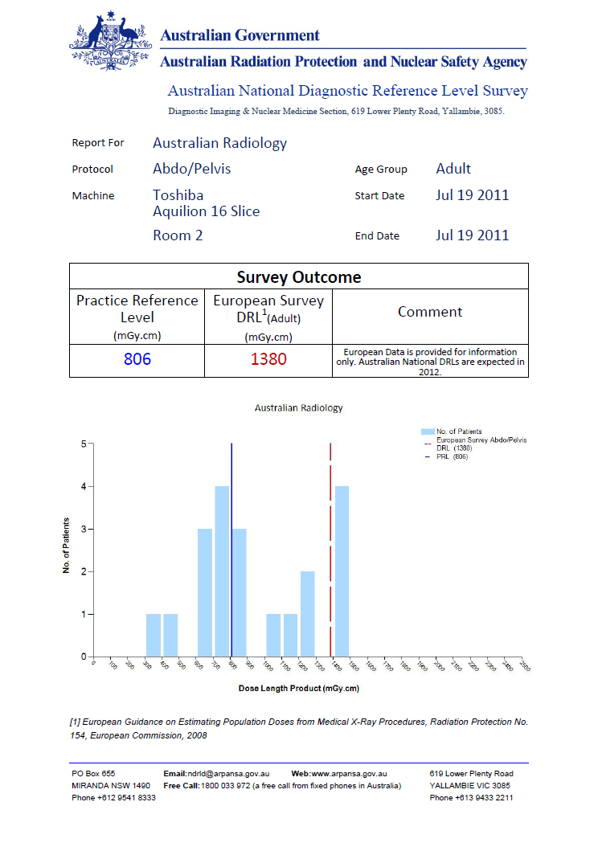 | 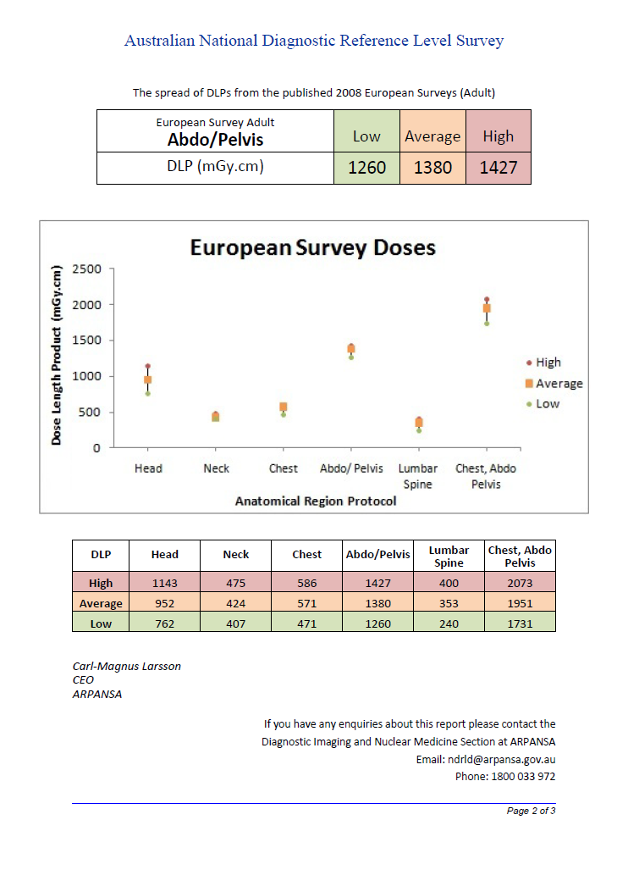
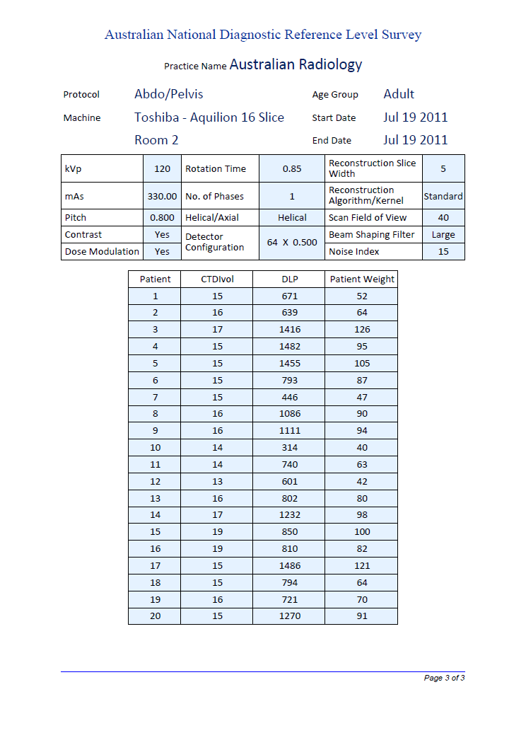
Figure 1: Pre-establishment of Australian DRLs FRL Report

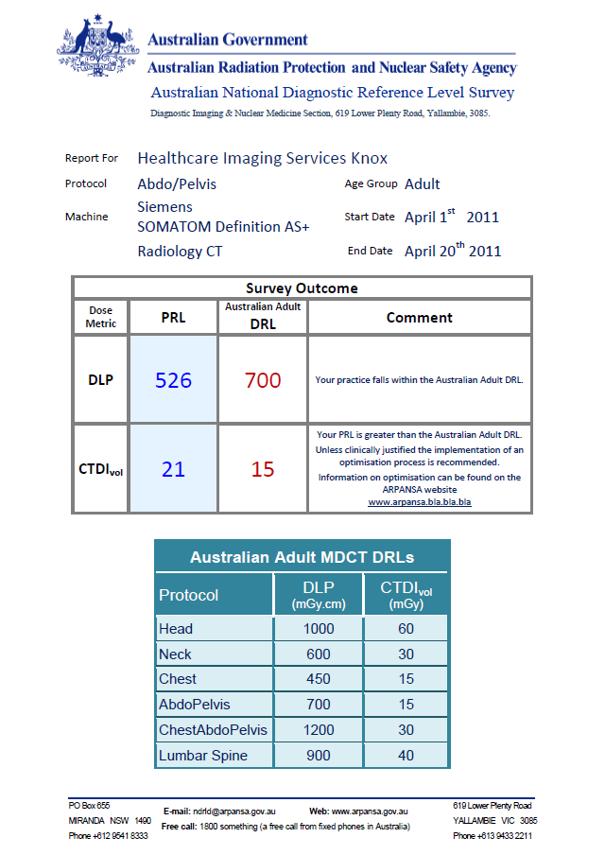 | 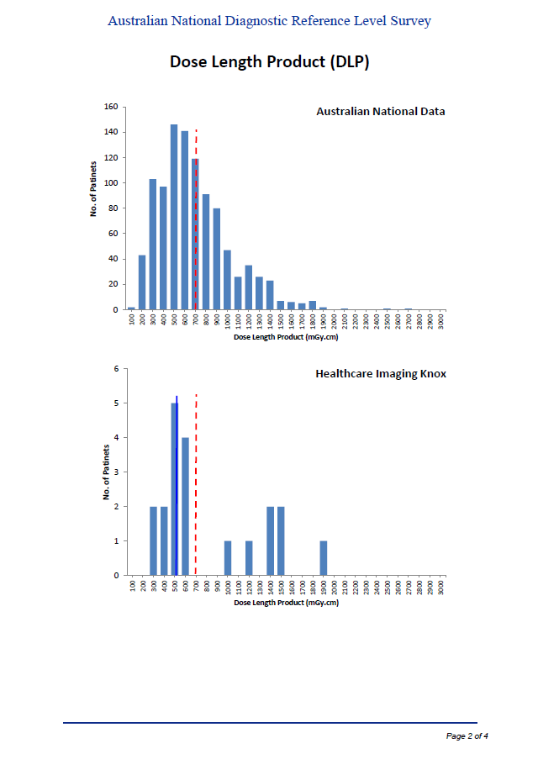
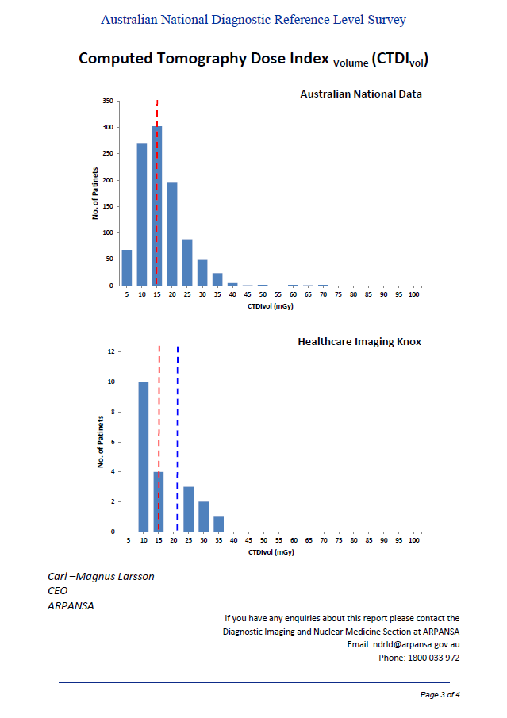 | 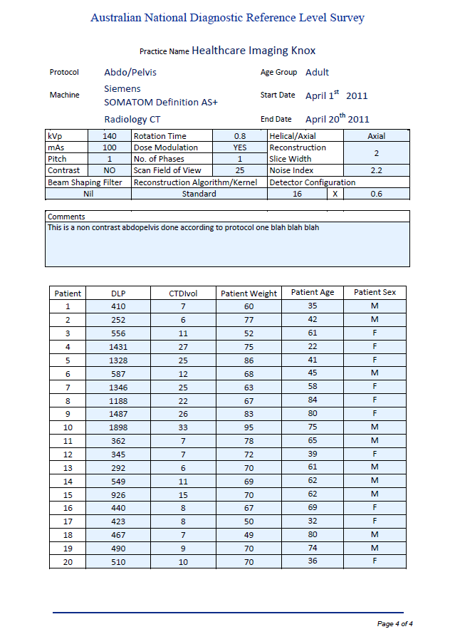
Figure 2: Post-establishment of Australian DRLs FRL Report

Adult Data – 2011 - 2013

Initial Collected Data
The survey website went live in August 2011 and it was decided to collect data until the end of the calendar year and assess whether enough data had been collected to establish MDCT DRLs. As of December 31st 2011 there were a total of 82 facilities registered for the survey with 378 individual surveys started of which 255 were compliant. A compliant survey was defined as one with complete data from at least ten patients. The remaining 123 non-compliant surveys were discarded. All 255 compliant surveys were for the adult age group, no compliant surveys were submitted for either the child or baby/infant age groups. Of the 82 facilities registered, only 51 contributed to the 255 compliant surveys submitted.
Table 2 shows the breakdown of registrations by Year, State/Territory and Facility Type.
Table 2: Facility Registrations by Year, State/Territory & Facility Type
Table 3 shows the breakdown of compliant surveys by Anatomical Region and State/Territory.
Table 3: Anatomical Regional Scan by Year & Survey Type

The Australian National DRLs for MDCT
The Australian national adult DRLs for MDCT were calculated by taking the 75th percentile of the spread of FRLs, the median metric values for each protocol. These values were then rounded to the nearest factor of fifty; the rounded and unrounded values are shown in Table 4.

Protocol | Australian National Adult DRL - unrounded |  | Australian National Adult DRL - rounded
Protocol | DLP (mGy.cm) | CTDI_{vol} (mGy) | DLP (mGy.cm) | CTDI_{vol} (mGy)
Head | 992 | 61 | 1000 | 60
Neck | 597 | 32 | 600 | 30
Chest | 458 | 14 | 450 | 15
Abdomen Pelvis | 697 | 17 | 700 | 15
Chest Abdomen Pelvis | 1147 | 32 | 1150 | 30
Lumbar Spine | 896 | 43 | 900 | 40
Table 4: The Australian National Adult DRLs for MDCT, rounded and unrounded values.
It should be noted that participation in the survey was voluntary and discretionary. Therefore the results do not represent a random sample of the facility population and may include some inherent and unintended bias. For comparative purposes a 95% confidence interval for the rankings of the FRLs around the 75th percentile level was derived using non-parametric statistics (Conover, 1999) and is given by Equation 1.
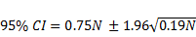
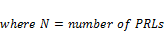
Equation 1: 95th percentile confidence intervals around the 75th percentile MDCT DRLs
The confidence intervals for the 2011 DRL calculations are shown in Table 5.

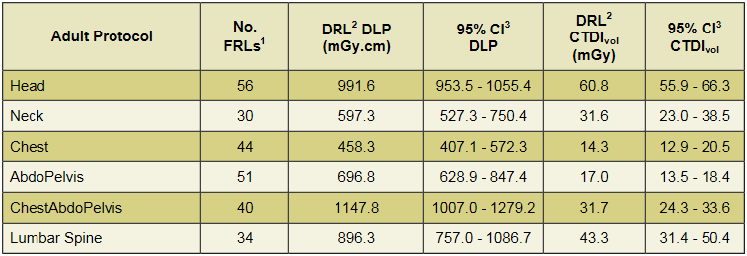
Table 5: National DRL 95% Confidence Intervals

Adult MDCT DRL Publication
After consultation with the liaison panel the draft Adult MDCT DRLs were sent to the principal stakeholder professional organisations for ratification and approval to publish.
The first and current set of Australian DRLs for MDCT was published in June 2012 and is shown in Table 6.
Australian Adult (15+ yrs)
MDCT Diagnostic Reference Levels
Adult  Protocol | DLP  (mGy.cm) | CTDI_{vol}  (mGy)
Head | 1000 | 60
Neck | 600 | 30
Chest | 450 | 15
AbdoPelvis | 700 | 15
ChestAbdoPelvis | 1200 | 30
Lumbar Spine | 900 | 40
Table 6: Australian Adult MDCT DRLs
Note: CTDIvol values for the Head are based on the 16 cm PMMA reference phantom and
Chest and Abdomen are based on the 32 cm PMMA reference phantom.

Facility Registrations
At 31 December 2013 there were 211 facilities registered, which is 129 more than were registered at 31 December 2011 (82 facilities). Table 7 shows the number of registrations by facility type for the years 2011 – 2013 per State/Territory.
Table 7: Facility Registrations by Facility Type, State/Territory & Year
The number of registrations for each type, with the exception of ‘Public Clinic in a Public Hospital’, approximately doubled from 2011 to 2012. In 2011 the greatest numbers of registrations were from ‘Public Clinics in Public Hospitals’ but in 2012 this changed to ‘Private Clinics’. In 2013 the growth in facility registrations slowed to around 50% of 2012 numbers. If it is assumed that there are approximately 850 facilities in Australia the total registered at the end of 2013 represents approximately 25% of facilities.

CT Platforms
In 2011 there was a total of 116 CT machines listed for 82 facilities; in 2012 there were 246 CT machines listed for 171 facilities and in 2013 there were 329 CT machines listed for 211 facilities. In 2011 the average number of CT machines listed per facility was 1.3, in 2012 it was 1.4 and in 2013 it was 1.6. For all three years the majority of facilities had only one CT machine listed. For ease of use, some organisations list CT scanners for multiples sites under the one facility, which has the potential to skew the average towards larger values.

Submitted Surveys
In 2011 there were a total of 378 surveys initiated of which 255 were compliant, in 2012 there were 977 surveys initiated of which 552 were compliant and in 2013 there were 1041 surveys initiated of which 794 were compliant. Table 8 shows a breakdown by anatomical region and age group of all compliant surveys submitted for 2011 - 2013.
Table 8: Anatomical Regional Scan by Year & Age Group
In 2011 no compliant surveys were submitted for either of the paediatric age groups, however, in 2012 there were 61 compliant surveys submitted and in 2013 there were another 70 compliant surveys submitted for the paediatric age groups.

Inter Year Data Comparison
During the years 2011 to 2013 there was no statistically significant change to the DRLs calculated in terms of CTDI_{vol} or DLP (Figures 3 and 4).

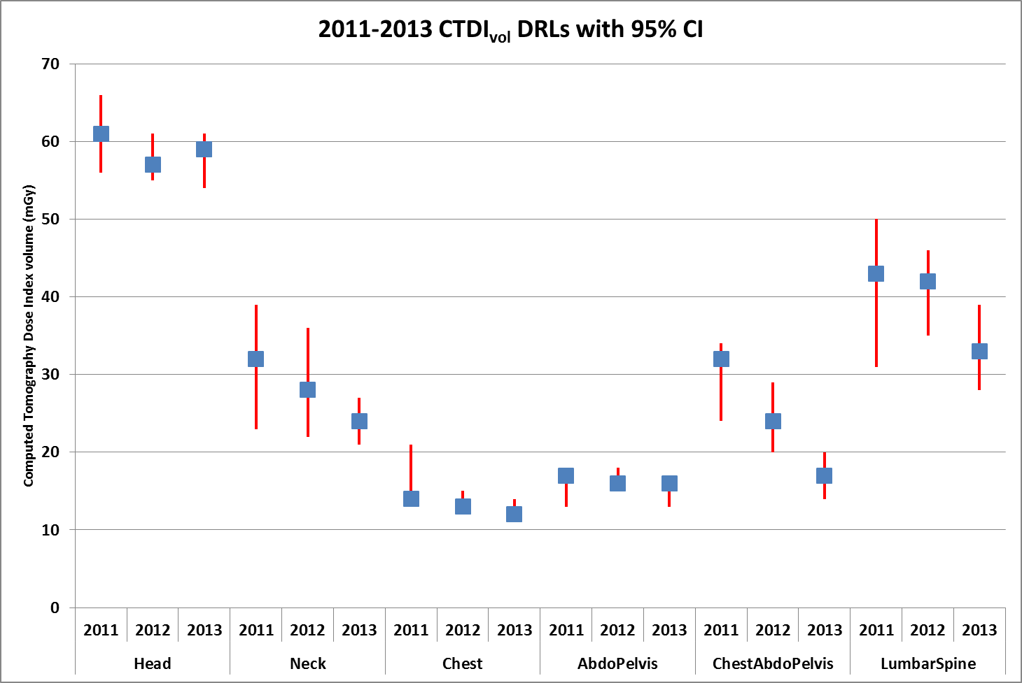
Figure 3: The 2011-13 Australian National DRLs for MDCT in terms of CTDI_{vol} with
95% confidence intervals.
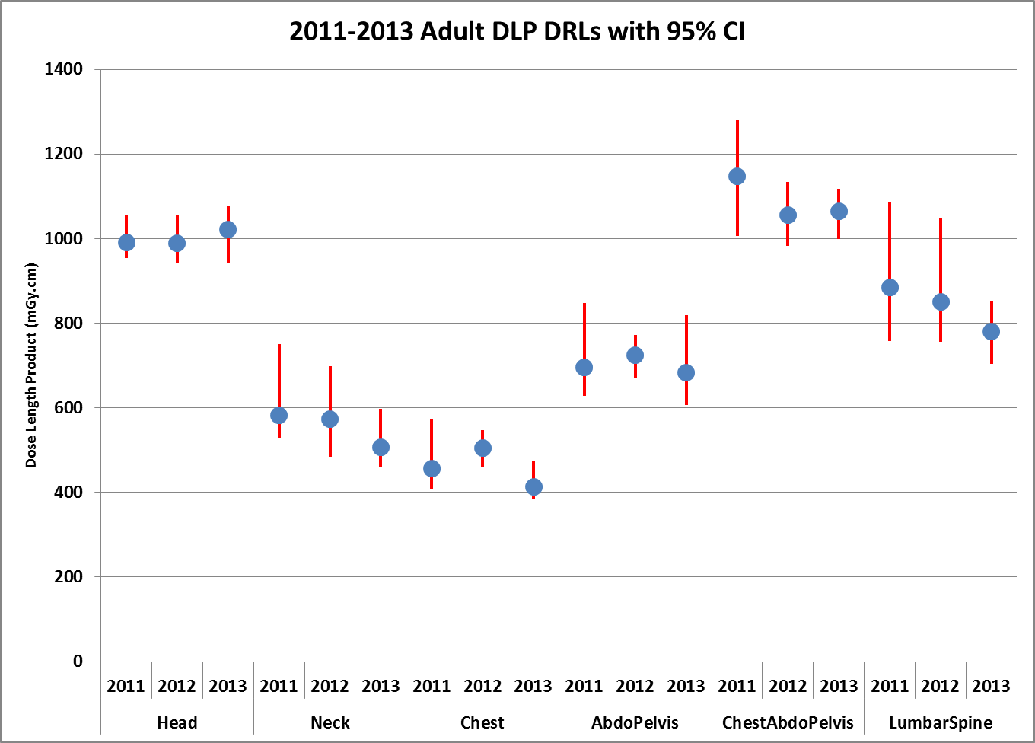
Figure 4: The 2011-13 Australian National DRLs for MDCT in terms of DLP with
95% confidence intervals.

Iterative Reconstruction
In early 2013 it was decided that the use of iterative reconstruction (Kordolaimi et al., 2014, Lambert et al., 2014) would be recorded in the survey protocol data. Consequently a tick-box field was added to the parameter settings that took effect from May onwards. It is expected that there will be a measurable effect that will be reflected in survey data. The impact will be detailed in the 2014 NDRLS Report. Table 9 shows the distribution of iteratively reconstructed scans and non-IR scans.
Table 9: Iterative Reconstruction Scans for 2013 and Anatomical Region

Paediatric Data – 2011 – 2013

Submitted Surveys
As previously mentioned, the submission of compliant surveys for paediatric MDCT was particularly disappointing in 2011 as there was no data submitted. Figure 5 shows a comparison between submitted surveys for adult and paediatric anatomical regions.
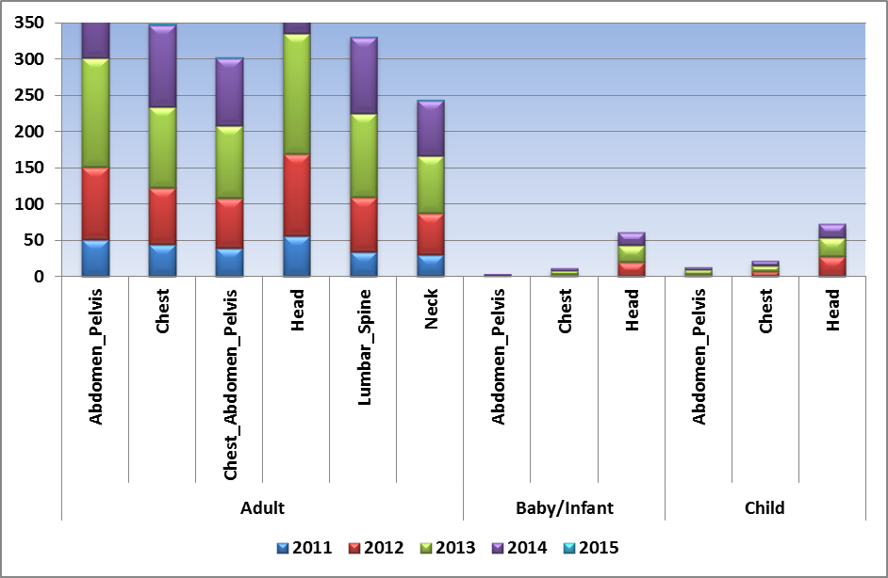
Figure 5: FRL Reports by Age Grouping, Anatomical Region and Year.

RANZCR Paediatric Data
At the end of July 2012, ARPANSA was given access to paediatric MDCT dosimetry data that had been collected via a Royal Australian and New Zealand College of Radiologist’s (RANZCR) supported survey of paediatric facilities in Australasia undertaken by RANZCR Quality Use of Diagnostic Imaging (QUDI, www.qudi.net.au/qudi/2010_2011.php). Sufficient paediatric data was provided for ARPANSA to calculate paediatric DRLs for baby and child cohorts for Head, Chest and AbdoPelvis protocols.
Due to differences in the surveyed scan parameters it was not possible to directly import the RANZCR data into the ARPANSA database and insufficient data was generated per facility for ARPANSA to be able to generate individual FRLs. However five fields, age, kVp, Girth (cm), CTDIvol (mGy) and DLP (mGy.cm) were able to be used in this analysis. It should also be noted that for multiple phase scans the CTDIvol was based on the average value and the DLP was based on the total value. More detail may be found on the NDRLS paediatric DRL webpage: www.arpansa.gov.au/services/ndrl/paediatric.cfm.
Adult MDCT DRLs had previously been determined by calculating the 75th percentile of the spread of FRLs. As the QUDI dataset did not allow this approach, the Paediatric MDCT DRLs were calculated by determining the 75th percentile of the spread of individual doses submitted (shown in Tables 10 and 11).

Australian Child (5-14 yrs)
MDCT Diagnostic Reference Levels
Child  Protocol | DLP  (mGy.cm) | CTDI_{vol}  (mGy)
Head | 600 | 35
Chest | 110 | 5
Abdomen | 390 | 10
Table 10: Australian Child (5-14 years) MDCT DRLs

Australian Baby (0-4 yrs)
MDCT Diagnostic Reference Levels
Child  Protocol | DLP  (mGy.cm) | CTDI_{vol}  (mGy)
Head | 470 | 30
Chest | 60 | 2
Abdomen | 170 | 7
Table 11: Australian Baby/Infant (0-4 years) MDCT DRLs
The paucity of national paediatric data submitted for both baby and child FRLs is shown in Figure 5. The national distribution of survey submissions and FRLs is varied as shown in Figure 6. Up until December 2013 there were only three States that provided any survey data.
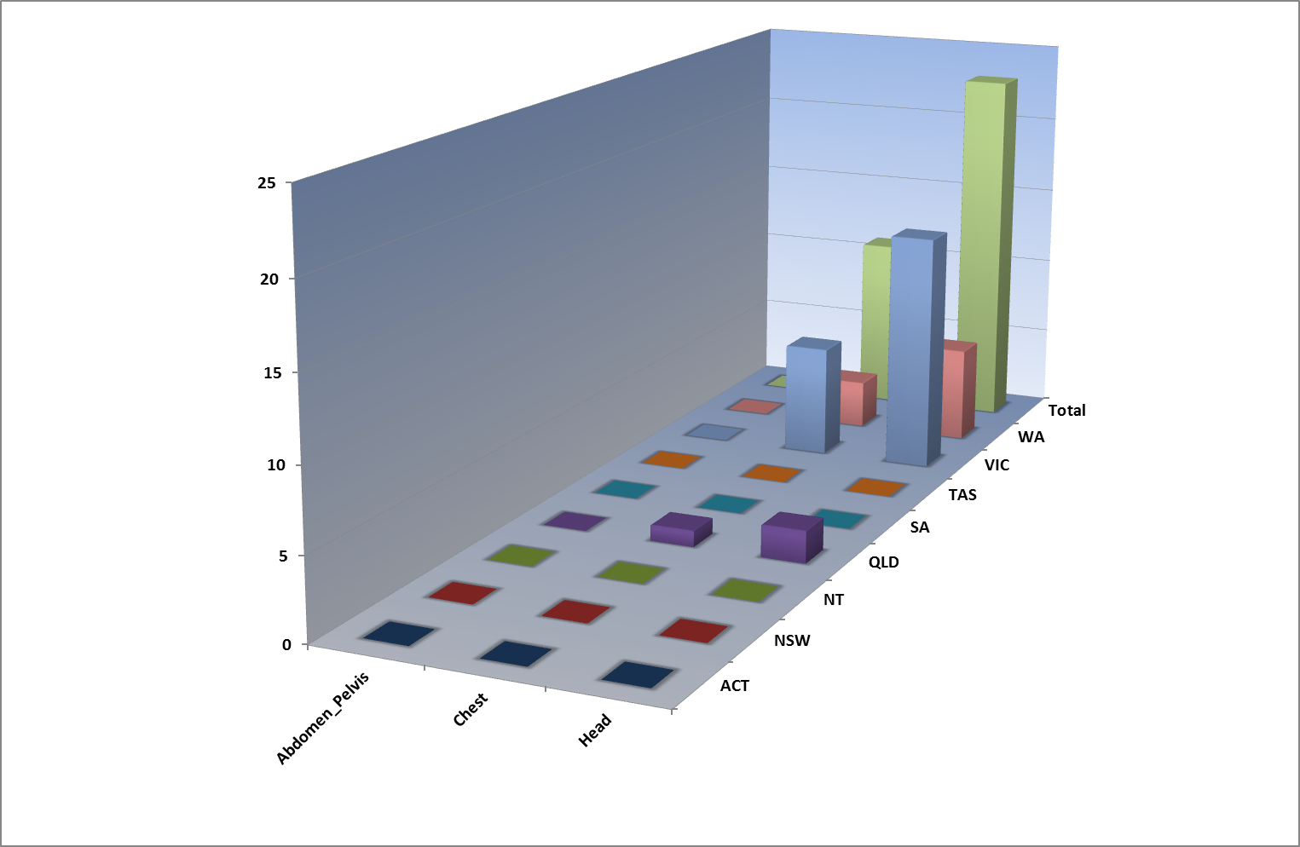
Figure 6: Paediatric FRL Reports 2011-2013

Conclusion
The NDRLS for MDCT has been successfully running for three years. It has adapted to changes in technology and remained responsive to the needs of the client base. National DRLs for MDCT have been established, approved by the stakeholder groups and disseminated to facilities via the ARPANSA NDRLS website and individual FRL reports.

References
ARPANSA 2008. RPS 14. Code of Practice for Radiation Protection in the Medical Applications of Ionizing Radiation, Yallambie, Australian Radiation Protection and Nuclear Safety Agency.
BOAL, TJ, HEDT, J. C. & EINSIEDEL, P. F. 1999. A survey of patient dose and image quality factors for CT scanners in Victoria. Austral.Phys.Eng.Sci.Med., 22, 103-110.
BRENNER, D. J., ELLISTON, C. D., HALL, E. J. & BERDON, W. E. 2001. Estimated Risks of Radiation-Induced Fatal Cancer from Pediatric CT. Am. J. Roentgenol., 176, 289-296.
EU COMMISSION, 2008. European Guidance on Estimating Population Doses from Medical X-Ray Procedures, Annex 1 - Dose Datamed Report 1 - Review of Recent National Surveys of Population Exposure from Medical X-Rays in Europe. Radiation Protection. Chilton, UK: European Commission.
CONOVER, W. J. 1999. Practical nonparametric statistics, New York, Wiley.
FOLEY, S. J., MCENTEE, M. F. & RAINFORD, L. A. 2012. Establishment of CT diagnostic reference levels in Ireland. British Journal of Radiology, 85, 1390-1397.
FUKUSHIMA, Y., TSUSHIMA, Y., TAKEI, H., TAKETOMI-TAKAHASHI, A., OTAKE, H. & ENDO, K. 2012. Diagnostic reference level of computed tomography (CT) in japan. Radiation Protection Dosimetry, 151, 51-57.
HALL, E. J. & BRENNER, D. J. 2008. Cancer risks from diagnostic radiology. Br J Radiol, 81, 362-78.
HART, D., HILLIER, M. C. & WALL, B. F. 2009. National reference doses for common radiographic, fluoroscopic and dental X-ray examinations in the UK. British Journal of Radiology, 82, 1-12.
HAUGE, I. H. R., BREDHOLT, K. & OLERUD, H. M. 2013. New diagnostic reference level for full-field digital mammography units. Radiation Protection Dosimetry, 157, 181-192.
HAYTON, A., WALLACE, A., EDMONDS, K. & TINGEY, D. 2009. Trends in Australian CT Statistics 1994 - 2008. Engineering & Physical Sciences in Medicine Conference 2009.
HAYTON, A., WALLACE, A., MARKS, P., EDMONDS, K., TINGEY, D. & JOHNSTON, P. 2013. Australian diagnostic reference levels for multi detector computed tomography. Australasian Physical & Engineering Sciences in Medicine, 36, 19-26.
ICRP 1996. Radiological Protection and Safety in Medicine. ICRP Publication 73. Ann. ICRP.
ICRP 2007. Managing patient dose in multi-detector computed tomography (MDCT). ICRP Publication 102. Ann ICRP, 37, 1-79, iii.
JARVINEN, H., MERIMAA, K., SEURI, R., TYRVAINEN, E., PERHOMAA, M., SAVIKURKI-HEIKKILA, P., SVEDSTROM, E., ZILIUKAS, J. & LINTROP, M. 2011. Patient doses in paediatric CT: feasibility of setting diagnostic reference levels. Radiation Protection Dosimetry, 147, 142-146.
JONES, D. G. & SHRIMPTON, P. C. 1991. NRPB-R250 Survey of CT Practice in the UK. Part 3: Normalised Organ Doses Calculated using Monte Carlo Techniques. London: National Radiological Protection Board.
KORDOLAIMI, S. D., SARADEAS, I., PLOUSSI, A., PANTOS, I., ARGENTOS, S. & EFSTATHOPOULOS, E. P. 2014. Introduction of an Effective Method for the Optimization of CT Protocols Using Iterative Reconstruction Algorithms: Comparison With Patient Data. American Journal of Roentgenology, 203, W434-W439.
LAMBERT, J., MACKENZIE, J. D., CODY, D. D. & GOULD, R. 2014. Techniques and Tactics for Optimizing CT Dose in Adults and Children: State of the Art and Future Advances. Journal of the American College of Radiology : JACR, 11, 262-266.
LARSON, D. B., RADER, S. B., FORMAN, H. P. & FENTON, L. Z. 2007. Informing Parents About CT Radiation Exposure in Children: It's OK to Tell Them. Am. J. Roentgenol., 189, 271-275.
MATHEWS, J. D., FORSYTHE, A. V., BRADY, Z., BUTLER, M. W., GOERGEN, S. K., BYRNES, G. B., GILES, G. G., WALLACE, A. B., ANDERSON, P. R., GUIVER, T. A., MCGALE, P., CAIN, T. M., DOWTY, J. G., BICKERSTAFFE, A. C. & DARBY, S. C. 2013. Cancer risk in 680,000 people exposed to computed tomography scans in childhood or adolescence: data linkage study of 11 million Australians. BMJ, 346.
METTLER, F. A., JR., HUDA, W., YOSHIZUMI, T. T. & MAHESH, M. 2008. Effective Doses in Radiology and Diagnostic Nuclear Medicine: A Catalog. Radiology, 248, 254-263.
NCRP 2009. Ionizing Radiation Exposure of the Population of the United States. NCRP Report 160. Bethesda, MD: National Council on Radiation Protection and Measurements (NCRP).
NFAOUI, K., BENTAYEB, F., EL BASRAOUI, O. & DE AZEVEDO, A. C. 2010. Evaluation of paediatric X-ray doses in Moroccan university hospitals. Radiat Prot Dosimetry, 142, 238-43.
ROCH, P. & AUBERT, B. 2013. French diagnostic reference levels in diagnostic radiology, computed tomography and nuclear medicine: 2004-2008 review. Radiation Protection Dosimetry, 154, 52-75.
SHRIMPTON, P. C. HART, D., HILLIER, M.C., WALL, B.F. & FAULKNER, K. 1991. NRPB - R248 Survey of CT Practice in the UK. Part 1: Aspects of Examination Frequency and Quality Assurance. NRPB Reports. Chilton, UK: NRPB.
SHRIMPTON, P. C., JONES, D. G., HILLIER, M. C., WALL, B. F., LE HERON, J. C. & FAULKNER, K. 1991. NRPB-R249 Survey of CT Practice in the UK Part 2: Dosimetric Aspects. London: National Radiological Protection Board.
TSAPAKI, V., ALDRICH, J. E., SHARMA, R., STANISZEWSKA, M. A., KRISANACHINDA, A., REHANI, M., HUFTON, A., TRIANTOPOULOU, C., MANIATIS, P. N., PAPAILIOU, J. & PROKOP, M. 2006. Dose reduction in CT while maintaining diagnostic confidence: diagnostic reference levels at routine head, chest, and abdominal CT--IAEA-coordinated research project. Radiology, 240, 828-34.
WALL, B. F. 2001. Diagnostic reference levels - the way forward. British Journal of Radiology, 74, 785-788.
WALL, B. F. 2005. Implementation of DRLs in the UK. Radiat Prot Dosimetry, 114, 183-7.
WALLACE, A. B., HAYTON, A., EDMONDS, K. & TINGEY, D. Utility of a web based data survey form for a national MDCT radiology practice survey. Third European IRPA Congress of the International Radiation Protection Association, 2010 Helsinki, Finland. IRPA.

