Safety Culture Assessment Report  
*of the Australian Radiation Protection and Nuclear Safety Agency*

March 2020

John Ward, Chris Nickel, Sarsha Collett, Danyel Zalsman, Emma Carey (ARPANSA),   
Traci Carse and Terry Foster (SafetyWorks),

© Commonwealth of Australia 2020

This publication is protected by copyright. Copyright (and any other intellectual property rights, if any) in this publication is owned by the Commonwealth of Australia as represented by the Australian Radiation Protection and Nuclear Safety Agency (ARPANSA).



**Creative Commons**

With the exception of the Commonwealth Coat of Arms, any ARPANSA logos and any content that is marked as being third party material, this publication, *Safety Culture Assessment Report of the ARPANSA Regulatory Service Branch*, by the Australian Radiation Protection and Nuclear Safety Agency is licensed under a Creative Commons Attribution 3.0 Australia licence (to view a copy of the licence, visit ([*http://creativecommons.org/licenses/by/3.0/au*](http://creativecommons.org/licenses/by/3.0/au)). It is a further condition of the licence that any numerical data referred to in this publication may not be changed. To the extent that copyright subsists in a third party, permission will be required from the third party to reuse the material.

In essence, you are free to copy, communicate and adapt the material as long as you attribute the work to ARPANSA and abide by the other licence terms. The works are to be attributed to the Commonwealth as follows:-

“© Commonwealth of Australia 2020, as represented by the Australian Radiation Protection and Nuclear Safety Agency   
 (ARPANSA)”

The publication should be attributed as: Safety Culture Assessment Report of the ARPANSA Regulatory Service Branch.

**Use of the Coat of Arms**

The terms under which the Coat of Arms can be used are detailed on the Department of the Prime Minister and Cabinet website ([www.dpmc.gov.au/government/commonwealth-coat-arms](http://www.dpmc.gov.au/government/commonwealth-coat-arms)).

Enquiries regarding the licence and any use of this report are welcome.

ARPANSA  
 619 Lower Plenty Road  
 YALLAMBIE VIC 3085

Tel: 1800 022 333 (Free call) or +61 3 9433 2211  
  
 Email: [info@arpansa.gov.au](mailto:info@arpansa.gov.au)  
 Website: [www.arpansa.gov.au](http://www.arpansa.gov.au)

### Acknowledgement of Country

ARPANSA respectfully acknowledges Australia's Aboriginal and Torres Strait Islander communities and their rich culture and pays respect to their Elders past and present. We acknowledge Aboriginal and Torres Strait Islander peoples as Australia’s first peoples and as the Traditional Owners and custodians of the land and water on which we rely.

We recognise and value the ongoing contribution of Aboriginal and Torres Strait Islander peoples and communities to Australian life and how this enriches us. We embrace the spirit of reconciliation, working towards the equality of outcomes and ensuring an equal voice.

**Contents**

Executive summary 1

Introduction 3

Purpose 3

Context 3

Methodology 5

Safety culture model 5

Data collection methods 6

Results 9

Element 1 – Leadership for safety 11

Element 2 – Individual responsibility & accountability 14

Element 3 - Safety oversight and systemic approach 17

Element 4 - Collaboration & open communication 21

Element 5 - Continuous improvement and self-assessment 24

Additional observations 27

Next steps 27

Table of findings 28

Bibliography 29

# Executive summary

### Introduction

The ARPANSA safety culture assessment project team developed a custom made safety culture maturity model for use at ARPANSA. The model ranks performance in five elements, each with four sub-elements. Maturity is ranked on a five-point scale from ‘pathological’ to ‘holistic’.

The model was developed from a safety culture report of the OECD Nuclear Energy Agency (NEA), and on the assessment model developed by Bel V, a subsidiary of the Belgian Federal Agency for Nuclear Control (FANC) with responsibilities for assessment and inspection of nuclear installations.

A pilot study that concentrated on ARPANSA’s regulatory services was conducted during February to March 2019. This report comprises the second and final stage of the study which covers the whole of ARPANSA.

### Summary of findings

Survey results for the five elements show an overall positive safety culture, ranging in maturity from ‘individual’ to ‘cooperative’ levels. The more detailed sub-elements spanned a broader range of responses and highlight strong attributes of ARPANSA’s safety culture maturity, as well as areas which deserve attention. These results are summarised below.

This study identified seven areas for improvement, including:

* **Leadership for safety** - This is considered mature overall, however some areas of leadership for safety are not clearly visible across the organisation. This includes an absence of a visible and systematic method for proactive risk identification and management.
* **Safety oversight and systemic approach** - The areas of risk awareness and situational awareness identified that staff desire a clear, effective and integrated system across the agency. This would allow individuals to more easily create, access, and disseminate information to inform decisions and maintain oversight of safety and operational issues. Two whole-of-agency projects are already underway, ‘platforms and systems’ and the ‘integrated management system’, which target this area.
* **Collaboration and open communication** - In a positive and mature safety culture, all employees are encouraged and provided opportunities to influence decision-making, and feel included at work. However, mixed results are seen in the involvement and inclusion sub-element, and this is viewed as an area for improvement.

This study identified one good practice:

* **Just and fair culture** – ARPANSA employees indicated a culture in which employees are treated fairly, rather than there being a culture of blame when things go wrong. This is essential in relation to safety and reliability where non-biased investigation is key to identifying and understanding triggering and contributing factors.

The complete list of recommendations, areas for improvement and good practice can be found in the Table of findings at the end of this report.

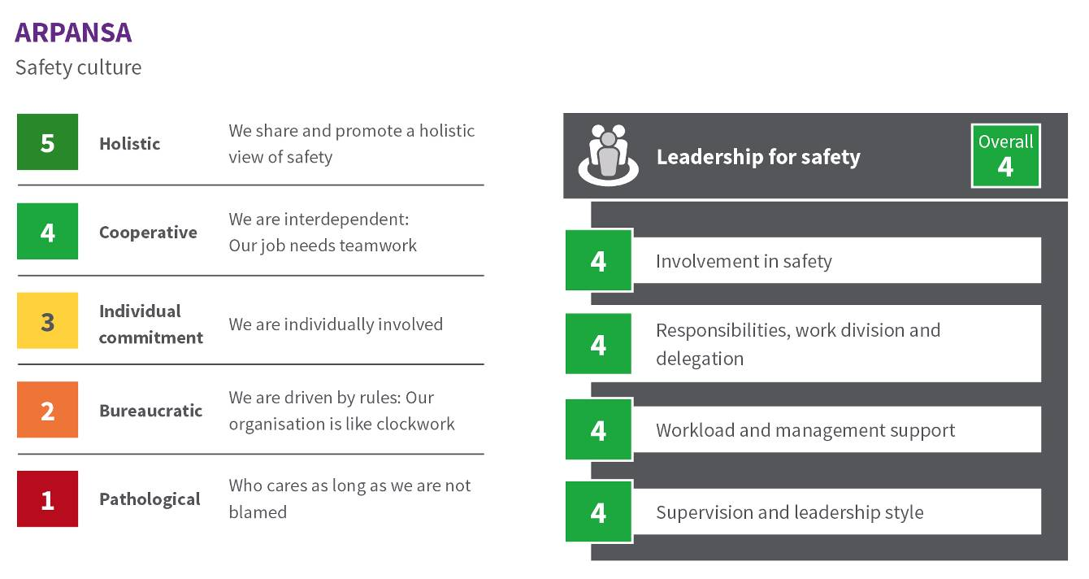

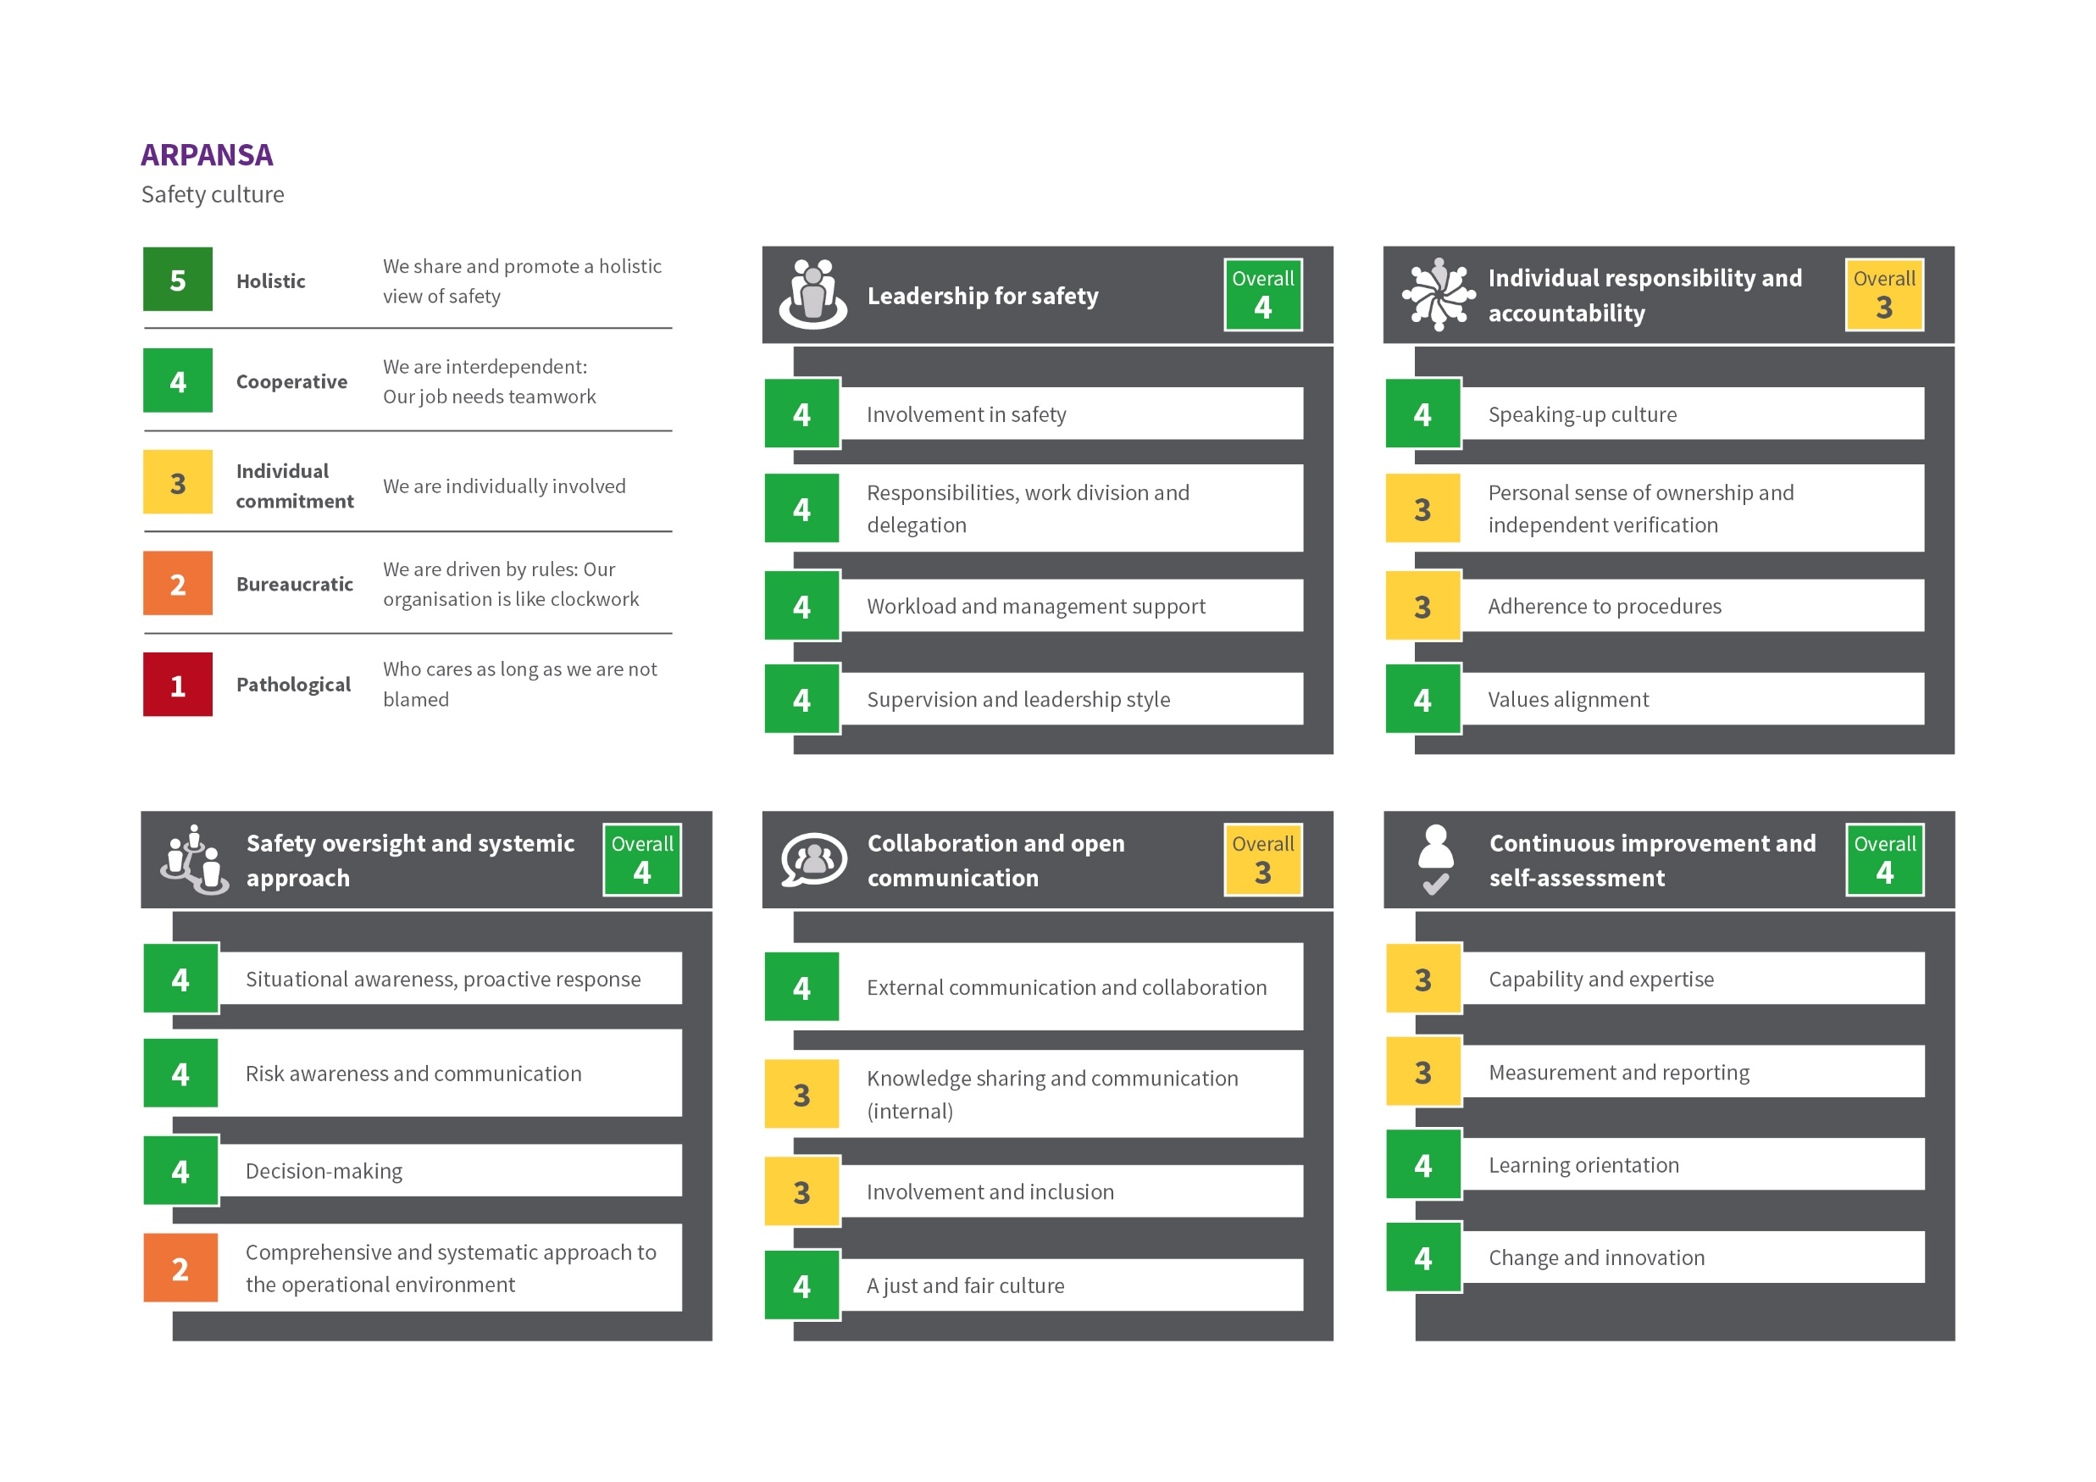

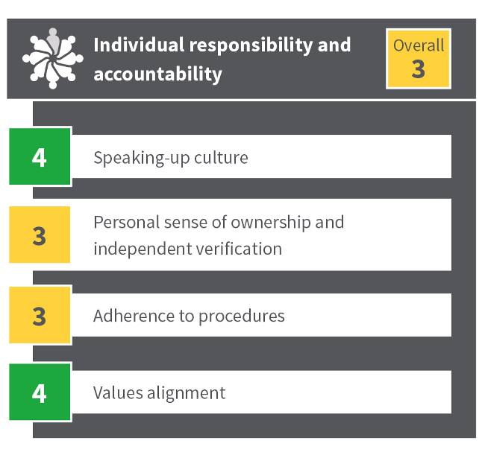

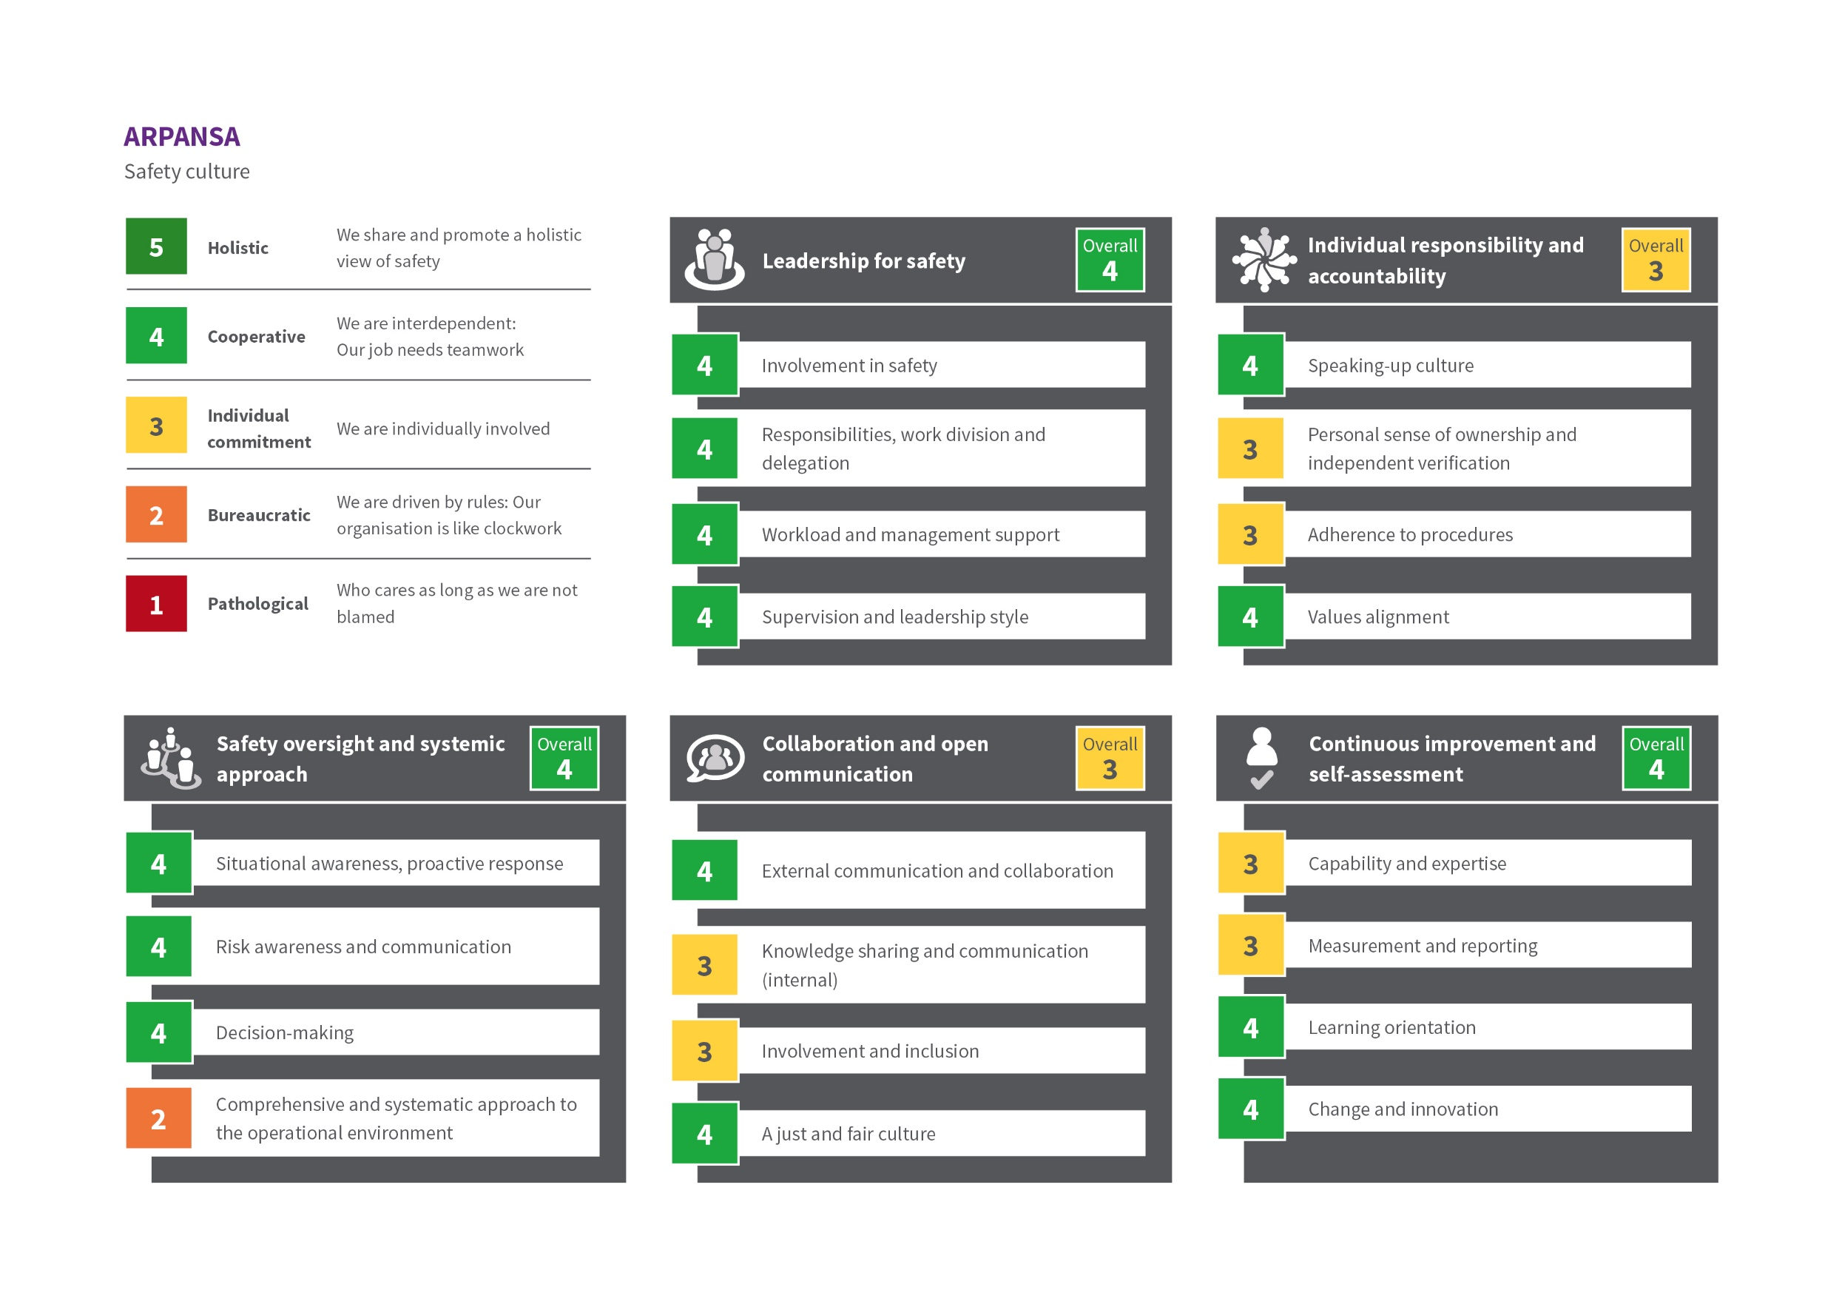

Note: The element maturity rank is the most common response for the element, not an average of the sub-elements. See page 10

# Introduction

The Australian Radiation Protection and Nuclear Safety Agency (ARPANSA) is the Australian Government's primary authority on radiation protection and nuclear safety. ARPANSA undertakes research, provides services, regulates commonwealth users of radiation, and promotes national uniformity and the implementation of international best practice.

ARPANSA conducted a safety culture self-assessment in the spirit of best practice. Under the requirements under the International Atomic Energy Agency (IAEA) General Safety Requirements Part 2: Leadership and Management for Safety (GSR Part 2). Requirement 14 of GSR Part 2 states ‘senior management shall regularly commission assessments of leadership for safety and of safety culture in its own organisation’.

This is ARPANSA’s first formal assessment of its safety culture. While some expertise in this area existed internally, these assessments are generally complex in nature and susceptible to bias, and therefore benefit from oversight from external parties. ARPANSA entered into partnership with the SafetyWorks Group to support the development of a custom-made safety culture assessment model. ARPANSA piloted the developed model by assessing the safety culture of the agency’s regulatory function, as a first step. The pilot study was undertaken in February to March 2019 and its results and an associated action plan are published on the [ARPANSA website](https://www.arpansa.gov.au/regulation-and-licensing/regulation/regulatory-integrity/safety-culture-assessment). This report covers the second and final stage of the safety culture assessment that includes data from the whole of ARPANSA.

## Purpose

The safety culture assessment project was designed with the following objectives:

* to provide ARPANSA with an appreciation of how the safety culture of the organisation currently looks
* to help develop a vision of where the organisation wants to be in the future
* to assist in identifying practical steps to maintain and improve the safety and security performance.

The assessment in terms of defining the maturity level is designed to obtain an overall picture of the safety culture at ARPANSA and identify priority areas for cultural change.

## Context

ARPANSA protects the Australian people and the environment from the harmful effects of radiation through understanding risks, best practice regulation, research, policy, services, partnership and engaging with the community. ARPANSA is functionally separated into six branches and offices:

* Corporate Office (CO) – focuses on agency supporting functions such as finance, information technology, strategic planning, security and risk, performance reporting, work health and safety, people and culture.
* Office of the CEO (OCEO) and Office of the General Council (which are combined for this assessment) – focuses on communication, government liaison, legal advice and supporting the functions of the CEO.
* Radiation Health Services (RHS) branch – focuses on the provision of advice, assessments and services related to radiation sources and the evaluation of the health risks to people and the environment.
* Medical Radiation Services (MRS) branch – focuses on advice on the safety and quality of the use of radiation in medicine to all Australians.
* Regulatory Service Branch (RSB) - focuses on ARPANSA regulatory functions such as licensing, compliance monitoring, inspection and enforcement.

The consultants engaged for this project were SafetyWorks Group, who have 20 years extensive experience in the development and implementation of safety culture assessments across a range of industries and work settings. This experience enables a comprehensive understanding of the variables involved in assessments and supports the co-design and implementation of this safety culture assessment to meet ARPANSA’s specific needs. The SafetyWorks consultants in this project were Traci Carse, organisational psychologist, and Terry Foster, Senior Leadership Consultant.

A joint project team was established to undertake the project, comprising the two SafetyWorks consultants, and five ARPANSA employees; two from the regulatory services branch (John Ward – Director, Safety Systems, and Christopher Nickel – Senior Regulatory Officer), supported by three employees from the ARPANSA Corporate Office (Danyel Zalsman - Assistant Director Workplace Relations, Emma Carey – Work Health and Safety Advisor, Sarsha Collett - Director Performance & Governance).

# Methodology

The safety culture assessment project team developed a custom made safety culture maturity model and piloted its application in a safety culture maturity assessment process within the Regulatory Services Branch (RSB) during February to March 2019. This approach was then applied to the organisation as a whole with minor modification to the text and approach, to reflect the specific operational aspect of the different units of ARPANSA. The results of the pilot study were published separately and are included in this report and analysis.

## Safety culture model

The safety culture model was developed to cover a large set of relevant safety and security culture attributes and to capture cultural issues. This model draws on international safety culture models and allows ARPANSA to understand the current safety culture as well as to help identify areas where work should be carried out to maintain and improve the organisation’s culture in the future.

The model is based on the OECD Nuclear Energy Agency (NEA) publication ‘Safety Culture of an Effective Nuclear Regulatory Body’. The model was adapted from the ‘Safety Culture Maturity Matrix’ and framework developed by Bel V (2018). Bel V is a subsidiary of the Belgian Federal Agency for Nuclear Control (FANC), which acts as an expert for the safety assessments of nuclear projects and carries out inspections of nuclear installations in Belgium. Bel V reviewed and commented on the ARPANSA model.

The approach is generally consistent with the guidance for safety culture assessment of the International Atomic Energy Agency (IAEA) Safety Standard GS-G-3.5 ‘The Management System for Nuclear Installations’. However, it has been modified to better target the role of ARPANSA, with recognition that a large focus of ARPANSA is on providing advice, regulation and specialised services rather than on manufacturing and sales.

### Maturity rating

The maturity model is anchored to five maturity levels as described below:

Improving safety culture – increasingly proactive

**Pathological**

**Bureaucratic**

**Individual Commitment**

**Cooperative**

**Holistic**

Who cares as long as we aren’t blamed

We are driven by rules: Our organisation is like clockwork

We are individually involved

We are interdependent: Our job needs teamwork

As ARPANSA, we share and promote a holistic view of safety

While the rating levels are in order of maturity, with the more desirable states being to the right, the model is not linear in that each state represents a discrete cultural trait. As such, variance in the response should not be seen as half-way between states, but rather that some aspects/individuals may be in one state of safety culture maturity while others are in a different state.

### Elements

The level of maturity is assessed through the following five safety culture elements:

* leadership for safety
* individual responsibility and accountability
* safety oversight and systematic approach
* collaboration and open communication
* continuous improvement and self-assessment.

These five elements are further broken down into sub-elements. Each element has four sub‑elements.

## Data collection methods

The key source of data is from an online survey distributed to all employees at ARPANSA. The previous survey results for RSB are included in this analysis. In addition, a ‘triangulation’ data collection process was used, which involved the gathering of data using four collection methods in total. This combination of methods ensured that available data was sourced from a variety of perspectives and places. Collation of these perspectives enabled comparison, verification and the ability to make sense of the data.

The four data collection methods are as follows:

### Perception survey

Safety culture surveys are designed to provide information about people’s perception of culture related factors such as leadership, risk, rule following, speaking up, team and divisional dynamics.

This survey is designed to align with the safety culture maturity model elements and sub-elements. Respondents are asked to select a ‘statement’ that corresponds to a maturity level that, in their opinion, best represents how they see the safety culture within their work area and at ARPANSA, for each of the sub-elements.

The most commonly selected response determines the culture score, both for the elements and sub-elements. This method is preferred over averages to more accurately describe the specific characteristics of maturity. For example, if four responses are at bureaucratic (2) and ten at holistic (5) maturity level, the average would yield cooperative (4.1) despite that none of the respondents selected the statement for cooperative. Instead this report uses the mode for the ranking, and variation is captured by including the 25th and 75th percentile scores which show the average response range. This means the most commonly selected response for an element may not be the same as the most common in each sub-element response.

In this way, maturity ratings are produced for each of the five elements and twenty sub-elements based on perceptions provided. Other data collection methods are used to explore and test the perceptions provided by the survey. The accompanying text discusses cases where those methods suggest a different maturity level from that provided by the survey results alone.

**Privacy considerations**

The project team took several steps to ensure the privacy and confidentiality of survey respondents. The survey was conducted as a voluntary and anonymous online survey and employees were not tracked in the process. Information that could have enabled identification was not collected. The Survey Monkey platform was used to host the survey with only members of the project team having access to the survey data. The analysis of groups was conducted using raw data with Microsoft Power BI which helped to ensure that results were not broken down to the individual level. The SafetyWorks consultants involved are bound by the code of conduct and ethical guidelines of the Australian Psychological Society and the Psychology Board of Australia.

### Document review

The document review involved collecting documentation/data, including systems documents (People and Culture; Work Health and Safety), strategy documents, values documents, policies and procedures, previous reviews and assessments, and communications that contain relevant information to the maturity profiling process. The document review was completed by the SafetyWorks consultants.

In reviewing documents, consideration was given to the degree to which:

* they align with the elements and sub-elements
* they provide insights into the organisation’s maturity, e.g. inclusiveness, holistic approach
* documentation is consistent
* documentation is available.

The documentation review is not intended to be a comprehensive assessment of all documentation, but provides insights and identifies areas for discussion, comparison and consideration, alongside the other data collection methods.

### Interviews and focus groups

The SafetyWorks consultants facilitated interviews and focus groups with a sample population of approximately half the ARPANSA workforce from the different business areas, functions and levels.

The purpose was to gather data to confirm, challenge or extend existing data.

Standardised questions for all focus groups and interviews were generated by the project team using the safety assessment model elements and the survey responses as points of reference. Open-ended questions were used, including about what is working well, not so well, and opportunities for improvement.

**a) Interviews**

Duration: 55 minutes

Eight interviews were conducted for this assessment:

1. Chief Executive Officer of ARPANSA.
2. All (six) Branch and Office heads.
3. Safety Representatives.

SafetyWorks consultant, Terry Foster, conducted the interviews.

**b) Focus groups**

Duration: 1 hour

Focus groups were held with staff chosen by the contractor based on an organisational chart to ensure a representative mix of work areas and levels. Employees were grouped according to branch/office with separate groups for managers.

Focus groups provide the opportunity to contextualise observations from other data collection methods and provide people the freedom to express issues that may not have been covered elsewhere. Focus group dynamics and language (verbal and body) are examples of observations that can also support an understanding of culture.

Focus groups were facilitated by SafetyWorks consultant Traci Carse, who was assisted by project team staff (John Ward and Chris Nickel) to record notes.

### Workplace behavioural interaction observation

Targeted observations of interactive forums (e.g. meetings, start-up talks) allow the profiling team to observe people at work. This helps to tell a story about the maturity profile and for staff to raise issues in their normal workplace.

In this assessment, the following interactive forums were selected for observation: pre-start meeting and operations in the medical radiation area, laboratory work in the radiation health area, a Corporate Office staff meeting and a Regulatory Branch managers meeting. Observations were conducted by the SafetyWorks consultants.

Results

The results below are generated from the survey responses across the whole agency. The survey response rate was 79% (112 responses were received from 142 invitations, which includes staff on leave). The response rate shows a high degree of engagement in the safety culture assessment process and is similar to other staff surveys undertaken at ARPANSA. In the narrative provided, additional findings from the other three data collection methods are integrated throughout the commentary as relevant and highlight instances where the assessment team believe that the actual maturity level may differ from that perceived from the survey results.

The overall survey result for the five elements, and each sub-element, is taken as the most common survey response (mode). This is represented by the solid rectangle in the graphs below. The range of responses is indicated by the line, which represents the central 50% of responses (25th to 75th percentile).

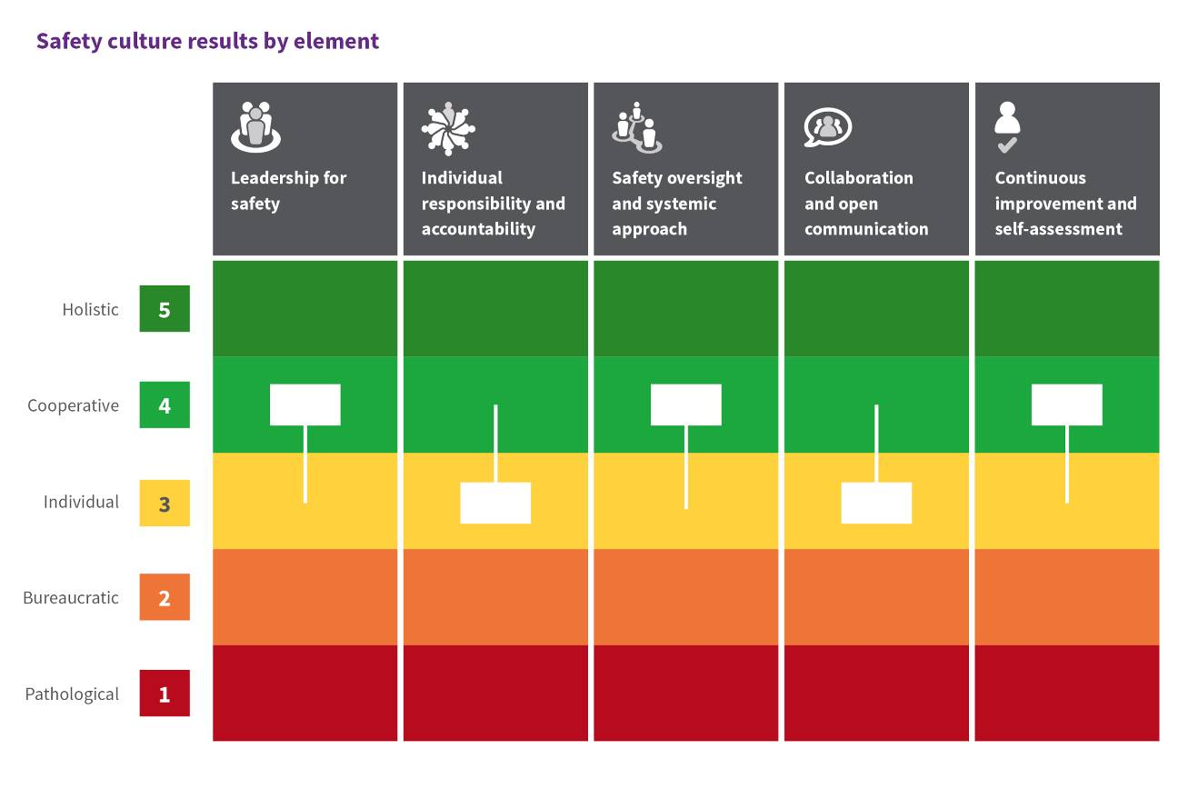

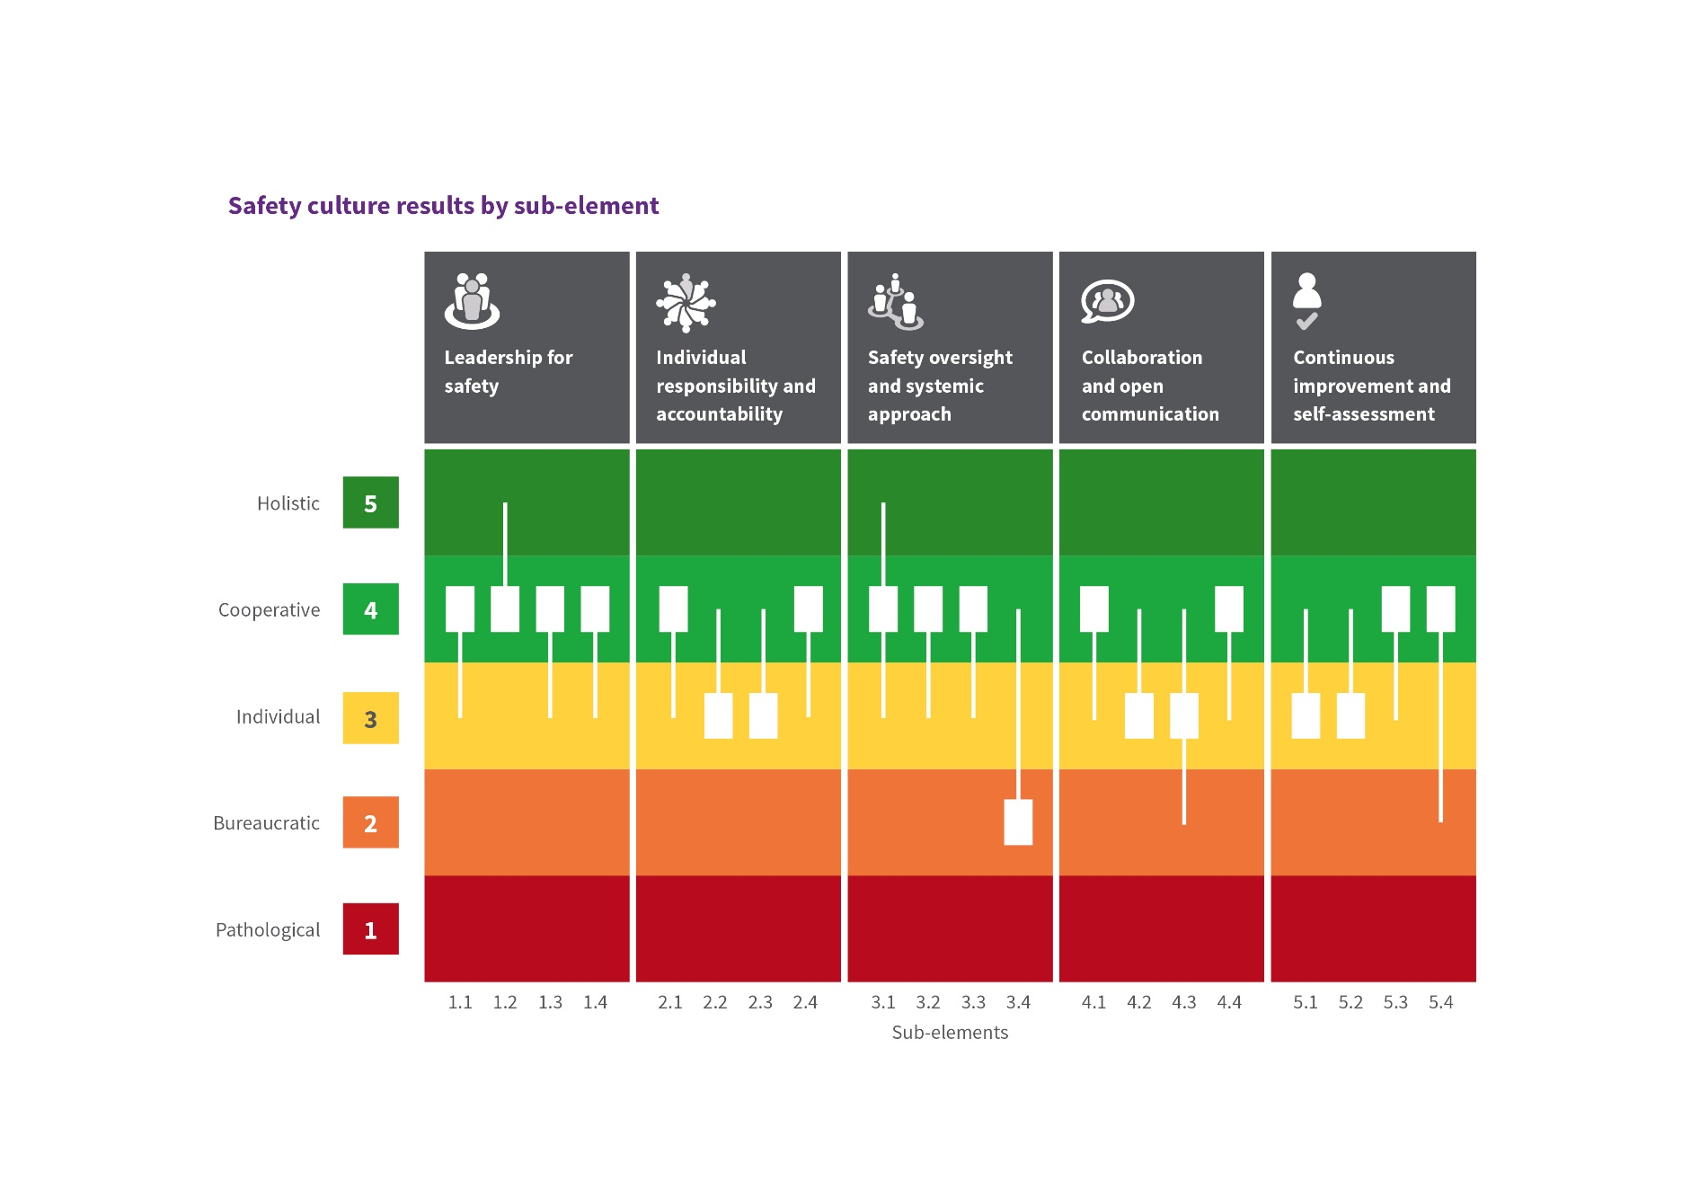

Each sub-element result is based on the (112) responses for that sub-element, while the element’s overall results are calculated based on the combination of all (448) sub-element responses. The element result (most common response for all element responses) may thus be different to the most common sub-element result (the most common response of each smaller group).

### Variation and sub-cultures

Overall there is broad agreement in rating between branches and offices particularly the non-regulatory branches. However, in some instances there are significant variations in responses, which is highlighted in the individual element analysis.

Results for subgroups are compared using the median result and the effect size (the difference in the average responses divided by the pooled standard deviation). Additionally, where a significant number of respondents highlighted a potential issue (e.g. 10% or more in pathological) these were further analysed.

Analysis of the variations and effect size showed that overall the RSB typically scores lower in the perception survey, while MRS scores higher. However, while there are differences in the absolute score (most common response), the relative scores (i.e. which sub-elements are rated higher or lower) are often similar. As such this may be an indication of a difference in perception, rather than a difference in how safety is managed. This was also supported by the issues raised in focus groups and interviews, which showed that issues faced are typically similar.

## Element 1 – Leadership for safety

This element describes leadership behaviours that have an impact on safety, security, and performance outcomes. Leadership functions, whilst focused on senior management levels, also reflect work performed at any level when staff undertake tasks and lead initiatives.

### Summary of element results

|  |  |
| --- | --- |
| **Overall perception rating:** | **Cooperative,** We are interdependent: Our job needs teamwork |

Evidence indicates that the safety culture regarding leadership for safety is felt by employees to be fairly mature. However, there is some variation across the sub-elements, operational areas and individuals.

Leaders at all levels have significant positive intentions when it comes to influencing safety at ARPANSA. The focus groups and interviews indicated that overall there is a high level of trust between managers and staff. However, there needs to be a balance between trust and challenge as trust without verification can lead to a decrease in proactively seeking out issues and independent challenge. The focus groups and interviews suggested that perhaps that balance is currently not optimised.

Area for improvement

The perception of leadership for safety indicates a high (cooperative) level overall. However, information from the surveys and focus groups indicates that areas of leadership for safety are not clearly visible across the organisation. In particular there is an absence of visible and systematic, proactive risk identification or management. In this regard, the data from interviews and focus groups suggest a lower maturity than the survey results.

Workers and managers reported that managers react well to any identified safety issues but outside of major projects and new tasks, which are subject to formal risk assessment, neither workers nor managers could identify what actions leaders take to challenge or monitor safety except for routine inspection, reporting and being open to reporting safety issues.

To explore opportunity for improvement to visible safety leadership, questions to consider include:

* What does strong visible leadership (versus - management of safety) actually look like?
* What visible and systematic methods are there in place to foresee safety issues?
* What will it take to have leaders at all levels be competent and confident visible leaders? Do we actually consider safety leadership capability when we on-board or promote people?
* How well do we keep ourselves and others (including our peers) accountable for visible safety leadership? How do we know?

| Sub element | Perception Rating | Question | Most common response |
| --- | --- | --- | --- |
| 1.1  Involvement in safety | Cooperative | How do leaders ensure that safety issues are properly considered? | Consultation on issues affecting safety takes place and ensures that options have been considered. Our leaders 'walk the talk'. |
| 1.2 Responsibilities, work division and delegation | Cooperative | How do leaders structure work processes & define responsibilities? | Whether I'm working in teams or individually my work affects others. Leaders set teams and ensure that we each know what we are responsible for. We ensure the work is delivered at a high standard and that ARPANSA's goals are met. |
| 1.3 Workload management & support | Cooperative | How do leaders ensure that resources are adequately allocated for performing your area’s activities? | Leaders, in consultation with their team, actively plan the team's workload. Work is spread based on availability, competency, and development needs. I am confident my team supports me. |
| 1.4  Supervision & leadership style | Cooperative | How do leaders supervise and engage with staff? | Leaders are frequently in the workplace and understand how work is actually performed. Supervision is typically hands-off and concentrates on support when it is needed. |

### Sub-element 1.1 - Involvement in safety:

At the bureaucratic level, organisations are characterised by focussing on compliance, relying on processes and procedures. At the individual level, people raise issues and leaders act on these; the cooperative level focuses on consultation on safety related issues.

While the most common response indicates a perception of a cooperative level of leadership for safety, the most common response for two of five branches (CO and OCEO) is at the individual level, and one (RSB) at the bureaucratic level. This demonstrates that there is a range of perceptions across the organisation.

During focus groups and interviews, there was broad consensus that leaders consider safety as part of major projects and new tasks through the risk assessment procedures in place. While some respondents indicated that leaders identified risks and monitored controls, in the main, responses indicate that people are not aware of any structured approaches by which leaders ensure safety issues are identified, managed and communicated.

Leader attributes typical of a higher maturity culture include positive leader behaviours such as effectively communicating and managing safety through a structured approach. This should include challenging assumptions, actively identifying risks, maintaining effective oversight of operations and controls, and periodically reviewing the effectiveness of controls.

### Sub-element 1.2 - Responsibilities, work division and delegation

ARPANSA employees in the main recognise that work performed by individuals is interdependent with others’ work. Most (45%) responses are at the co-operative level, with a significant number (32%) reporting the holistic level. The holistic level is the most common response for the CO and OCEO.

### Sub-element 1.3 - Workload management & support

The most common response (41%) indicates a cooperative level, however, a significant number (39%) of responses are at the individual level. Respondents believe that resource allocation exists to enable employees to successfully perform their work tasks.

Some participants express the perception that leaders are under pressure due to their high workloads. A number of participants also indicated a desire for more active, dynamic, planning to enable agility in resource deployment throughout the organisation. This included the use of more modern and flexible approaches, including more remote working. These factors have implications in the level of support employees’ experience as being provided by their team and leaders.

### Sub-element 1.4 - Supervision & leadership style

The most frequent response points to a safety culture with a cooperative climate in relation to the style of leadership displayed. However, there is significant variation - MRS branch’s most common response is holistic, while the RHS is individual commitment, and RSB has a significant fraction (32%) reporting a bureaucratic level. This demonstrates the range of responses for this sub-element.

During focus groups and interviews, inconsistencies in the leadership influencing strategy were observed. Overall, a strong trust for leaders and co-workers is displayed. However, some participants hold the view that managers focus on technical issues and that managers follow a traditional top-down approach. Traditional top-down approach, can be experienced as micro‑management and result in diminished worker motivation and engagement.

These results highlight, that there may be an opportunity to align how leaders, across the organisation at all levels, need to ‘be’ to positively influence safety. Effective leadership for safety can be cascaded down through the organisation through setting positive expectations and accountability for behaviours/processes. As such, these initiatives should typically start with senior leadership, and build an understanding of what ‘good’ looks like in visible safety leadership.

There is an expressed desire for managers to be more 'modern' and more focused on enabling performance of staff, rather than driving their own initiatives or the traditional top-down management approach. For example, seeking out issues and proactive change, rather than waiting for someone to come to them with an issue to solve. This also involved adopting modern work practices and assistance to support working flexibly.

## Element 2 – Individual responsibility & accountability

This element describes individual commitment and ownership around their role and the standards they meet to support safety and outcomes.

### Summary of element results

|  |  |
| --- | --- |
| **Overall rating:** | **Individual commitment -** We are individually involved |

The overall safety culture maturity result for this element is at an individual level. Personal accountability and commitment to a high standard for behaviours is exhibited and performance is important in a healthy safety culture. Support and reinforcement of this responsibility and accountability should come from leaders, and the management systems in place. Findings indicate that there is some room for improvement in building a shared view of collective responsibility.

Area for improvement

At present, ARPANSA does not appear to hold a clear and shared perception that each person is ‘individually **and collectively** responsible for ARPANSA’s outcomes’. While significant positive intent was observed in the way that people work together, generally divisions and teams appear to be working independently from each other. This typically has a negative impact on safety culture, at the very least it leads to a lack of synergy and alignment and has a negative effect on relationships. Evidence of separation appeared at all levels of the organisation. Differences can cascade through the workings of each division.

 Questions to consider for improvement going forward:

* What would an optimal collaborative and inclusive culture look like for teams and divisions at ARPANSA?
* Is there an opportunity for the Regulatory Services Branch and the ARPANSA licence holders to have optimal alignment and relationship? What would it take?
* What might be the cost of not acting on it?

Area for improvement

Issues are highlighted in relation to procedural adherence and the management system, including data management. This should be considered in conjunction with the area for improvement identified in element 3. Questions to consider for improvement going forward:

* Does the current suite of documents meet our needs?
* Are factors such as ease of use, currency, procedural drift, or complacency affecting procedural adherence?
* How are exemptions and deviations handled and captured?
* What are employees’ views in relation to the demands of the management system?
* How do the interfaces between people and the management system affect the efficiency and effectiveness, in terms of meeting key outcomes?

| Sub element | Perception Rating | Question | Most common response |
| --- | --- | --- | --- |
| 2.1  Speaking-up culture | Cooperative | How comfortable are staff to speak-up and is this behaviour supported by the organisation? | We are encouraged to raise ideas and issues and we collaborate on the resolution. My team expects me to speak-up even about tough issues, and it is safe to do so. |
| 2.2 Personal sense of ownership and independent verification | Individual | How is personal responsibility and ownership enacted e.g. verifying information when called for? | I take pride in my work and strive to meet high standards. I take opportunities to learn and improve my own performance and also identify better ways of working. I seek further information if I am unsure about something. |
| 2.3 Values alignment | Individual | How aligned are the values employees live by, to ARPANSA's published values? | Our values and behaviours are important. I am familiar with the values, they reflect who we are, and I strive to meet them at all times. |
| 2.4 Adherence to procedures | Cooperative | How closely do employees adhere to procedures? | Our management system is important. My colleagues and I work together to meet its requirements and improve it following change procedures. |

### Sub-element 2.1 - Speaking-up culture

Survey responses indicate that people rate the speaking up culture at a collaborative level. However, a number of responses (19%) also indicate a bureaucratic or pathological response. Focus groups comments indicate that this may be related to people who feel that during past consultation they have not been listened to, and so are reluctant to speak up if it will not impact decisions. This is further discussed under Element 4 - Collaboration & open communication.

### Sub-element 2.2 - Personal sense of ownership and independent verification

Most respondents see safety culture maturity of this sub-element as being at the individual maturity level (41%) or collaborative (29%). An essential component of a more mature (holistic) safety culture is one where employees not only take pride in their work but also consider it as part of delivering the business of ARPANSA, rather than doing work for one’s own purposes.

During focus groups, discussions indicated that some people are considering their work according to function (e.g. individual or work area) rather than process. An example of this way of thinking might be - ‘our section did our work, but it was not completed on time because of… another section/applicant didn’t supply something/waited for approval.’ This suggests that the output by the agency is not considered the end goal but rather how the job was done by the individual.

Some individuals commented that when promoted or acting in higher roles they started to develop an increased sense of responsibility for the safety and outcomes of the team. Prior to this, they felt that collective work, such as reviewing documents, took them away from ‘their’ work. One individual reflected that in hindsight they had not thought much about the safety of their co-workers before becoming a manager.

### Sub-element 2.3 - Values alignment

Most respondents saw safety culture maturity of this sub-element as being at the individual maturity level (39%) or collaborative (26%). While respondents were consistent in their view in relation to their individual commitment to ARPANSA’s values, there is opportunity to improve the alignment of ARPANSA’s values with those of the employees throughout the agency to engender a greater sense of identification with the organisation and engagement.

### Sub element 2.4 - Adherence to procedures

The cooperative response is the most common in the perception survey. However, the variation in responses (across all levels of culture maturity) indicates that there is no consistent work practice or culture across the organisation for procedural adherence. Sub-areas that have a number of laboratory or quality functions, such as medical radiation services, indicated higher average levels of procedural adherence maturity, but they also display significant variation.

In the focus groups, some areas indicate that there is a significant number of high level documents (e.g. frameworks, policies) that are not backed up by procedures and work instructions. This can result in a large amount of variation in how tasks are carried out. There is some ambiguity on the applicability of requirements to specific tasks or areas, with no clear understanding on how the perception of how deviations or exemptions from these requirements are handled. Some of these documents have been in draft for years, this can have negative effects on safety culture where there is an expectation to follow unapproved documents. A number of other factors can also affect procedural adherence, including poor ease of use, lack of currency, procedural drift, and/or complacency.

## Element 3 - Safety oversight and systemic approach

This element describes how comprehensive, resilient and systematic the organisation’s approach to safety is.

### Summary of element results

|  |  |
| --- | --- |
| **Overall rating:** | **Cooperative,** We are interdependent: Our job needs teamwork |

Survey results for three of four sub-elements place the result at a cooperative level. The most common response to the fourth element, a systematic approach to safety, is bureaucratic, however, the rating is evenly split from bureaucratic to cooperative with less than 2% separating the three levels.

Area for improvement

Considering the results for the systematic approach, risk awareness and situational awareness, it is clear that effective and integrated systems are desired across the agency. This will allow individuals to more easily access and disseminate information, inform decisions, and maintain oversight of safety and operational issues. It is recognised that two projects, the platforms and systems project and the integrated management system project, are currently underway and will affect this result area. This also affects the issues identified in responses relating to the ‘measurement and reporting’ sub-element 5.

Across ARPANSA, it is suggested that this area is further explored. For instance, questions could include:

* How is information captured and retrieved? How efficient is this process?
* How well is data capture and reporting integrated in to work items and operational activities?
* How effective are the current indicators, selected for measurement and oversight, in providing data to drive strategic and operational planning and improve performance?
* How well are the reporting outcomes communicated? Who sees the benefit? What tools are available to ensure people can utilise the data?

| Sub element | Perception Rating | Question | Most common response |
| --- | --- | --- | --- |
| 3.1  Situational awareness, proactive response | Cooperative | How effective is [your area]'s situational awareness and proactive response capacity? | As a team, my colleagues and I often meet to share information, plan work, anticipate issues and decide how to respond to current issues. |
| 3.2 Risk awareness and communication | Cooperative | How effectively do we recognise and monitor risk? | Across our team, we raise awareness of the risks in our area and as a team assess them based on agreed guidelines. We monitor our critical controls. |
| 3.3 Decision-making | Cooperative | How good is ARPANSA at decision-making, and taking safety into account? | Important decisions are made by multi-disciplinary teams, who consider the potential consequences and balance the risks/rewards. |
| 3.4 Comprehensive and systematic approach to the operational environment | Bureaucratic | How well does ARPANSA collect and use information to inform our decisions and functions? | We maintain key information and follow periodic reporting requirements, records of which are saved in our system. Reviews are scheduled periodically. |

### Sub-element 3.1 - Situational awareness, proactive response

Situational awareness is the ability to know what is going on around you, that you are aware of risks and hazards, whether anyone or anything around you is a threat to your or other people’s safety and security. The most common survey response is a cooperative rating, i.e. as a team we share information, plan work, anticipate issues and decide how to respond. This is a positive response, however, it contrasts with the bureaucratic level indicated in 3.4 the ‘comprehensive and systematic approach to the operational environment’, which affects the situational awareness.

There is some indication that people do not fully understand the question or the concepts of situational awareness and proactive response. The survey found that people perceive safety as proactively managed; however during focus groups people identified examples of ‘proactive’ management that were largely reactive. Most examples of ‘proactive’ involve the reaction to an incident or event, including minor events that resulted in a change, which is not limited to the direct initiating event. For example, when electrical safety concerns were raised following a ‘shock’ (static discharge), a number of other electrical systems were investigated and repaired which were not related to the shock received. While this is better than simply addressing the proximal cause, it is still a reaction to a raised issue. Other examples raised as proactive included improvements from ‘regulatory inspections’, and mandatory ‘WHS safety audits’, which also focused on how identified issues were addressed.

Some examples of proactive management were noted for high level corporate risks and new significant projects, which may require a safety assessment such as a HIRAMs. Examples of proactive systems not described include:

* Routine risk reviews, taking into account operating experience of the organisation.
* Reviews of our external operating environment
* The effective review of working practices by groups.
* Benchmarking of practices, for example the review of practice or guidance from another area/organisation to see if better approaches could be adopted.
* A range of tools beyond formal audits and HIRAM, including informal tools such as take 5 risk assessments, STAR, or workplace observations and formal tools for in-depth risk assessment.
* Challenge by management or other professionals, as distinct from staff raising issues observed.

People reported that safety is talked about more often than it was previously, and that particularly awareness of psychological safety has improved. There is a high level of trust between managers and staff that these issues are being managed appropriately. However, without verification, trust can easily turn into complacency and lead to circumstances where people are not aware of their operating environment. This is further discussed under *Sub-element 3.2 - Risk awareness and communication*, below, and *Element 1 – Leadership for safety*.

### Sub-element 3.2 - Risk awareness and communication

This sub-element focuses on how risks are communicated following the identification of hazards and controls as discussed in 3.1 above, and if people are aware of the residual risks and potential consequences. The survey results are consistent across the agency and indicate a cooperative maturity. This indicates awareness of the risks, documented risk assessments, and monitoring of critical controls. However, during focus groups and interviews people were confident they took place, but often unable to articulate how these concepts are applied in practice.

The majority of people did not express a clear connection of how safety related to their work. It was generally considered that radiation hazards are well known but other risks are less well known or understood. While some staff, particularly in the regulatory and scientific branches, showed an understanding of safety culture, it is clear that this concept was not well understood broadly across the organisation. This includes the scope of safety culture and its concepts. This may affect how people responded to the survey and how they consider safety more broadly in the workplace.

There is positive intent on the way that people communicate across the agency. Communication is regarded as open. However, focus groups suggest a number of potential improvements including:

* While hazard and risk identification and communication tools are seen as useful, additional assessment tools (beyond HIRAM & project risk tools) are desirable. This would allow for the identification and management of risk in a broader range of situations, and lead to greater alignment across the agency with high level requirements. The high level documents are currently not as well supported by working level documents.
* It was reported that communication of safety issues is not highly visible and some people are not always aware of hazards. Systems such as ISAAC and the ARPANSA news (which were considered to be good) could be more effective if safety issues are more clearly highlighted.
* A number of focus groups identified that communication, and the associated relationship, between the Regulatory Services Branch and the scientific branches is not optimal. Instances where there was a lack of understanding and agreement on expectations were identified. This leads to situations where there is no common understanding of safety and regulatory requirements by each party, and may lead to radiation protection outcomes not being optimised.

### Sub-element 3.3 - Decision-making

Overall, there is strong support for statements that indicate decision making is cooperative. This indicates that most people (32%) feel that important decisions are made by multi-disciplinary teams, who consider the risks/rewards. A significant fraction (27%) consider decisions are made by experts (individuals) who take into account best available information. Some people (9%) agreed with the bureaucratic statements indicating knee-jerk reactions and limited long term planning. This suggests that a range of decision making methods are used, and that while there is room for improvement most people feel that there is a high level of maturity. A higher level of maturity is categorised by considerations such as the effects of action and inaction, weighing up future opportunities and threats and taking into account human, technical, and organisational issues.

How people’s views are considered in decision making is also discussed under *Sub-element 4.3 - Involvement & inclusion*.

### Sub-element 3.4 - Comprehensive and systematic approach to the operating environment

This sub-element relates to the behaviours and the systems/processes that promote the collection and application of knowledge in decision making. The survey responses indicate overall bureaucratic maturity, that key information is recorded and scheduled reviews take place. This is expected in organisations where there is a reliance on knowledge maintained by particular individuals, and information management systems are considered primarily as a record of work performed.

However, the response levels for bureaucratic, individual, and cooperative are similar at about 30%. Bureaucratic is the most common response in most branches, except Medical Radiation Services (individual) and Radiation Health Services (cooperative). At the individual level, information is organised and reviews are triggered by deviations and information, while at the cooperative level information is sought out and analysed.

The focus groups and interview comments indicate that systems are generally seen as inconsistently applied across divisions, which affects awareness of hazards, responsiveness and the ability to make and evaluate effective decisions. Participants indicated that the current system is not effective due to a variety of factors including time and workload pressure, useability issues, and communication related issues. Good decision making can be impacted where people do not have the right information available at the time of making a decision, for example due to information being sought from the wrong sources/people or not maintaining awareness of a changing situation.

Two current projects are identified which affect these considerations. These are the integrated management system (IMS) which is being progressively rolled out, and the platforms and systems project which is currently in a consultative phase.

Higher levels of maturity go beyond the reliance on human actions and include system configuration to enable and support these activities. This supports the rapid flow of information to where it needs to go, and drives a deep understanding of the operating environment. Both the IMS and platform and systems project have the potential to improve future maturity ratings.

Limitation in the free-flow of communication across the organisation is also discussed in Sub-element 4.2 - Knowledge sharing and communication (internal).

## Element 4 - Collaboration & open communication

This element describes the degree of cooperation and transparency in communications internally and externally, and how ‘just and fair’ the work environment is.

### Summary of element results

|  |  |
| --- | --- |
| **Overall rating:** | **Individual commitment -** We are individually involved |

Findings for the sub-element content are mixed. Overall results are positive with strong communication externally and an expectation of being fairly treated in the workplace. However, opportunities for improvement remain around internal communication, including involvement and inclusion around consultation and decisions.

Good practice

A positive result is found in relation to a ‘just and fair’ culture. The internal work environment presents as one in which employees are treated fairly, rather than being a culture of blame when things go wrong. This is essential in relation to safety and reliability where non-emotional and non-biased decision making is key to the problem-solving process in effectively understanding root cause.

Area for improvement

A positive and mature culture is one where all employees are encouraged and provided opportunities for influence in decision-making and feel included at work. Given the mixed results in the involvement and inclusion sub-element, this is viewed as an area for improvement and should be further explored with staff.

The level of consultation with staff is not easy to understand. Consultation mechanisms appear to be in place, but many advised that decisions had been made without consultation across divisions and teams. Focus group members identified that they often felt they were consulted towards the end of the process, and that this was often too late to influence the outcome as decisions had already been made.

 Questions to consider for improvement going forward:

* At what stage in a project should the consultation process be initiated?
* How well do we consult divisions and teams before making decisions regarding change, procurement, systems and processes?
* What potential impact could this have on cohesion and safety performance?
* What changes have been made as a result of consultation, and how are these communicated?

| Sub element | Perception Rating | Question | Most common response |
| --- | --- | --- | --- |
| 4.1  External communication and collaboration | Cooperative | How well do we communicate and collaborate with external stakeholders? (e.g. Public, professional bodies, partner institutions, international bodies) | We seek advice and change policy decisions based on feedback as appropriate. We publish guidance and significant decisions including the basis of decisions and advice. |
| 4.2 Knowledge sharing and communication | Individual | How well do we share knowledge and communicate within ARPANSA? | I think it’s essential to share knowledge to improve the performance of the organisation. Team members share resources and knowledge with each other. |
| 4.3 Involvement and Inclusion | Individual | How well does the organisation involve and include all employees? | There are some clearly identified opportunities for involvement, such as working groups and committees. Inclusion in these processes is viewed as an individual responsibility (let people know if you want to be a part of it). |
| 4.4  A just and fair culture | Cooperative | How well does ARPANSA understand and foster a 'just and fair' culture? | There is a collective expectation amongst employees that people will be treated fairly and with respect. |

### Sub-element 4.1 - External communication and collaboration

Results are spilt between co-operative (38%) and individual (38%). The most common response is individual in all branches except the Medical Radiation Services Branch where it is co-operative. Employees’ respond with general agreement that there is consultation and feedback provided to inform decision-making. The nature of collaboration is that information is sought from (not just provided to) external parties. There is an opportunity to further build on this strength and seek feedback from staff about what a unified approach to stakeholder cooperation, communication (holistic level) would look like, and how this can be developed.

### Sub-element 4.2 - Knowledge sharing and communication (internal)

Overall, employees state that sharing knowledge and information is imperative, but do not appear to agree that there is a purposeful and strategic approach to communication. Overall, the most common survey response is at the individual level (38%). However, within the scientific and technical branches a significant number of responses (RSB 16%, RHS 10%, MRS 15%) perceive a pathological level ‘No commitment to transparency in messaging. Misunderstanding is common. Communications are haphazard with information not well shared.’

The ARPANSA Communication Strategy and Communication Plan FY 2014–2017 was reviewed in light of this survey finding. The document comprises clear articulation of objectives, goals, outcomes, success measures and office responsible. Additional communication related documentation reviewed evidenced organisational efforts to support the sharing and exchange of information in alignment with strategic planning.

Discussions and feedback highlight a perception of a limitation in the flow of information. This issue may lie in behavioural norms, implementation, ease of use, and employee perceptions about internal collaboration, rather than policy issues at a strategic-level.

### Sub-element 4.3 - Involvement & inclusion

The most common response for this element is the individual level, indicating that most (40%) respondents felt that there were opportunities for involvement in decision making which can be sought out. However, a significant portion of respondents agree with bureaucratic statements that ‘I am not involved in decisions’ (15%), or the cooperative statement ‘Consultation with affected parties is the norm’ (27%).

This range of opinions most likely indicates that there are different practices across the organisation. Consultation mechanisms are clearly in place across ARPANSA. However, during focus groups and interviews many advised that decisions had been made without consultation across divisions and teams, or that people are often consulted towards the end of the process, when it was often too late to have a desirable influence on the outcome.

‘Involvement’ and ‘inclusion’ are somewhat imprecise terms. However, there is general principle that safety is fostered and supported by creating an environment where inclusion is actively promoted, and all employees feel, and are involved. Where consultation is only undertaken after a position has been developed and has been agreed to by executives or managers, that position may be less likely to be undone or changed. This can lead to the consultation being seen as tokenistic in nature, which can inhibit involvement and inclusion.

Ideas offered in focus groups include practical suggestions in relation to opportunities for increasing bi-directional communications and/or information sharing. For example, seeking staff views before meetings and discussing the results of meetings, rather than simply posting them.

### Sub-element 4.4 - A just & fair culture

A strong and positive result for this sub-element with more than half (55%) of individuals indicating the cooperative maturity level, and some (13%) at the holistic level. A just and fair culture is conducive to maintaining an atmosphere of trust within which people are treated fairly when things go wrong.

## Element 5 - Continuous improvement and self-assessment

This element describes the organisational commitment to continuous improvement and learning.

### Summary of element results

|  |  |
| --- | --- |
| **Overall rating:** | **Cooperative,** We are interdependent: Our job needs teamwork |

Overall, ARPANSA performs well against this element showing individual commitment to improvement and self-assessment. ARPANSA undertakes a significant number of assessments including this safety culture assessment, a recent Integrated Regulatory Review Service (IRRS) mission, and routine internal reporting – including the census, annual Regulatory Performance Framework (RPF) assessments and similar periodic assessments.

Area for improvement

Given the variance in responses in the learning and capability response, there may be benefit in assessing the training needs and supporting this through effective reporting. This should consider technical requirements, future needs, emerging issues and technologies, and soft-skills.

|  |  |  |  |
| --- | --- | --- | --- |
| Sub element | Rating | Question | Most common response |
| 5.1  Capability and expertise | Individual | How does ARPANSA ensure appropriate capability and expertise? | Individual employees consider and improve their own capability and expertise, and are expected to generate personal development and training goals (responsibility lies with the individual). |
| 5.2 Measurement & reporting | Individual | How is measurement and reporting managed? | Employees recognise the value of reporting. They maintain accurate records in relation to data. |
| 5.3 Learning orientation | Cooperative | How well does your area improve its activities and learn from experience? | We regularly reflect on our work and try to identify improvements. We learn and improve practice based on a range of sources including from deviations, when things go wrong, our reviews and audits, feedback, and other sources. |
| 5.4  Change and innovation | Cooperative | How do we value change and innovation at ARPANSA? | We collaborate to identify best practice and new ways of working. We promote change internally, locally, and internationally. We are open to exploring new and innovative ways to do our work. |

### Sub-element 5.1 - Capability and expertise

Survey responses indicate that employees are motivated for their own training and development. Higher responses would require integration into agency training initiatives. Focus Group discussions identified that some areas did not feel that a comprehensive training needs assessment had been established. Typically, individuals at ARPANSA are highly skilled and qualified in their specific job requirement, for example many hold postgraduate degrees and PhDs in a relevant field or have significant experience. However, where further competencies are not mapped out and there is not an awareness of the missing skill there is often a reliance on the skills and knowledge that individuals have acquired, which may not always be the optimal solution. This includes technical and non-technical skills. ARPANSA utilises a learning management system which provides individuals the opportunity for further learning and records mandatory training, such as inductions and respectful workplace training. However, managers identified that they are not able to see their staff training records on completion of optional or mandatory training.

Higher levels of cultural maturity have a focus on systematic training needs analysis. This should consider future needs (including succession planning), emerging issues and technologies (including research), and soft-skills. At a holistic level, growth and development should be seen as an integral part of employee psychological health and wellbeing as well as an important strategic issue for the organisation.

### Sub-element 5.2 - Measurement & reporting

The most common survey response (33% overall) is a rating at the individual level. However, a significant number of responses are at the bureaucratic (22% overall) or cooperative (25% overall) level. The most common response in CO is cooperative (45% of corporate responses). This is an area which includes a lot of reporting and so may have greater visibility of the discussions that take place around reporting. However operational areas report lower levels of perceived maturity - RSB’s most common response (45% of RSB responses) indicates a bureaucratic maturity level, with all other areas indicating the individual level (40-53% of area responses).

During focus groups and interviews, a common view expressed was that staff saw little focus beyond the numbers, and that much of the reporting does not add value but is seen more as a tick and flick exercise. However, some people indicate that they have been exposed to conversations around reporting and safety that take place at a high level, such as the senior executive meetings, which go beyond the numbers.

Overall, the reporting and data is not seen as a comprehensive system, the objective of which is to understand the organisation and drive safety and performance. This may be as some staff do not see the results and value of their reporting that takes place and have limited access to reporting as diagnostic tools.

This is related to Sub-element 3.4 - Comprehensive and systematic approach to the operating environment, and the related area for improvement identified in Element 3 - Safety oversight and systemic approach.

### Sub-element 5.3 - Learning orientation

The most common survey response (47%) is the cooperative level perception. This result indicates that ARPANSA has solid improvement programs and that improvements are driven by operational experience and reviews.

Focus groups, highlighted many positive examples of where identified issues were dealt with appropriately. For example, issues involving electrical safety, access requirements, and workplace configuration. However, a number of issues were also identified as not being dealt with well. For example, an incident which resulted in an injury occurred on the entrance steps and some remediation works were carried out. However, many staff in the focus groups expressed dissatisfaction with the solution, and did not understand why alternative works were not undertaken.

A holistic level of response additionally calls for the proactive seeking out of learnings and shaping international best practice. Views on the reactiveness of the learning ranged from opinions that someone has been hurt before the organisation learns, to everything raised related to safety is immediately actioned. A common response is that the organisation has improved in this regard. Proactive responses are further discussed in Sub-element 3.1 - Situational awareness, proactive response.

### Sub-element 5.4 - Change and innovation

The most common response (36%) indicates that ARPANSA is open to change regarding factors affecting safety culture. However, a significant number of responses indicate lower levels (12% of respondents indicate the pathological level, and 16% the bureaucratic level). This shows a broad range of opinions toward change.

Discussions in focus groups and interviews found a variety of reasons for these attitudes. Some participants indicate that some staff were resistant to change as they did not see the need for change, particularly for changes that comes from a source outside their area.

As shown by the learning orientation perception, work groups typically incrementally improve their own processes over time and reacts to identified issues. However, significant change can be more challenging, particularly when it is initiated from an external source. For example, change to digital/management systems, adopting common approaches, or as a result of an independent review. A reason why these changes can meet with resistance is where change is proposed to something that the work group considers themselves expert in. This can lead to issues either where the solution does not fit the need, or where there is a perception that this is the case. This attitude hampers adoption, which can make the change ineffective. This can often be overcome with active collaboration and consultation to ensure business and user needs are understood and met. However, in the focus groups some participants expressed the view that change was often forced on them and that consultation about proposed change occurred ‘too late’ - after a decision had already been made. Consultation and collaboration is further discussed in Sub-element 4.3 - Involvement & inclusion.

# Additional observations

The external consultants on the project team note that the level of positive engagement and willingness to contribute displayed by all parties who were invited to participate in this assessment was universally high. Furthermore, informal interactions observed between various employees, and from employees towards external stakeholders such as the reviewer, were respectful, warm, professional and inclusive. For example, in the meeting observed as part of the assessment, there were several instances of validation and positive responses (verbal and non-verbal) to participants’ ideas put forward, a use of light-hearted banter and humour, and an unsolicited apology when one participant self-reflected that they had talked over a colleague.

According to the employee and external stakeholders who participated in this assessment, contributing factors in relation to the safety culture at ARPANSA have ‘improved in recent years’ and are ‘continuing to improve’. Moreover, this present culture assessment was cited as a demonstration of organisational transparency and safety culture maturity.

Other comments provided speak to the sense of pride employees feel in relation to the specific work ARPANSA does, including that ARPANSA is maturing well as an organisation and the external partners find value in our services or response.

# Next steps

The following actions are proposed to be undertaken following this assessment:

1. The project team will present the findings to ARPANSA’s executive group and to the workforce through the talkshop program, and **collectively discuss the recommendations**.
2. The **report** will be **distributed** to the workforce, including comments and any commitments by management in relation to the report’s recommendations. This will facilitate staff discussion and feedback on the summary and proposed commitments.
3. Using the findings, recommendations and any further exploration as appropriate, each branch will **develop an action plan.** This plan will align improvement activities and interventions with existing work undertaken including the outcomes of the ARPANSA post-census workshops and strategic business plans, as applicable. These branch action plans will need to be aligned with each other to have effect across divisional boundaries, though involvement at an executive, branch and individual level.

# Table of findings

| # | Type of finding | Related element | Finding |
| --- | --- | --- | --- |
| 1 | Area for improvement | 1.1 | While leadership for safety measured a high (cooperative) level overall, some areas of leadership for safety where not clearly visible across the organisation. This includes an absence of, visible and systematic method for proactive risk identification or management. In this regard, the data from interviews and focus groups suggest a lower maturity than the survey results obtained.  Workers and managers reported that managers reacted well to any identified safety issues but outside of major projects and new tasks (that are subject to formal risk assessment) neither workers nor managers could identify what actions leaders take to challenge or monitor safety except for routine reporting and being open to reporting safety issues. |
| 2 | Area for improvement | 2.2 | At present ARPANSA does not appear to hold a clear and shared perception that each person is ‘individually **and collectively** responsible for ARPANSA’s outcomes’. While significant positive intent was observed in the way that people work together, divisions and teams appear to be working independently from each other. This typically has a negative impact on safety culture; at the very least it leads to a lack of synergy and alignment and has a negative effect on relationships. Evidence of separation appeared at various levels of the organisation, including the very top of the organisation. Differences at the top can cascade down through the workings of each division. |
| 3 | Area for improvement | 2.3 | Issues were highlighted in relation to procedural adherence and the management system, including data management. |
| 4 | Area for improvement | 3.1-3.4, 5.2 | Considering the results for the systematic approach, risk awareness and situational awareness, it is clear that an effective and integrated system is desired across the agency. This would allow individuals to more easily access and disseminate information, inform decisions, and maintain oversight of safety and operational issues. It is recognised that two projects the platforms and systems and the integrated management system are currently underway and will impact on this result area. |
| 5 | Good Practice | 4.4 | A positive result was found in relation to a ‘just and fair’ culture. The internal work environment presents as one in which employees are treated fairly, rather than being a culture of blame when things go wrong. This is essential in relation to safety and reliability where non-emotional and non-biased decision making is key to the problem-solving process in effectively understanding root cause. |
| 6 | Area for improvement | 4.3 | Given the mixed results in the involvement and inclusion sub-element this is viewed as an area for improvement and should be further explored with staff.  A positive and mature culture is one where all employees are encouraged and provided opportunities for influence in decision-making and feel included at work. |
| 7 | Area for improvement | 5.1 | Given the variance in responses in the Learning and capability response there may be benefit in assessing the training needs and supporting this through effective reporting. This should consider technical requirements, future needs, emerging issues and technologies, and soft-skills. |

Bibliography

OECD, 2016. *The Safety Culture of an Effective Nuclear Regulatory Body,* NEA No. 7247

Bernard B., 2018. *A Safety Culture Maturity Matrix for Nuclear Regulatory Bodies*, Safety 4, 1-9*.*

International Atomic Energy Agency, 2009. T*he management system for nuclear installations, IAEA* Safety Standards Series No. GS-G-3.5