Guide to using Airthings Home radon meter

The Airthings Corentium Home radon meter is an electronic meter that can be used for measuring radon levels in the home. It measures in units of becquerel per cubic metre (Bq·m-3) and requires several days to take an accurate measurement. The meter runs continuously and there are no controls on the meter. The results are displayed on the screen and the meter does not log or record this data.

**Instructions**

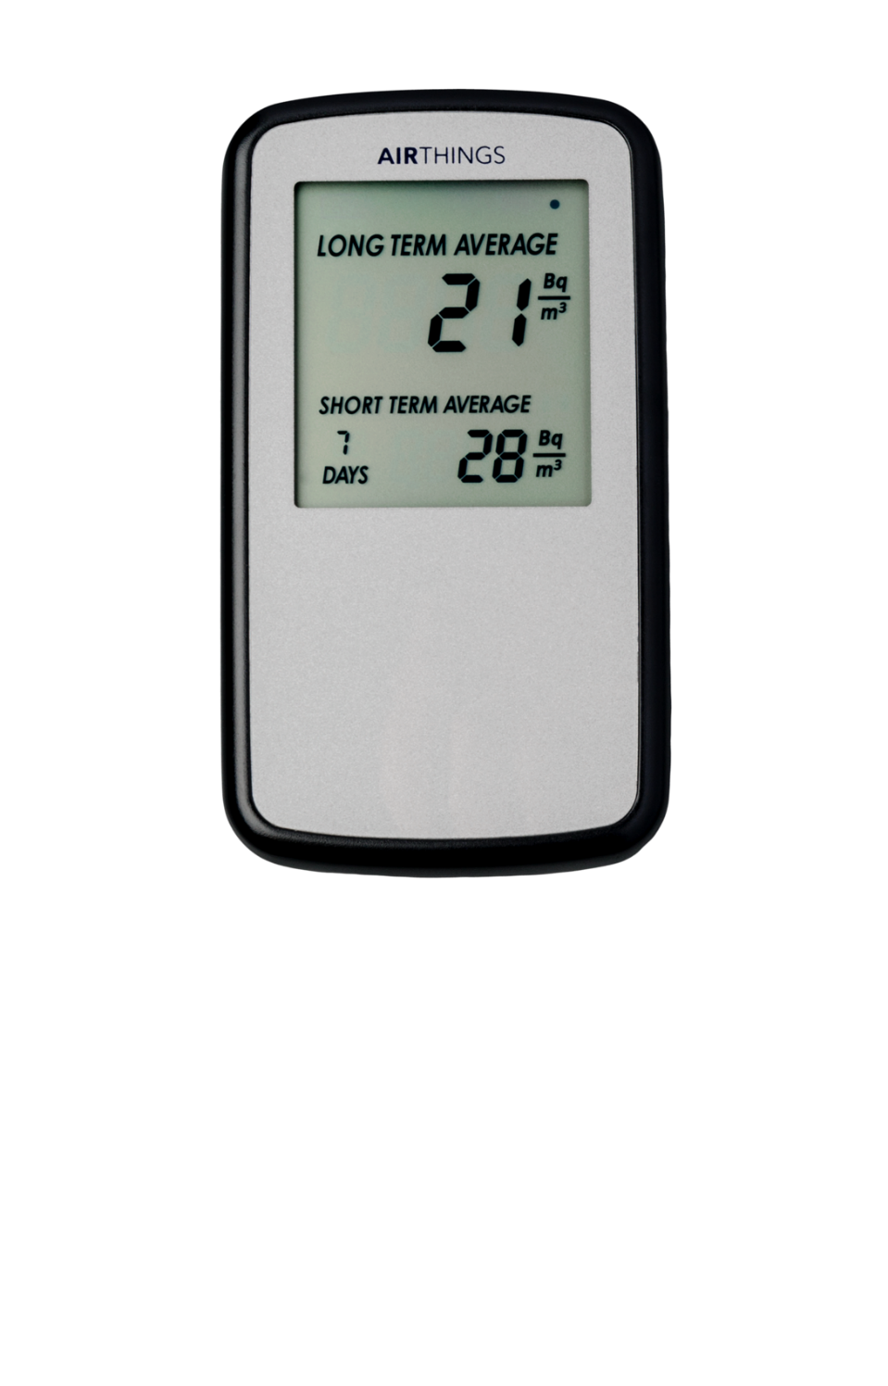

Figure 1: The front of the meter

The meter will arrive turned on and monitoring. In order to take a measurement:

1. Place the meter in the room to be measured.
2. The meter will automatically calculate a 1 day, 7 day and long term average of measurements. The long term average is displayed continuously while the 1 day and 7 day averages alternate on the display.
   1. The 1 day measurement can be highly variable and must be regarded as only an indication of the radon level. It is calculated each hour.
   2. The 7 day average is the most relevant for this use case. It is recalculated once each day.
   3. The long term average is an average of all measurements taken since the meter was switched on and is not relevant in this situation.
3. Once the meter has been in place for 7 days record the 7 day average. The meter may now be placed in a different room or returned to ARPANSA.

## Meter placement

The meter should be placed in a representative position in the room undergoing monitoring and left in position in a room for at least 7 days in order to give an accurate measurement. It should not be moved during a measurement. For smaller rooms a single measurement will be sufficient but in larger rooms a second measurement in a different location may assist in obtaining a representative result. The meter will give the most accurate results if placed between 0.5 m and 1.5 m high in the approximate centre of the room. The meter should not be exposed to direct sunlight or moisture. Avoid placing the meter near the following items as they may alter the measured concentration:

* Granite benchtops
* Brick or stone walls
* Ventilation ducts, air conditioners or fans
* Open windows

## Results

After 7 days the meter will give an average radon concentration for the room. Should you wish to obtain advice on the measurements you have taken please contact the ARPANSA Talk to a Scientist team:

**phone:** 1800 022 333, Tuesday and Thursday 11:00 am to 12:30 pm in Melbourne

**email:** [info@arpansa.gov.au](mailto:info@arpansa.gov.au)

Radon concentrations in Australian homes are typically less than 20 Bq·m-3. This is lower than in many other countries. ARPANSA recommends implementing protective measures to control radon in homes when the radon concentration exceeds the derived reference level of 200·Bq m-3 averaged over a year. If the radon concentration measured is over 200 Bq·m-3 please contact ARPANSA at your earliest convenience to discuss remediation options.

The measured radon concentration is accurate for the measured time period; however, it is possible for the radon concentration to vary over both long and short time periods. This variation can be caused by changes in ventilation, seasonal changes or modification to the building. Generally seasonal variation in Australia is small, but changes to ventilation or building modification may cause significant changes in radon concentration. In the event of significant changes which could affect radon levels ARPANSA recommends that the radon concentration is remeasured.

## Additional information

Further information about radon is available from the ARPANSA website at <https://www.arpansa.gov.au/understanding-radiation/radiation-sources/more-radiation-sources/radon>

Information on typical radon levels in Australia is available from the national radon map at <https://www.arpansa.gov.au/understanding-radiation/radiation-sources/more-radiation-sources/radon-map>

If you have any other questions or problems using the meter please contact the ARPANSA Talk to a Scientist team:

**phone:** 1800 022 333, Tuesday and Thursday 11:00 am to 12:30 pm in Melbourne

**email:** info@arpansa.gov.au