ARPANSA National Diagnostic Reference Level Survey User Guide

  - Version 1.4, March 2019
© Commonwealth of Australia 2019
This publication is protected by copyright. Copyright (and any other intellectual property rights, if any) in this publication is owned by the Commonwealth of Australia as represented by the Australian Radiation Protection and Nuclear Safety Agency (ARPANSA).



Creative Commons

With the exception of the Commonwealth Coat of Arms, any ARPANSA logos and any content that is marked as being third party material, this publication, National Diagnostic Reference Level Survey User Manual, by the Australian Radiation Protection and Nuclear Safety Agency is licensed under a Creative Commons Attribution 3.0 Australia licence (to view a copy of the licence, visit http://creativecommons.org/licenses/by/3.0/au). It is a further condition of the licence that any numerical data referred to in this publication may not be changed. To the extent that copyright subsists in a third party, permission will be required from the third party to reuse the material.

In essence, you are free to copy, communicate and adapt the material as long as you attribute the work to ARPANSA and abide by the other licence terms. The works are to be attributed to the Commonwealth as follows:

“© Commonwealth of Australia 2016, as represented by the Australian Radiation Protection and Nuclear Safety Agency (ARPANSA)”

The publication should be attributed as: National Diagnostic Reference Level Survey User Manual.

Use of the Coat of Arms

The terms under which the Coat of Arms can be used are detailed on the It's an Honour website (www.itsanhonour.gov.au/coat-arms/index.cfm).

Enquiries regarding the licence and any use of this report are welcome.

ARPANSA
619 Lower Plenty Road
YALLAMBIE VIC 3085
Tel: 1800 022 333 (Freecall) or +61 3 9433 2211
Email: info@arpansa.gov.au
Website: www.arpansa.gov.au

All care has been taken in the preparation of this work and its conclusions. However, where the data or results presented are utilised by third parties, the Commonwealth of Australia shall not be liable for any special, indirect, consequential or other damages whatsoever resulting from such use. Nor will the Commonwealth of Australia be liable for any damages arising from or in connection with any errors or omissions that have inadvertently occurred in this work.
  - Acknowledgement of Country
ARPANSA proudly acknowledges Australia’s Aboriginal and Torres Strait Islander community and their rich culture and pays respect to their Elders past and present. We acknowledge Aboriginal and Torres Strait Islander peoples as Australia’s first peoples and as the Traditional Owners and custodians of the land and water on which we rely.

1 Introduction 5
1.1 Purpose of the Australian National Diagnostic Reference Level Survey 5
1.2 Definition of Diagnostic Reference Levels 5
1.3 Participants 5
1.4 Survey Format 5
1.5 Collected Data 6
1.6 Feedback Provided To Participating Facilities 7
1.7 Browser Compatibility 7
2 Registration Process 8
2.1 Introduction 8
2.2 Information Collected in the Registration Process 8
2.3 Specifics of information collected 8
2.4 How to Register 10
2.5 CT Scanner not Listed 15
3 Logging In 18
3.1 Introduction 18
3.2 First LogIn 18
4 Updating details 22
4.1 Introduction 22
4.2 Updating Details 22
5 Completing a survey 30
5.1 Introduction 30
5.2 Survey categories 30
5.3 Information collected in a survey 30
5.4 Navigating to the survey page 31
5.5 Starting a new survey 33
5.6 Continuing a Survey 40
5.7 What happens when you submit a survey? 42
6 Facility Reports 44
6.1 What are the Facility Reports? 44
6.2 How to access Facility reports 44
6.3 A Guide to Your Facility Report 46
7 Managing multiple facilities 52
7.1 Introduction 52
7.2 Registering a new network 52
7.3 Manage Facilities Section 52
8 Contact Us 56
8.1 If you are logged in 56
8.2 If you are not logged in 57
Appendix A Protocol Scan Margins 59
Head ……………………………………………………………………………………………………………………………………………….59
Soft-Tissue Neck 60
Cervical Spine 61
Chest ……………………………………………………………………………………………………………………………………………….62
Abdomen-Pelvis 63
Kidney-Uereter-Bladder 64
Chest-Abdomed-Pelvis 65
Lumbar Spine 66
Appendix B Scan Settings Technical Information 67
Appendix C Patient Data Information 71
Appendix D Glossary of Terms 72

Introduction

Purpose of the Australian National Diagnostic Reference Level Survey
The purpose of the Australian National Diagnostic Reference Level Survey is to gather data that will be used to update National Diagnostic Reference Levels for common CT imaging procedures.
The survey is being conducted by the Australian Radiation Protection and Nuclear Safety Agency (ARPANSA), in consultation with various stakeholders. These stakeholders include:
- Royal Australian and New Zealand College of Radiology (RANZCR)
- Australian Society of Medical Imaging and Radiation Therapy ( ASMIRT, formerly AIR)
- Australasian College of Physical Scientists and Engineers in Medicine (ACPSEM)
- Australian and New Zealand Society of Nuclear Medicine (ANZSNM)
- Department of Health (DoH)
- State and Territory Regulators

Definition of Diagnostic Reference Levels
A diagnostic reference level is a form of investigation level used as a tool to aid in optimisation of protection in the medical exposure of patients for diagnostic and interventional procedures. It is used in medical imaging with ionising radiation to indicate whether, in routine conditions, the amount of radiation used for a specified procedure is unusually high or low for that procedure¹.
The objective of a diagnostic reference level is to help avoid radiation dose to patient that does not contribute to the clinical purpose of a medical imaging task².
A Diagnostic Reference Level is not a dose constraint. It should be applied with flexibility, to allow higher doses where indicated by sound clinical judgment¹.
1. ICRP Publication 135: Diagnostic Reference Levels in Medical Imaging, Ann. 46 No. 1, 2017
2. ICRP Publication 105: Radiological Protection in Medicine, Ann. 37 No. 6, 2007

Participants
All facilities in Australia that carry out diagnostic CT imaging procedures are invited to participate and all participation is voluntary.

Survey Format
The Australian National Diagnostic Reference Level Survey is an online survey. The survey can be accessed via the ARPANSA web page at https://ndrld.arpansa.gov.au/.
The collection of survey data is entirely online. There are no physical paper mail outs but it is possible to print forms and pages of the survey from the web.
To participate in the survey you must first register your facility online via the website (see Section 2). Once registered you may then access the data entry sections of the survey.

Collected Data
The CT section of the survey asks for data on eight common protocols for three age groups. The three age groups are:
- Baby/Infant (0-4 years)
- Child (5-14 years)
- Adult (15+ years)
The eight protocols are:
- Head
- Cervical spine*
- Soft-Tissue Neck*
- Chest
- Abdomen-Pelvis
- Chest-Abdomen-Pelvis*
- Lumbar Spine*
- Kidney-Ureter-Bladder*
*Indicates a protocol available only for the Adult age group
For more information on the scan margins for each protocol see Appendix A.
For each protocol we require information relating to the protocol settings used as well as basic dose data from between 10 and 20 patients. The following protocol data is required:
- kVp (or average kVp for dual source or kV-switching scans)
- starting or reference mAs
- pitch
- if contrast media was used
- if dose modulation was used
- rotation time
- the number of phases
- if the image was acquired helically or axially
- detector configuration
- if iterative reconstruction was used
- reconstruction slice width
- reconstruction algorithm/kernel
- scan field of view
- beam shaping filter
- noise index (or equivalent)
More specific information on what is required for each of these fields is given in Appendix B.
The survey requires the following data from each patient:
- The average CTDI_{vol} for the examination*
- The total Dose Length Product (DLP) for the examination*
- The patient weight in kg
- The patient age in years (months for baby/infant age group)
- The patient gender
More specific information on what is required for each of these fields is given in Appendix C.
*Information on how to report the CTDI_{vol} and DLP for acquisitions that involve multiple runs (e.g. with and without contrast or Chest-Abdomen-Pelvis scans done in two parts) is given in Appendix C.
Each set of data collected will be used to calculate a Facility Reference Level (FRL) that is specific to the protocol, age group and CT scanner used.
For facilities with more than one scanner at the one location (i.e. same LSPN):
- A facility reference level is defined by the protocol chosen, the age group and the scanner it was acquired on. Therefore an LSPN with multiple scanners could have multiple FRLs for the same age group and protocol. Each individual protocol should then be compared against the Australian National DRL.

Feedback Provided To Participating Facilities
All participating facilities receive reports detailing how their individual Facility Reference Level for each protocol compares with the National Diagnostic Reference Level for that protocol. Reports are generated when each data set is submitted so facilities may complete the survey at their own pace. There is, however, a cut off time for submitting data sets based on the calendar year. After the year-end close-off you will no longer be able to add to your data for that year.
For a detailed explanation of the reports see Section 6.3.

Browser Compatibility
The survey web portal requires Internet Explorer 11 or later or Internet Explorer 10 with compatibility mode turned on. No issues have been found using other recent browsers.
Table of Contents

Registration Process

Introduction
In order to participate in the survey each facility must first register their details. This is to ensure all data submitted is legitimate and to ensure that each participating facility is recognised. For each facility that registers, three user accounts are created. The first account is for a radiologist (or business owner/manager) who has oversight of the facility, the second is for the designated contact person (e.g. the chief radiographer) and the third account is a generic account, which has limited privileges and is administered via the contact/radiologist accounts.

Information Collected in the Registration Process
The registration process involves collection of the following data:
- Facility Details
- Radiologist Details
- CT Scanner Details
- Contact Person Details
Please ensure that you have entered details for all these categories.

Specifics of information collected

Facility Details
Facility Name This should be the name of the facility as registered with Medicare Australia.

Facility LSPN This is the Location Specific Practice Number as registered with Medicare Australia.

Facility Type There are four options for facility type:
        - Public Clinic in a Public Hospital
        - Private Clinic in a Public Hospital
        - Private Clinic in a Private Hospital
        - Private Clinic

Facility Address This should be the address of the facility as registered with Medicare Australia.

Radiologist Details
This refers to the radiologist in charge of the facility or the head of department if your facility is part of a large hospital/organisation.
The mandatory details are:
- Title
- Family Name
- First Name
- Phone (Office)
- Email
Non-mandatory details that can be provided are:
- Phone (mobile)
- Fax

CT Scanner Details
This refers to the CT scanners in use at your facility.
The mandatory details are:
- Scanner Make
- Scanner Model (as defined by the manufacturer)
- Additional Identifier
The ‘Additional Identifier’ field is intended as a tool for you to help differentiate between CT scanners at your facility, particularly if you have more than one CT scanner of the same make and model. What you enter in the ‘Additional Identifier’ field is entirely up to you but we suggest that it reflect the location of the CT scanner, e.g. ‘Emergency CT’, ‘Room 1’ or ‘2nd Floor, East Wing’, etc.
Please note that the ‘Additional Identifier’ field is mandatory even if your facility only has one CT scanner.

Contact Details
This refers to another person at your facility who will, in most instances, manage the survey (for example the chief radiographer, CT supervisor or medical physicist, etc.). It is expected that this person will be the one registering the facility.
The mandatory details required are
- Title
- Family Name
- First Name
- Phone (Office)
- Email
Non-mandatory details that can be provided are
- Occupation (e.g. radiographer, CT supervisor etc.)
- Phone (mobile)
- Fax

How to Register
Visit the webpage https://ndrld.arpansa.gov.au/ and select Register.
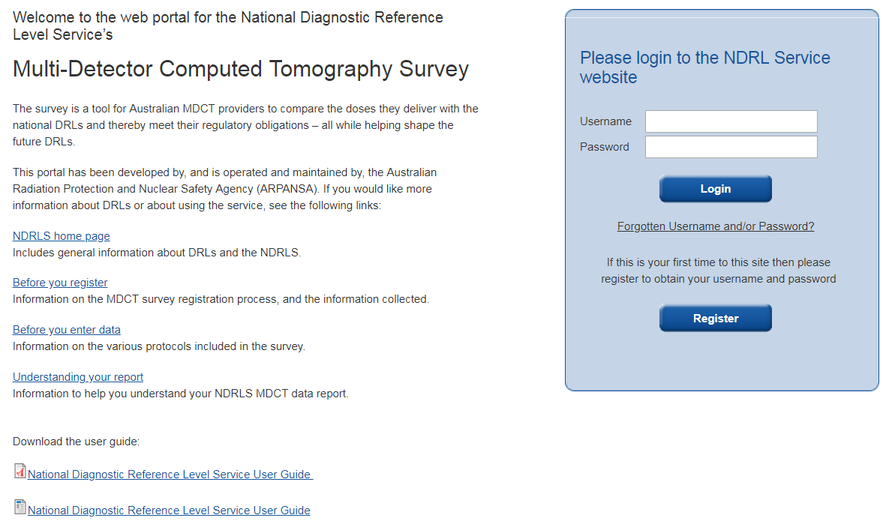
This will take you to the first stage in the registration process, which is the Facility and Radiologist Details.

Facility Details and Radiologist Details
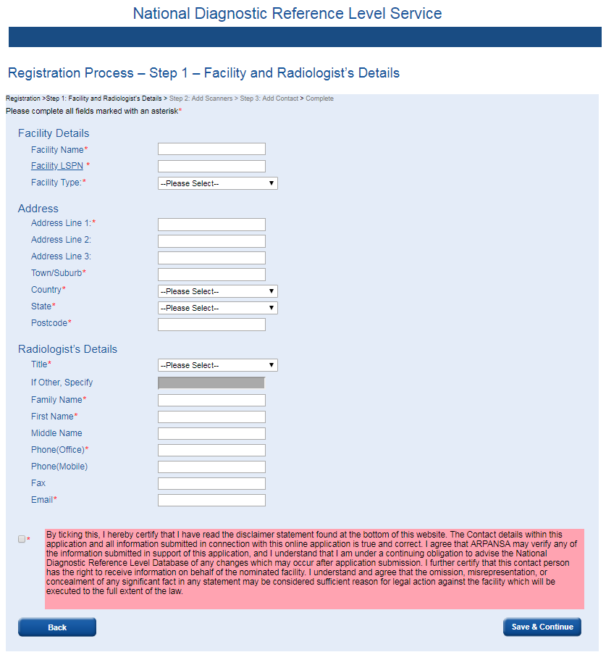
For more information on the specifics of any mandatory fields see Section 2.3.1 and Section 2.3.2.
Once you have filled in all fields marked with an * and checked the disclaimer box, selecting Save & Continue will take you to the ‘Registration Step 1 Complete’ Page. Note this does not mean registration is complete; there are still the scanner details and contact details to enter.
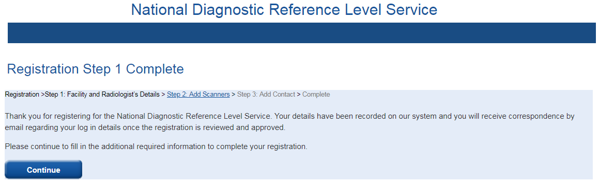
At this stage your facility and radiologist details will be sent to the survey administrators, once these details have been confirmed as valid the radiologist will be sent an email listing a username and temporary password.
If you close the window at this stage, only the radiologist will be able to login and complete the registration process (after their details have been approved and they receive a username and temporary password). We recommend that you select Continue to proceed through the remainder of the registration process.
The next step in the registration process is the ‘Add MDCT Scanner Details’.

MDCT Scanner Details
In this section you are required to give information on the make and model of each CT scanner at your facility.
To add a scanner you should select the make and model of the scanner from the drop down lists, fill in the ‘Additional Identifier’ field, then select Add This Scanner.
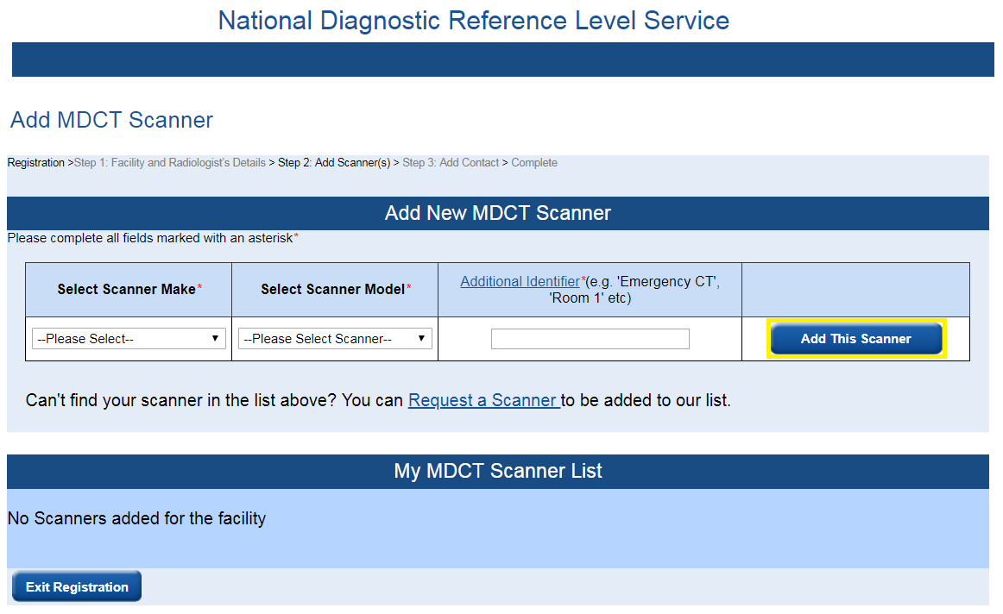
For more information on the ‘Additional Identifier’ please see Section 2.3.3.
Once you have added a CT scanner it will appear under ‘My MDCT Scanner List’.
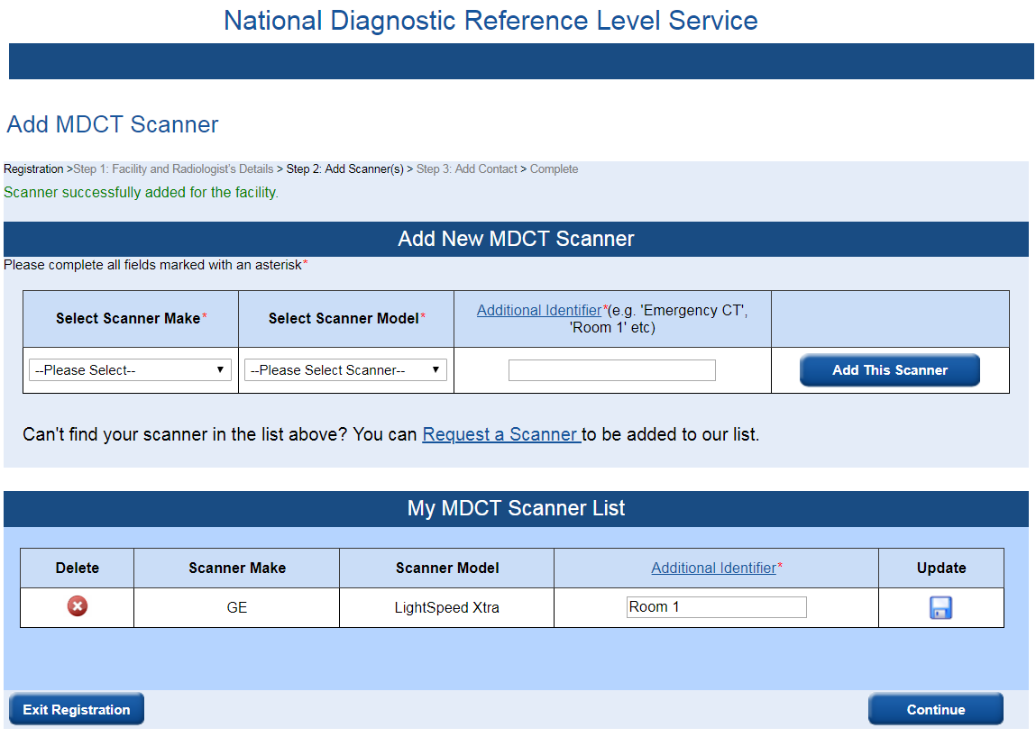

To delete a CT scanner from this list you select the next to the scanner you wish to delete. To alter the ‘Additional Identifier’ for a scanner you should alter the text in the field then select to save your changes.
If a CT scanner at your facility is not in the drop down lists you can select ‘--Can’t find my Scanner Make/Model--’ from either the ‘Make’ or ‘Model’ drop down lists or you can click Request a Scanner (see Section 2.5 for more details).
Once you have listed all the CT Scanners at your facility you should select Continue. By selecting Exit Registration the data entered will be saved but you will be logged out of the registration process. Only the Radiologist will be able to login and complete the registration process. We recommend that you select Continue to proceed through the remainder of the registration process.
This will take you to the final part of the registration process, which is Add Contact Details.

Contact Person Details
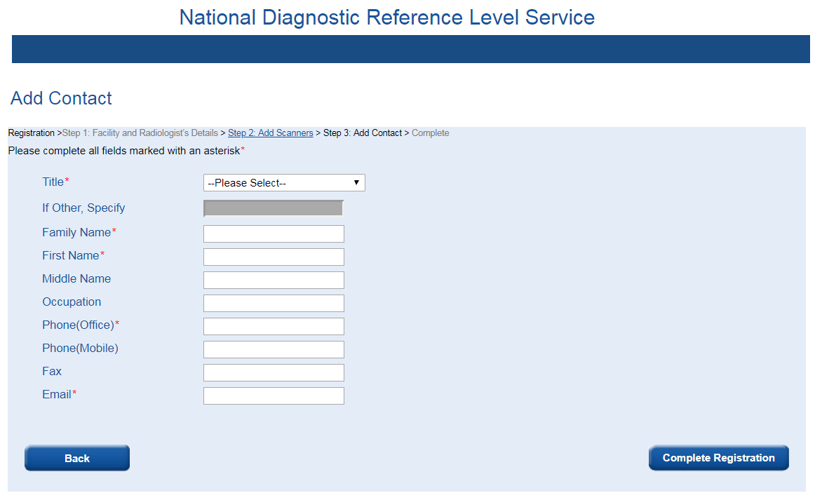
For more information on the specifics of any mandatory field see Section 2.3.4.
Once you have filled in all fields marked with an * you should select Complete Registration.
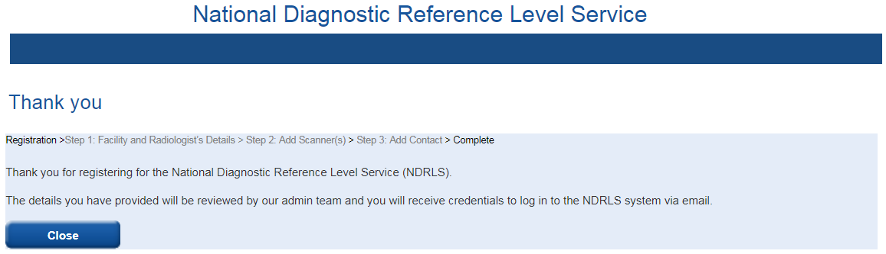
This completes the registration process. Once the details you have submitted have been checked by a survey administrator, a username and temporary password will be emailed to the Radiologist and Contact Person within five working days. These usernames and temporary passwords can then be used to login from the Login page.
Selecting Close will close the webpage.
By selecting Back in the Add Contact page, you will return to the CT Scanner Details Page and none of the data you entered for the contact person will be saved.

CT Scanner not Listed
The survey administrators have tried to ensure that all CT scanners currently in use in Australia are listed in the drop down boxes. The CT scanners in the drop down lists are worded as defined by the manufacturer so please check the wording carefully.
If a CT scanner at your facility is not in the drop down lists you can select ‘--Can’t find my Scanner Make/Model--’ from either the ‘Make’ or ‘Model’ drop down lists or you can click Request a Scanner.
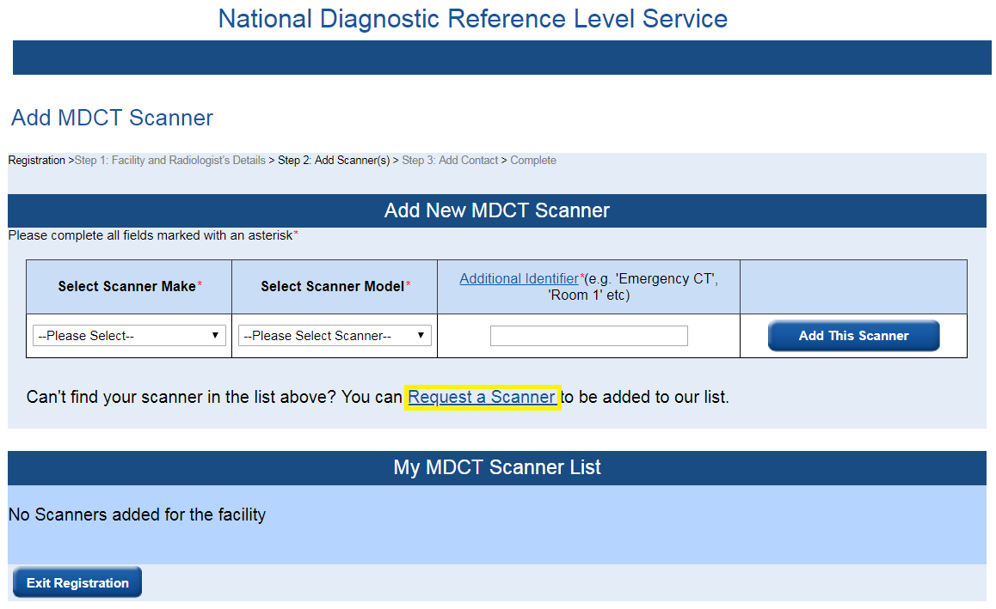
This will take you to the Request Scanner page.
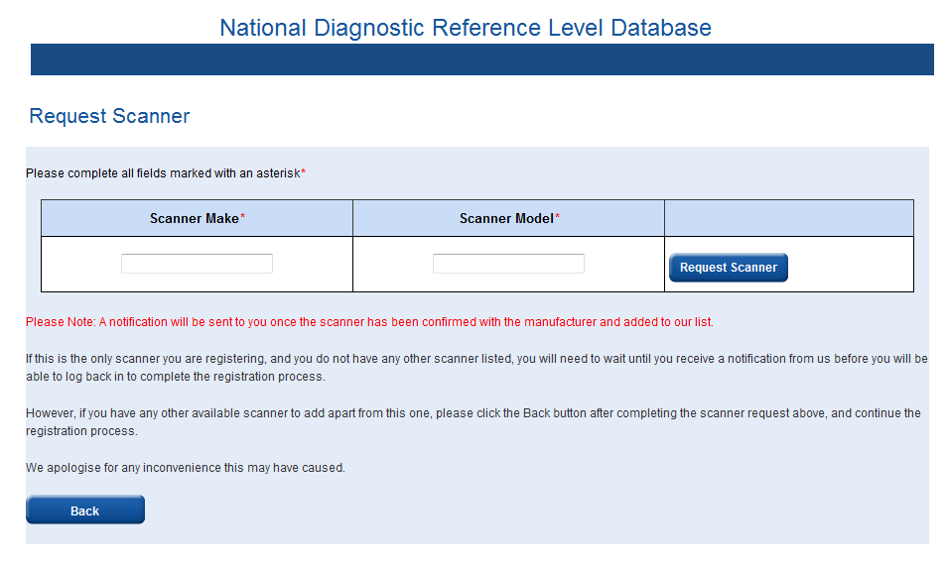
On this page there are two fields where you can type in the make and model of your scanner. Once you have filled in both fields you should select Request Scanner and a notification will be sent to the survey administrators:
- If you are requesting a CT scanner during the registration process and this is the only scanner you are registering and you do not have any other CT scanners listed, you cannot complete the registration process at this time. You should select Back, then select Exit Registration on the ‘CT Scanner Details’ page.
- The Radiologist will receive notification from the survey administrator via email once the CT scanner has been added to the system. Once the Radiologist has received this notification they will be able to login and complete the registration process.
- If you have any other available CT scanners to add apart from this one, please select Back after completing the CT Scanner request above, and continue the registration process.
- If you have already completed the registration process and are adding another CT scanner you should select Back or use the menu items on the left hand side of the screen to navigate to another page.
Table of Contents

Logging In

Introduction
To access the survey you are required to login with a username and password. This is to ensure that all data submitted is legitimate, that each participating facility is recognised and that the data for your site can only be accessed by authorised persons.

First LogIn
Once you have been issued with a username and temporary password you will be able to use these to login to the system from the Login page.
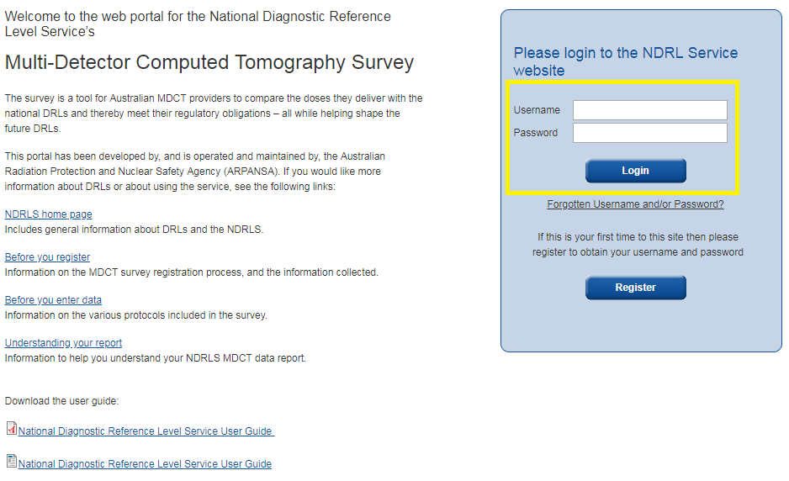
On your first log in you will be required to change your temporary password.
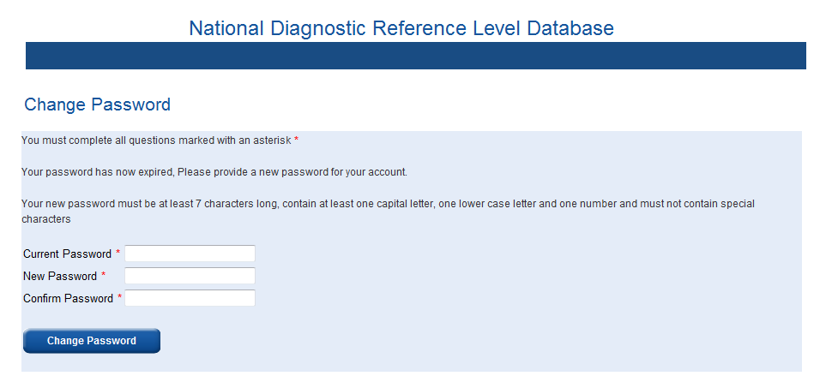
When changing your password you must choose a new password that:
- is at least seven characters long
- contains at least one capital letter
- contains at least one number
Once you have filled in all fields marked with a * correctly you should select Change Password and you will be notified that you have successfully updated your password.
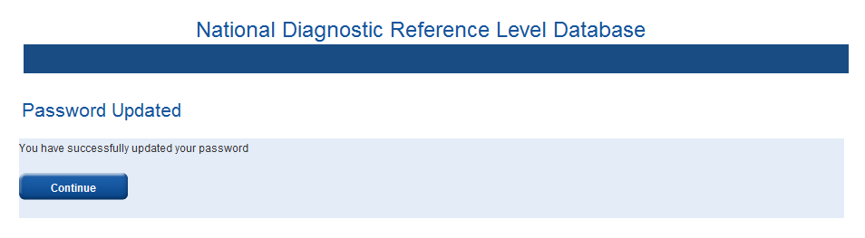
By selecting Continue you will either be prompted to complete the registration process (if you have not already done so) or you will be directed to your facility’s home page.

Generic Login
The first person, i.e. the Radiologist or Contact, to login to the survey will also be asked to set a password for a generic user login. This generic login will only provide access to the survey data entry pages - the generic user cannot update any details or access facility reports.
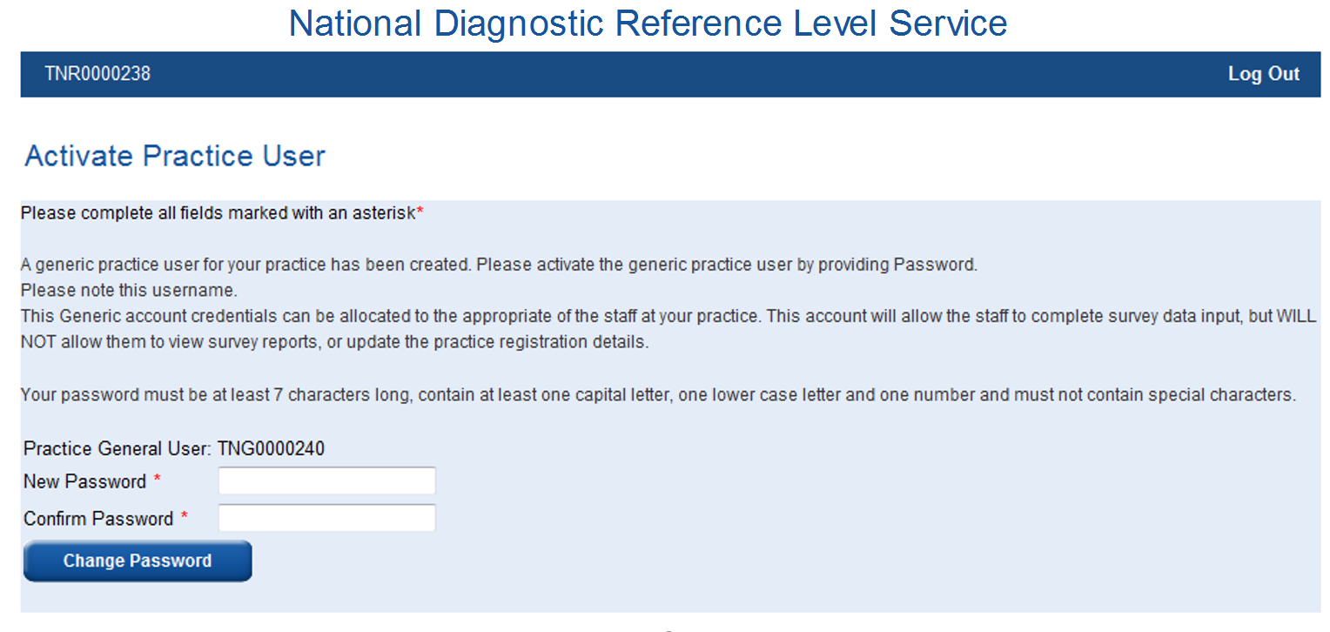
Once you have filled in all fields marked with an * you should select Change Password.

Your Facility Home page
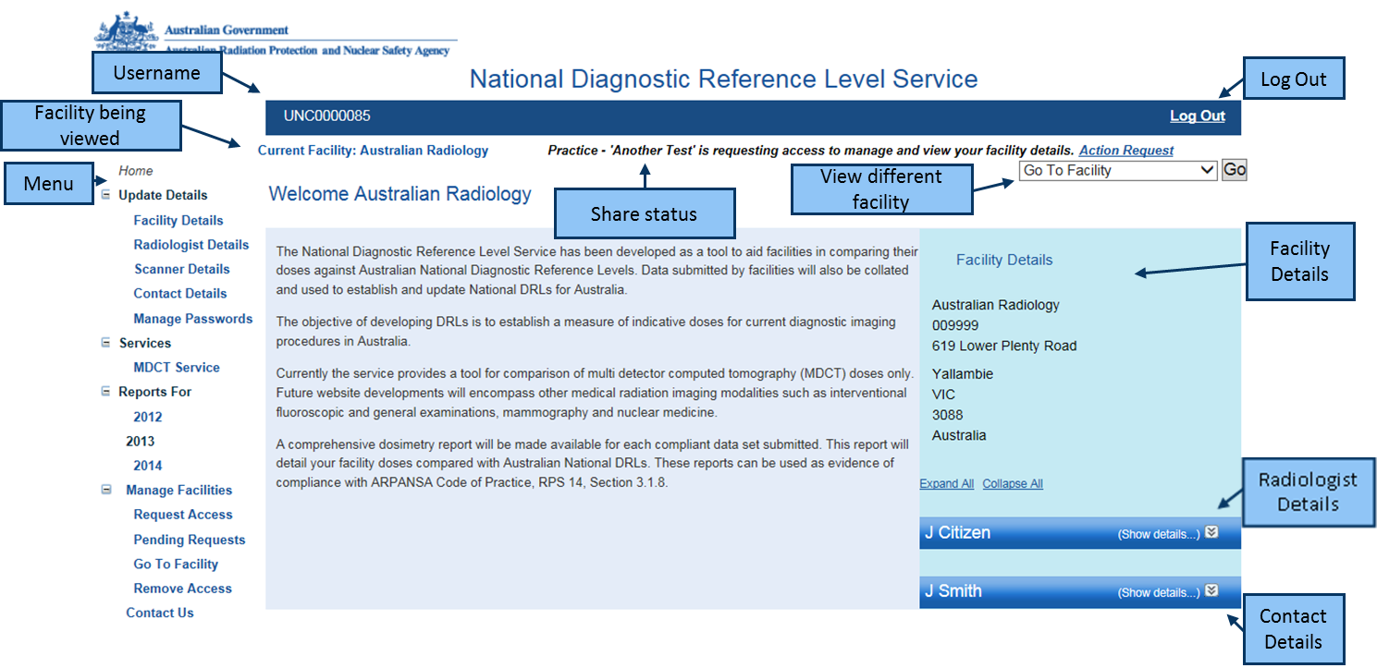
From the survey home page there are a number of menu options on the left hand side of the page, these are :
- Home
- Update Details
- Services
- Reports For
- Manage Facilities
- Contact Us
On the right hand side of the page are your Facility details as well as the details of the Radiologist and Contact. In the upper left side of the screen your username is displayed and in the upper right hand side of the screen there is an option to Log Out.
The facility being viewed, share status, ‘Manage Facilities’ and ‘Go To Facility’ areas of the home page are only relevant if your facility is part of an imaging network that shares data between its members. For information on sharing data between sites, refer to Section 7.
Table of Contents

Updating details

Introduction
The details you submit in the initial registration process may not be applicable to your facility in the future. The ‘Update Details’ option allows you to update certain parts of your registration details as it becomes necessary.

Updating Details
All of the details entered during the registration process can be updated at any time. Please note that updating the facility LSPN may require you to register as a new facility.
To update any of your details simply select the details you wish to update from the menu on the left hand side of the screen. You may select to update
- Facility details
- Radiologist details
- Scanner details
- Contact details
- Passwords
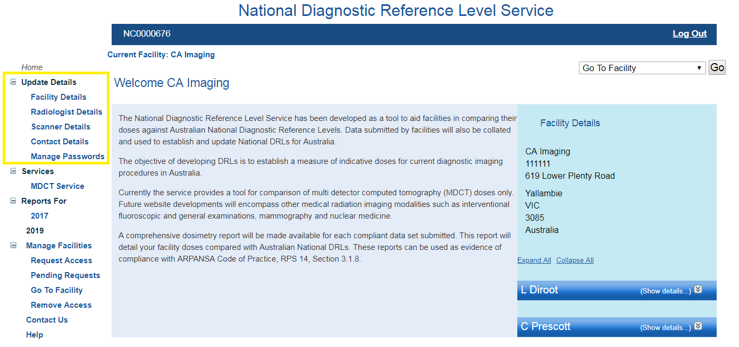

Update Facility Details
If you selected ‘Facility Details’ you will be taken to the Facility Details Page.
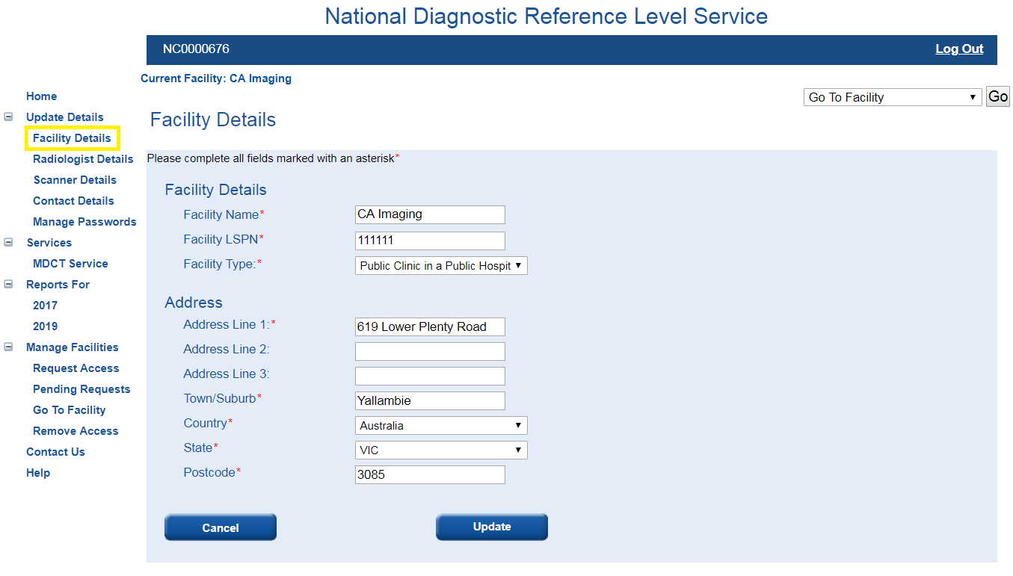
All fields on the page will be pre-filled with your current details, to change any details simply delete the fields that have been pre-filled and enter your new details.
Once you are happy with the changes you should select Update.
Any changes you make will need to be approved by a survey administrator before they are saved to the database. This should take no longer than five working days and you will be able to continue to access the survey during this time.
Please note changing your facility address or LSPN may require you to register as a new facility.
If you select Cancel you will be asked if you wish to discard any changes you have made and you will return to the survey home page.

Update Radiologist Details
If you selected ‘Radiologist Details’ you will be taken to the Radiologist Details Page.
- If you used the Radiologist login you will see the following screen.
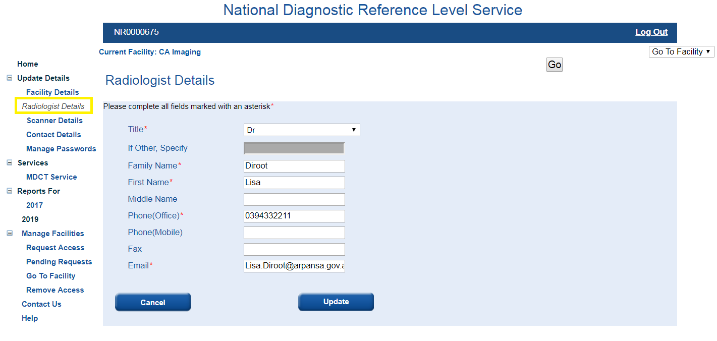
All fields on the page will be pre-filled with your current details, to change any details simply delete the fields that have been pre-filled and enter your new details.
Once you are happy with the changes you should select Update, and you will be notified that the ‘Request to update radiologist details has been submitted and is pending approval’. The updates made will be checked by a survey administrator and if they are not approved you will be notified by email. This should take no longer than five working days and you will be able to continue to access the survey during this time.
- If you used the Contact login you will see the following screen.

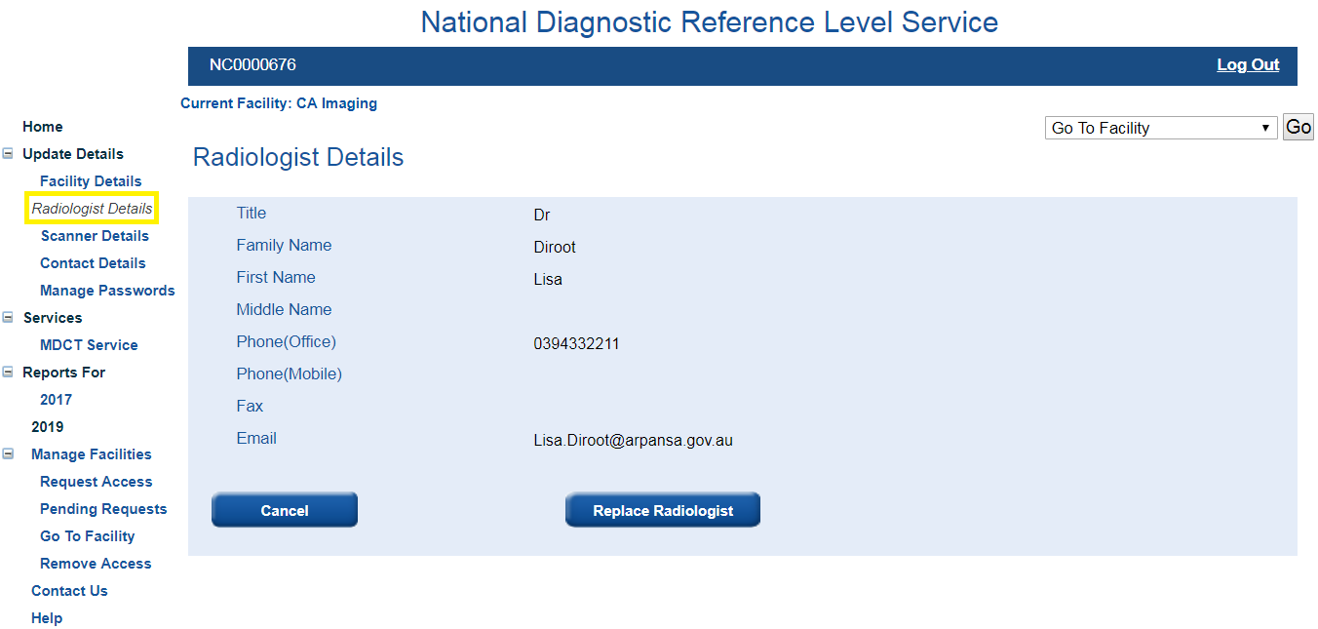

To make a change to any field you must first select Replace Radiologist, which will take you to the Replace Radiologist page. Please note that replacing the Radiologist will render the username and password for the previous Radiologist invalid. A new username and temporary password will be emailed to the new Radiologist within five working days.
If you only wish to change the title, phone, fax or email of the Radiologist then you should have the Radiologist log in using their own account and update their details themselves.
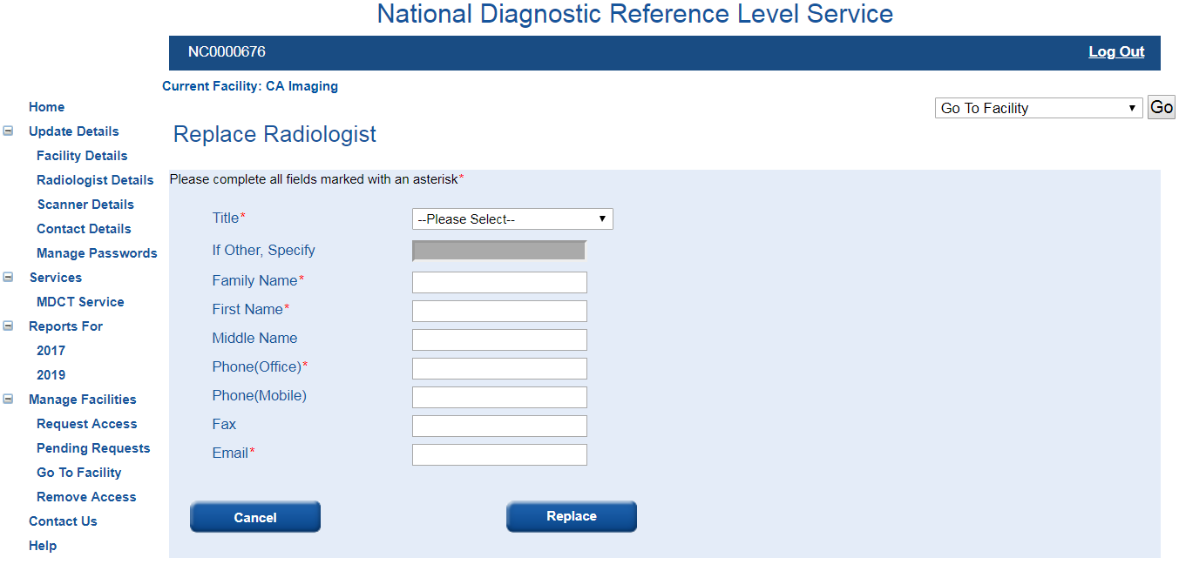

Once you have filled in all fields marked with an * you should select Replace, and you will be notified that ‘A request to replace this radiologist has been submitted and is pending approval’. Once this has been approved by a survey administrator it will be saved to the database. This should take no longer than five working days and you will be able to continue to access the survey during this time.
If you select Cancel you will be asked if you wish to discard any changes you have made and you will return to the survey home page.

Update Scanner Details
If you selected ‘Scanner Details’ you will be taken to the Facility MDCT Scanners Page.
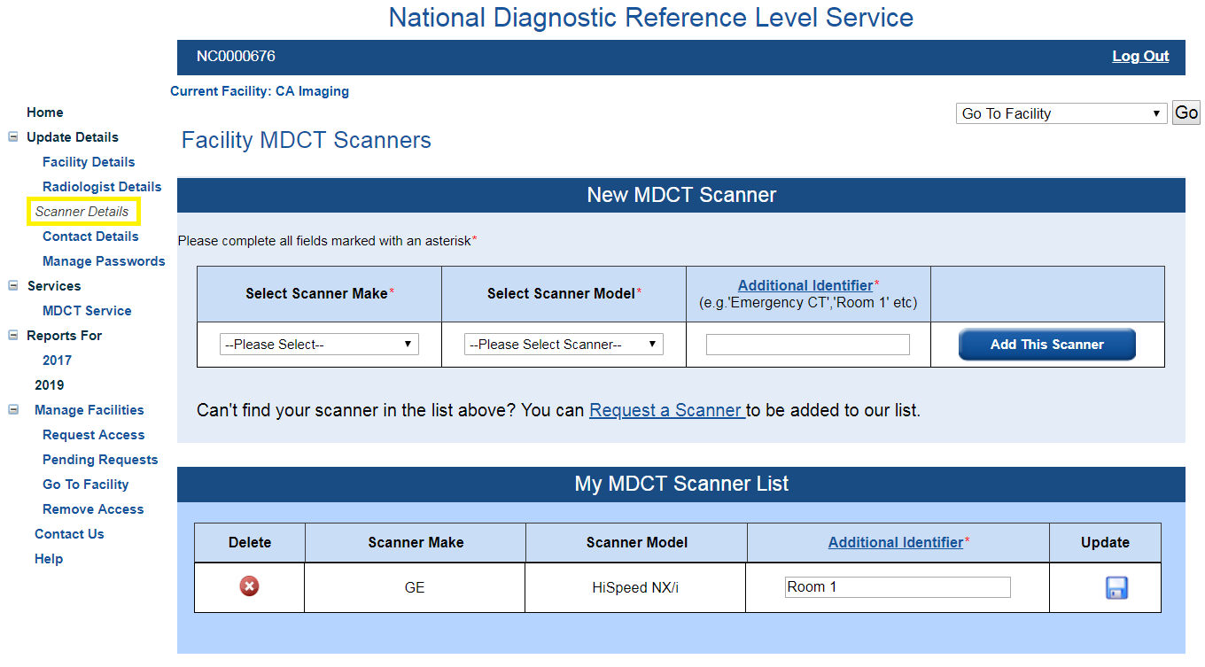
The CT scanners you have already listed will appear under the title ‘My MDCT Scanner List’.
If you wish to add a new scanner you should select the make and model of the scanner from the drop down lists, fill in the Additional Identifier field then select Add This Scanner. For more information on Additional Identifiers see Section 2.3.3.
To delete a CT scanner from this list you select the next to the CT scanner you wish to delete. To alter the ‘Additional Identifier’ for a CT scanner you should alter the text in the field then select  to save your changes.
If a CT scanner at your facility is not in the drop down lists you can select ‘--Can’t find my Scanner Make/Model--’ from either the ‘Make’ or ‘Model’ drop down lists or you can click Request a Scanner (see Section 2.5 for more details).
Once you have made all the desired changes you should select Back to Home.

Update Contact Person Details
If you selected ‘Contact Person Details’ you will be taken to the Contact Details Page.
- If you used the Radiologist login you will see the following screen.
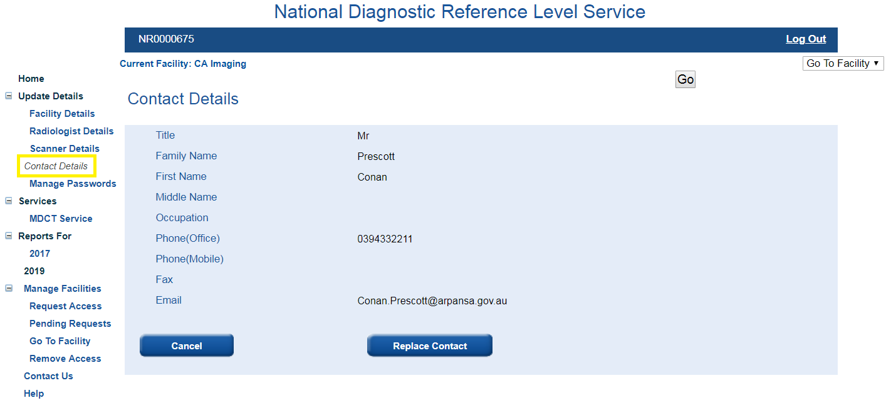
To make a change to any field you must first select Replace Contact, which will take you to the Replace Contact page. Please note that replacing the Contact Person will render the username and password for the previous Contact Person invalid. A new username and temporary password will be emailed to the new Contact Person within five working days.
If you only wish to change the title, phone, fax or email of the Contact Person then you should have the Contact Person log in using their own account and update their details themselves.
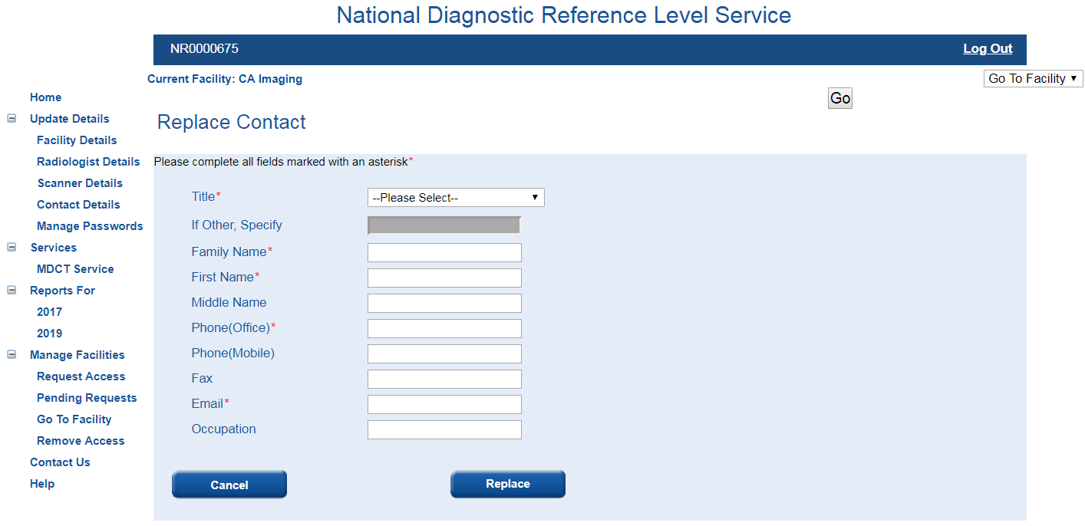
Once you have filled in all fields marked with an * you should select Replace, and you will be notified that ‘A request to replace this contact has been submitted and is pending approval’. Once this has been approved by a survey administrator it will be saved to the database. This should take no longer than five working days and you will be able to continue to access the survey during this time.
If you select Cancel you will be asked if you wish to discard any changes you have made and you will return to the survey home page.
- If you used the Contact login you will see the following screen.
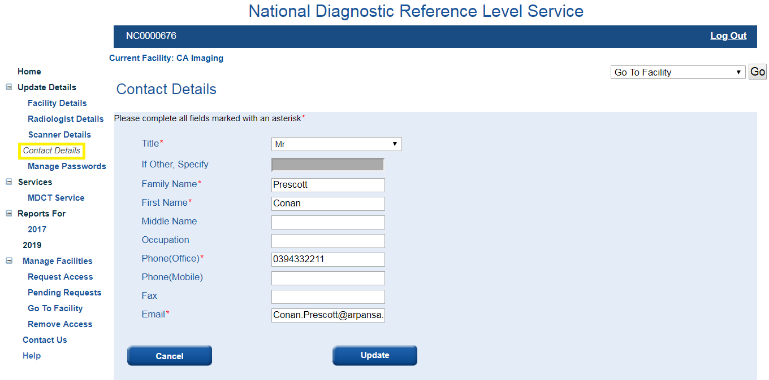
All fields on the page will be pre-filled with your current details. To change any details simply delete the fields that have been pre-filled and enter your new details. Once you are happy with the changes you should select Update, and you will be notified that ‘A request to update contact details has been submitted and is pending approval’.

Manage Password
Both the Radiologist and the Contact can update their own password, their counterpart’s password and the generic user password at any time. Please note that when logging in using the generic username you are not able to update any details including the passwords.
To change a password, select the Manage Passwords section under the ‘Update Details’ menu heading.
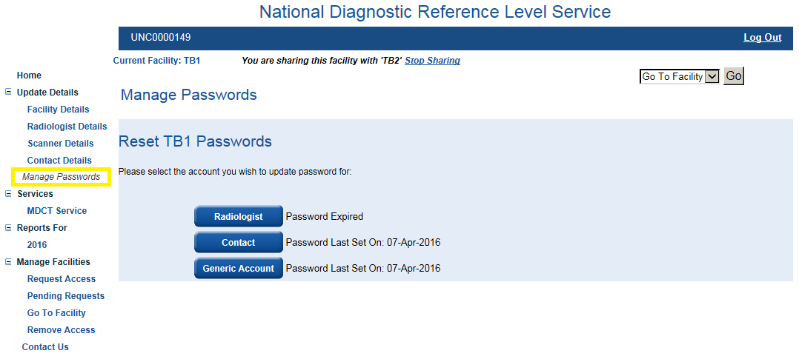
Select the password you wish to alter and you will be taken to a page similar to the following.
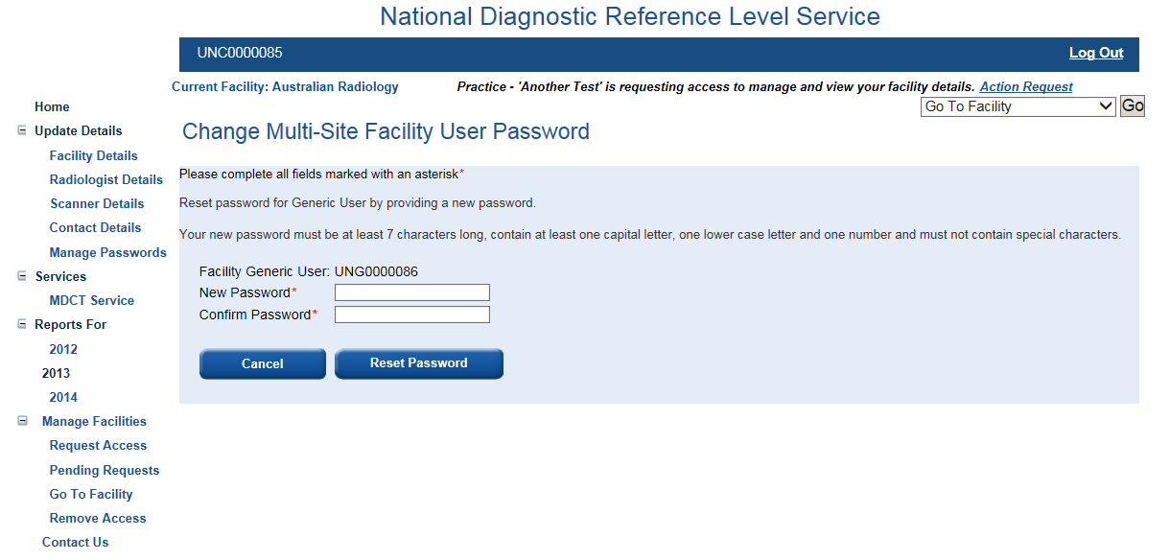
Fill in the two fields marked with an asterisk. The new password should:
- be at least seven characters long
- contains at least one capital letter
- contains at least one number
Once you have filled in all fields marked with an * you should select Change Password, and you will be notified that the ‘Password for your account is updated successfully’.
Table of Contents

Completing a survey

Introduction
Each set of survey data submitted will be added to the national data set from which the Australian National DRLs will be updated. Also, for each survey that you submit you will be provided with a comprehensive dosimetry report detailing the specific protocol doses you entered and a comparison with the corresponding national DRL. This report can be taken as an indication of compliance with the ARPANSA Code of Practice – Radiation Protection in the Medical Applications of Ionizing Radiation, RPS 14, Section 3.1.8(a).

Survey categories
Each new survey you begin must be specified by the age group, protocol and CT scanner used. The three age groups are:
- Baby/Infants (0-4 years)
- Children (5-14 years)
- Adults (15+ years)
The eight protocols are:
- Head
- Soft-Tissue Neck*
- Cervical Spine*
- Chest
- Abdomen-Pelvis
- Chest-Abdomen-Pelvis*
- Lumbar Spine*
- Kidney-Ureter-Bladder*
*Indicates a protocol available only for the Adult age group
For more information on the scan range and indications for each protocol see Appendix A.
The CT scanner used will be a choice of the CT scanners you listed during the registration process.

Information collected in a survey
For each survey you must enter information on the technical scan settings used and data on 10 to 20 patients. The patient data is entirely anonymous; no personal patient information is required.
The scan settings required are:
- kVp (or average kVp for dual source or kV-switching scans)
- mAs (starting or reference mAs)
- pitch (set pitch)
- if contrast media was used (YES/NO)
- if dose modulation was used (YES/NO)
- rotation time (in sec)
- the number of phases (1/2/3/4, etc.)
- how the image was acquired (Helically/Axially)
- detector configuration (number of detector rows and acquisition slice width in mm)
- if iterative reconstruction was used (YES/NO)
- reconstruction slice width (in mm)
- reconstruction algorithm/kernel
- scan field of view (in cm) – not mandatory
- beam shaping filter – not mandatory
- noise index (or equivalent) (numerical) – not mandatory
With the exception of the scan field of view, beam shaping filter and noise index all scan settings data is mandatory and must be filled in before you may enter any patient data.
More specific information on what is required for each of these fields is given in Appendix B.
There is also a comments box below the scan settings in which you can record any other information about the protocol, and/or something relevant to you at the facility to help you differentiate between surveys.
The patient data required is:
- The total Dose Length Product (DLP) in mGy.cm
- The average volume Computed Tomography Dose Index (CTDI_{vol}) in mGy
- The patient weight in kg - (it may be useful to have a set of scales handy)
- The patient age in years (in months for the Baby/Infant age group)
- The patient gender (Male or Female)
More specific information on what is required for each of these fields is given in Appendix C.
A fully complete survey includes data for 20 patients. You may submit a survey with data from between 10 and 19 patient data sets but the statistical confidence of the FRLs calculated will be limited.

Navigating to the survey page
From the survey home page, the list of modalities available for which to complete a survey is listed under the Services menu on the left hand side of the screen.
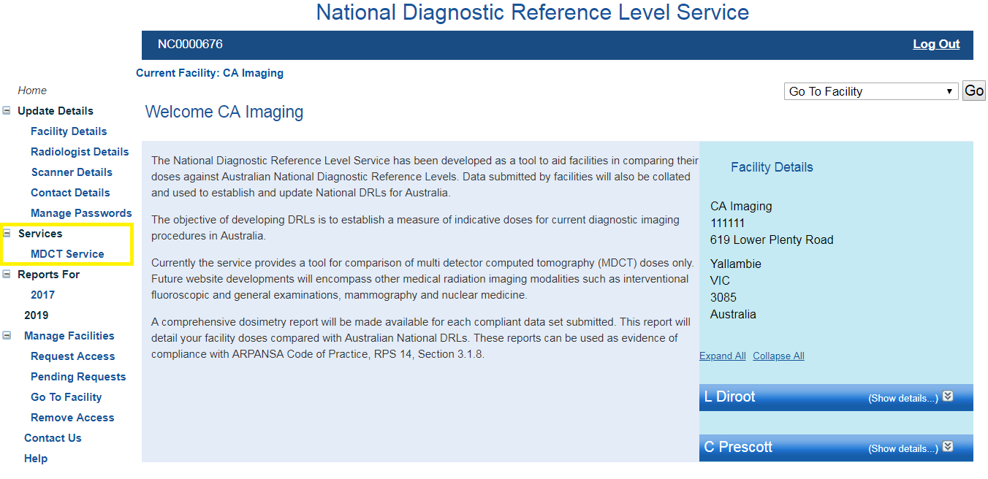
Currently the only survey open is the Multiple Detector Computed Tomography (MDCT) Survey.
By selecting MDCT Service you will be taken to the ‘MDCT Survey’ page.
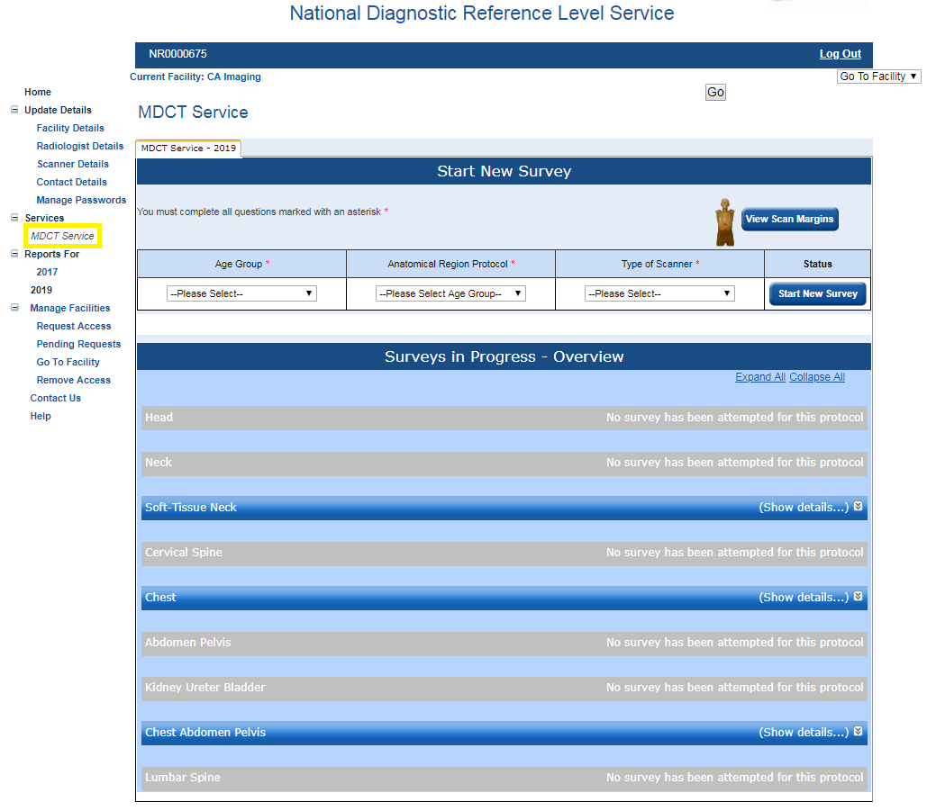
This page is split into two parts ‘Start New Survey’ and ‘Surveys in Progress - Overview’. There is also an option to view the scan margins. From this page you have the option to start a new survey or continue a survey you have started previously.
If you cannot see the ‘Surveys in Progress – Overview’ section in the bottom part of the screen there is a problem with the way your browser renders the page. This can be corrected in older versions of Internet Explorer by turning on Compatibility View. Please contact the NDRL Service at ndrld@arpansa.gov.au if you have this problem with other browsers.

Starting a new survey
To start a new survey you need to select the protocol, CT scanner and age group of the survey you wish to begin from the drop down lists under ‘Start New Survey’ at the top of the page.
There are three age groups:
- Baby/Infant (0-4 years of age)
- Child (5-14 years of age)
- Adult (15+ years of age)
There is a set list of protocols, these are:
- Head
- Cervical spine*
- Soft-Tissue Neck*
- Chest
- Abdomen-Pelvis
- Chest-Abdomen-Pelvis*
- Lumbar Spine*
- Kidney-Ureter-Bladder*
*Indicates a protocol available only if you have selected the Adult age group
The scanner drop down list will be made up only of the scanner/s you listed in the registration process. Once you have selected the Age Group, Protocol and Scanner you should select Start New Survey. This will take you to the data entry page for the survey you have just created.
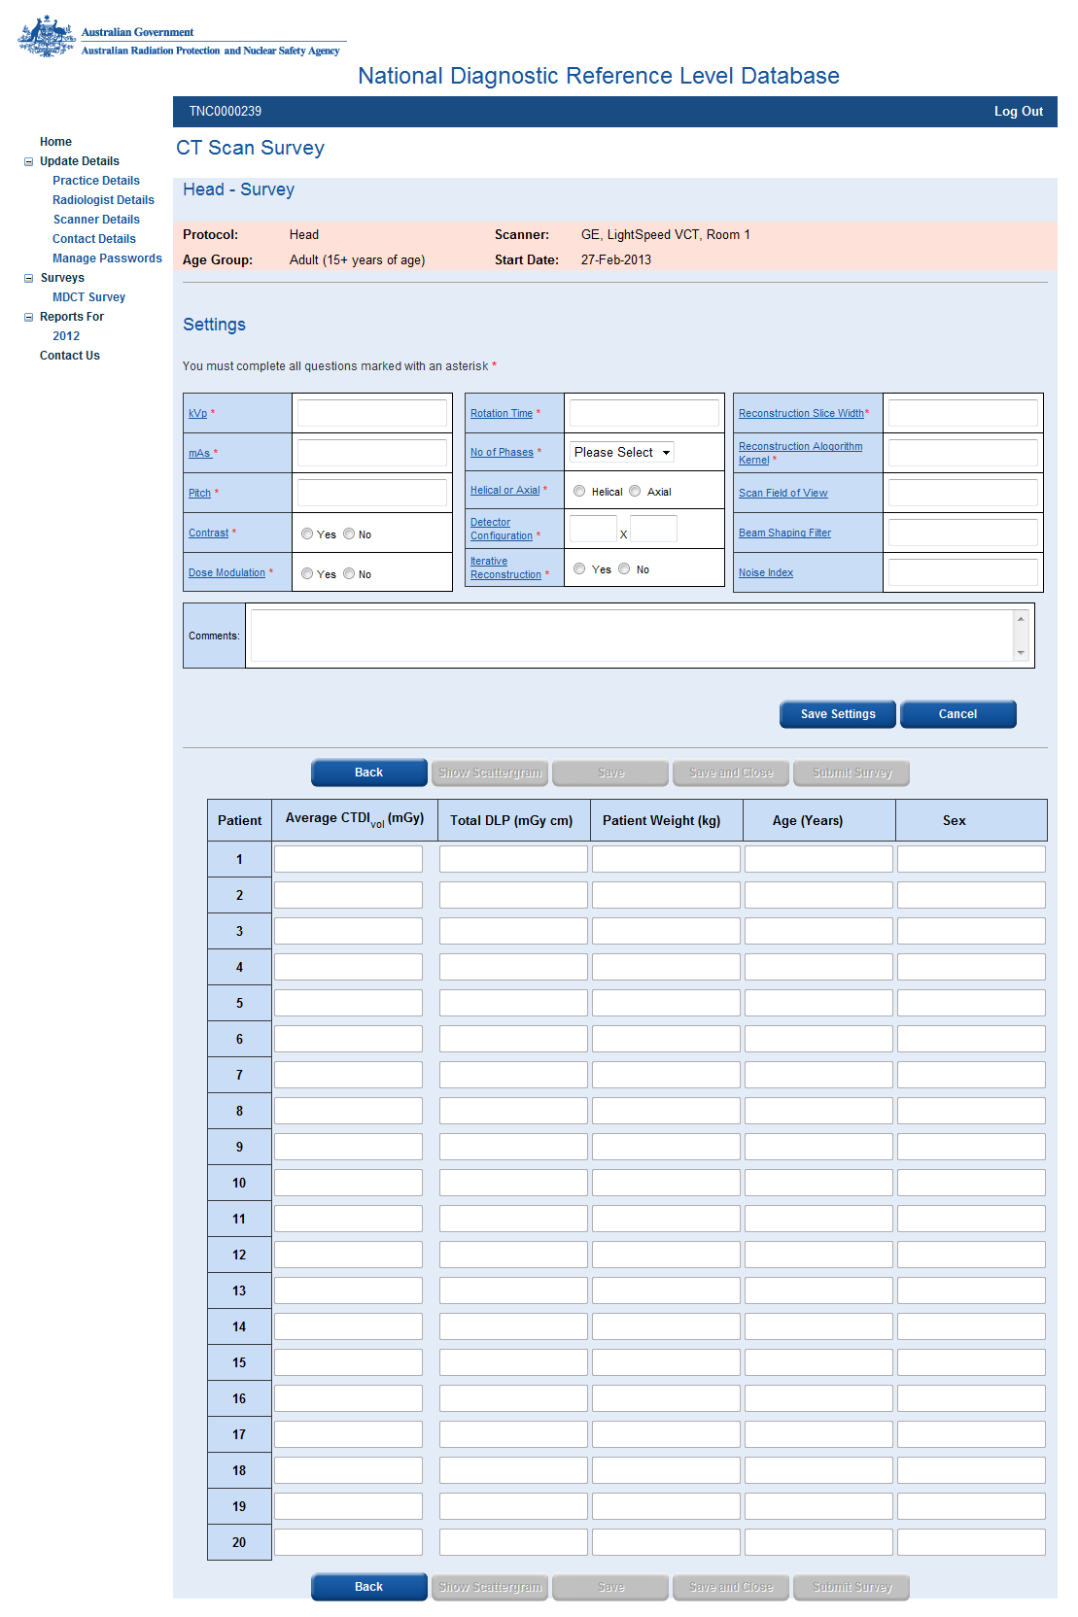
At the top of the page the Protocol, CT Scanner Make, Model and Additional Identifier, Age Group and Start Date of the survey are listed.
Below this are a series of fields relating to the technical settings used to acquire the images. In this section we request the settings used for the general protocol. The 20 sets of patient data from this survey do not have to match all of the settings exactly but they should be close.
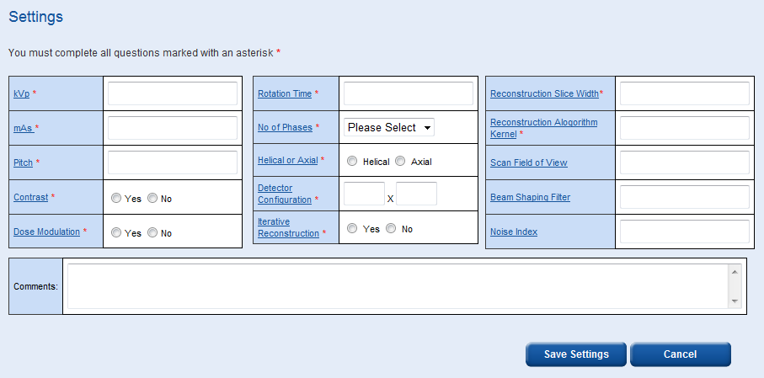
All mandatory fields in this section must be filled out before any patient data can be added to the table below.
For guidance on the information required for each field please see Appendix B. The field titles for each setting parameter are also hyperlinked to a help page.
There is also a comments box below the scan settings in which you can record any other information about the protocol, to better define the specific protocol (e.g. what mAs value was recorded, was it starting, reference, minimum etc.? If it was a survey of paediatric patients was the 16 or 32 cm reference phantom used for DLP and CTDI_{vol} values?) and/or something relevant to you at the facility to help you differentiate between surveys.
When you have filled in all fields marked with an * you should select Save Settings. You will be informed that ‘Proceeding will lock scanner settings, Are you sure you wish to continue?’ By selecting OK the data in the scan settings table will become locked and you will not have another chance to edit it. At this point the patient data entry table will become unlocked.
You can now enter data into the patient data entry table. Also, at the top right of the page there is an option to Print, this will produce a black and white copy of the data entry page on a single A4 page. We recommend recording your patient data on this printed page then entering the full 20 patient data sets electronically in one go.
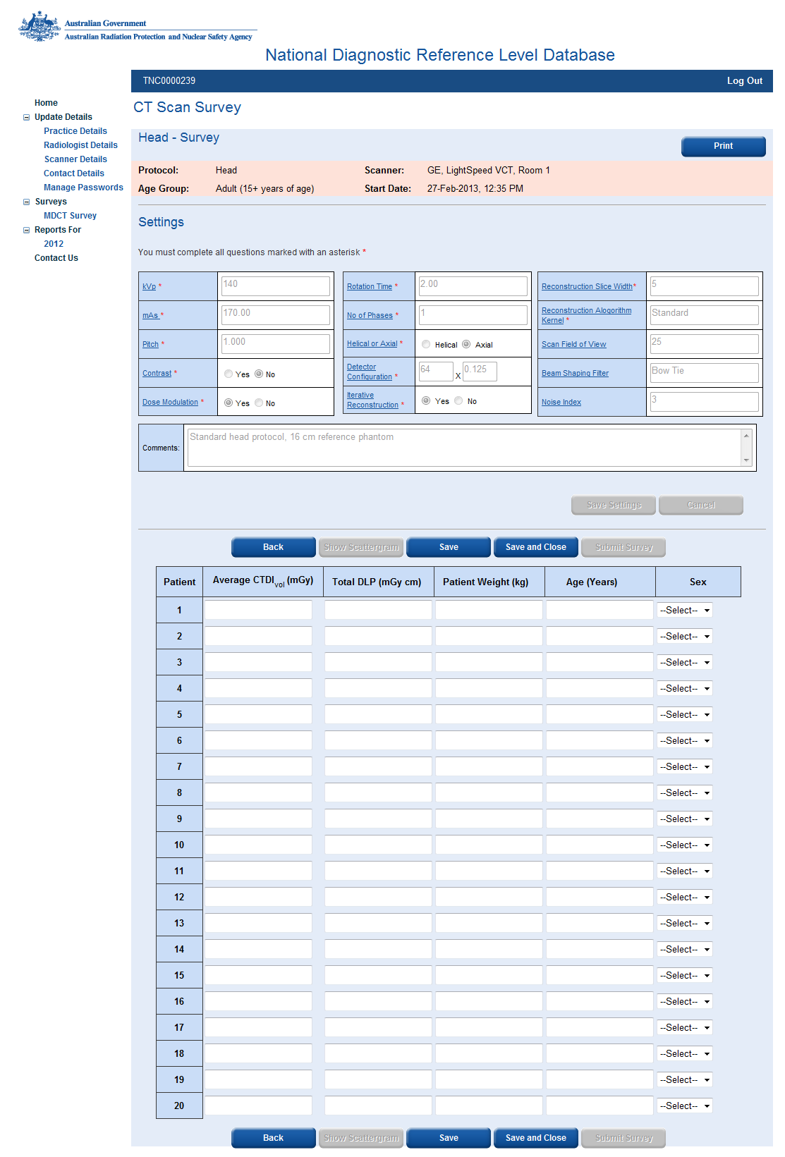
In the patient data entry table you should enter the average CTDI_{vol}, total DLP, patient weight, patient age and sex information you have collected.
There are a number of options you can select once you have entered your data. These are ‘Back’, ‘Show Scattergram’, ‘Save’, ‘Save and Close’ and ‘Submit Survey’.

Save
To save your data at any time you can select Save. Please note that selecting Save will lock any data you have entered in the table and you cannot change any of these data once they are locked.
Please note also that all five fields in the table must be filled in for each patient. If all five fields are not filled in and you select Save, only the data up to the point where the last complete set of five fields is filled in will be saved.
Please note that if you have filled in all 20 data sets and you select Save this will also automatically submit the survey.

Save and Close
If you select Save and Close the data in the patient data table will be saved and you will return to the survey home page. This will also cause the data you have entered to be locked. You may return to this survey and add more data at any time but will not be able to modify the locked data.
Please note that if you have filled in all 20 data sets and you select Save and Close this will also automatically submit the survey.

Show Scattergram
The show scattergram button will only become active when you have entered data for at least 1 patient and saved the data.
By selecting Show Scattergram, a scattergram of the DLP data vs patient number you have entered will be displayed. This will also cause the data you have entered to be locked so that it cannot be changed later.
Please note that if you have filled in all 20 data sets and you select Show Scattergram this will also automatically submit the survey.
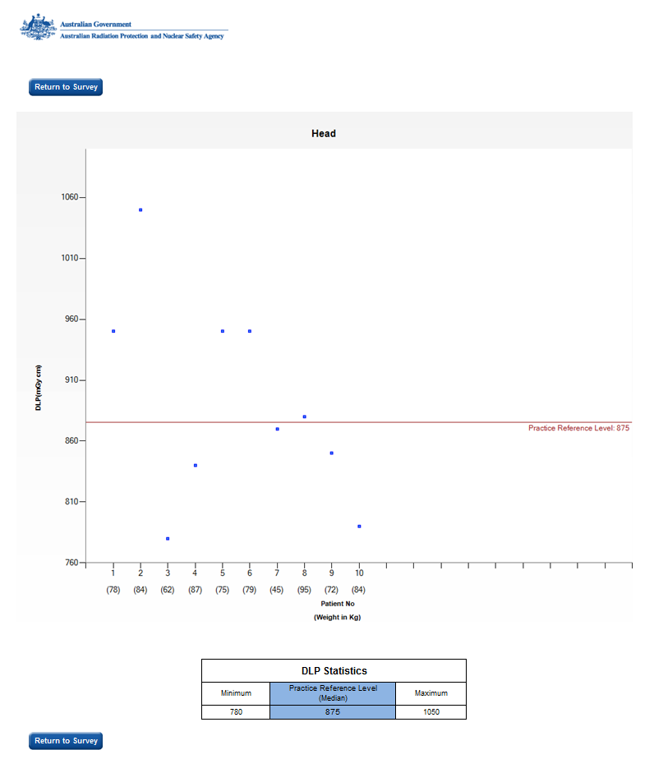
The scattergram is intended to give you a graphical representation of the spread of the DLP values for the patients you have entered. You will also notice that the patient weight is displayed on the x-axis below each patient number in parenthesis.
Also, below the scattergram some brief statistics of your DLP values will be displayed. These include the minimum DLP, maximum DLP and median DLP. To return to the Data Entry page for this survey you should select Return to Survey.

Submit Survey
The Submit Survey button will only become active when you have entered and saved data for at least 10 patients.
You should only select Submit Survey if you have entered data for a full 20 patients. You may submit the survey with data from between 10 and 19 patients entered but the statistical significance of the FRLs generated will be limited.
Once a survey has been submitted all the data will become locked. You will be able to view the data entry page but you will not be able to make any changes including entering additional data. Hence, if you submit a survey set with less than 20 data sets you will not be able to add more patient data at a later date. Once a survey is submitted you will only be able to view the data.

Continuing a Survey
On the bottom half of the MDCT Survey home page is a list of Surveys in Progress, once expanded, this list will show you all the surveys you have started in the current calendar year.
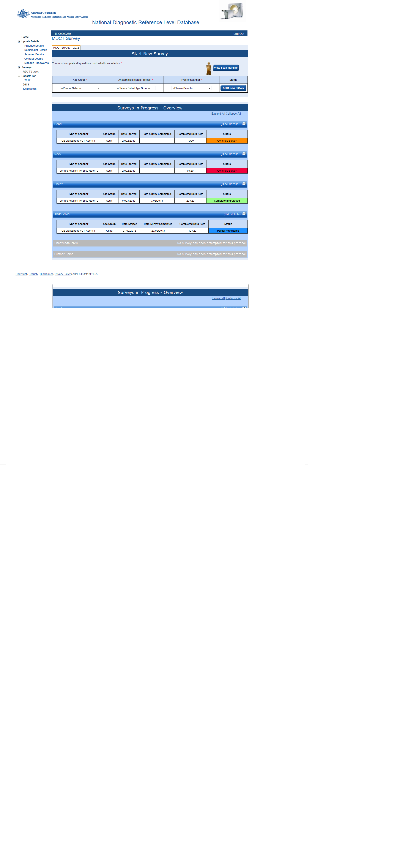
The list includes the ‘Type of Scanner’ including the ‘Additional Identifier’, the ‘Age Group’, the ‘Date Started’, the ‘Date Survey Completed’, the number of ‘Completed Data Sets’ and ‘Status’ of the survey.
There are several survey status categories, these include:
 | Indicates that the survey has been started but less than 10 patient data sets have been completed. This survey can be continued at any time.
 | Indicates that the survey has been started and between 10 and 19 patient data sets have been completed. This survey can be continued at any time.
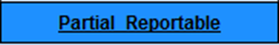 | Indicates that the survey has been submitted but with between 10 and 19 patient data sets completed. The data entry page for this survey can be viewed at any time but this survey cannot be continued. A survey report is available on the ‘Survey Reports’ page.
 | Indicates that the survey has been submitted with all 20 patient data sets completed. The data entry page for this survey can be viewed at any time but this survey cannot be continued. A survey report is available on the ‘Survey Reports’ page.
If no survey has been started for a protocol the following message will be shown along with the protocol name

What happens when you submit a survey?
When you submit a survey you will be taken to the Thank You page.
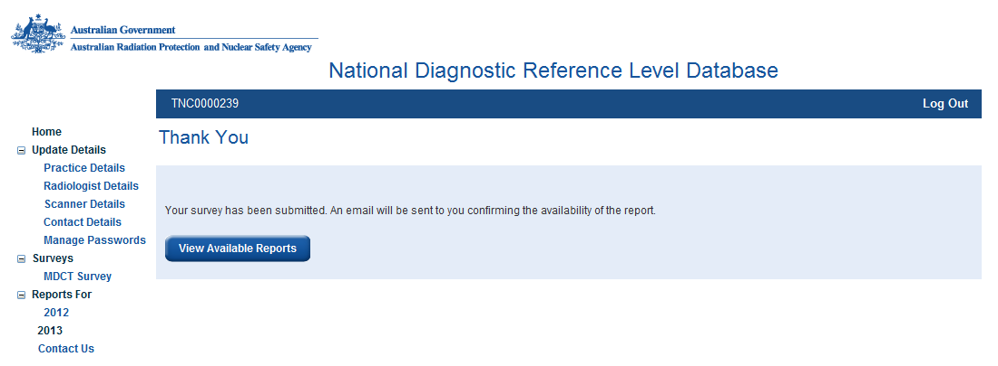
From here you can select View Available Reports, this will take you to the Survey Reports page for the current year.
Also, every time a survey is submitted an email will automatically be sent to the Radiologist and Contact informing them that a ‘Survey report is now available’.
Please note that if you have filled in all 20 patient data sets and you select ‘Show Scattergram’, the survey will be submitted automatically and emails will be sent to the Radiologist and Contact but you will not navigate to the ‘Thank You’ page. To obtain the report for this survey you will have to navigate to the Reports Page by selecting the relevant year from the menu on the left under the ‘Reports For’ title.
Table of Contents

Facility Reports

What are the Facility Reports?
For each survey submitted ARPANSA will provide a comprehensive dosimetry report. This report will detail the following for the submitted data set:
- the spread of DLP and CTDI_{vol}
- the Facility Reference Level (FRL) in terms of DLP and CTDI_{vol}
- how the FRLs compare with the National DRLs for that protocol

How to access Facility reports
Only the Radiologist and Contact can access the facility reports, the Generic User cannot.
On submission of a survey you will be taken to the Thank You page.
From here you can select View Available Reports, this will take you to the Survey Reports page for the current year.
Also, every time a survey is submitted an email will automatically be sent to the Radiologist and Contact informing them that a ‘Survey report is now available’.
Available facility reports can also be accessed anytime via the ‘Reports For’ item on the menu. For example, the facility reports for surveys submitted in the year 2013 can be accessed by selecting 2013.
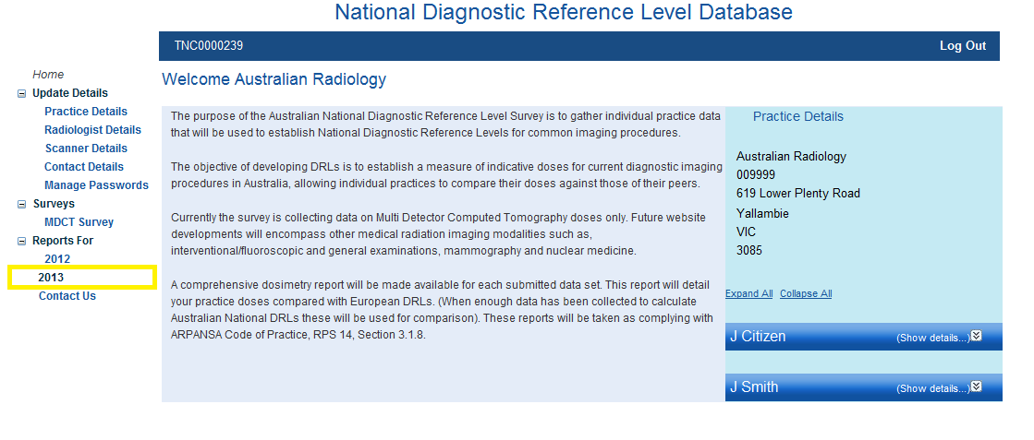
This will take you to the Survey Reports page for 2013.
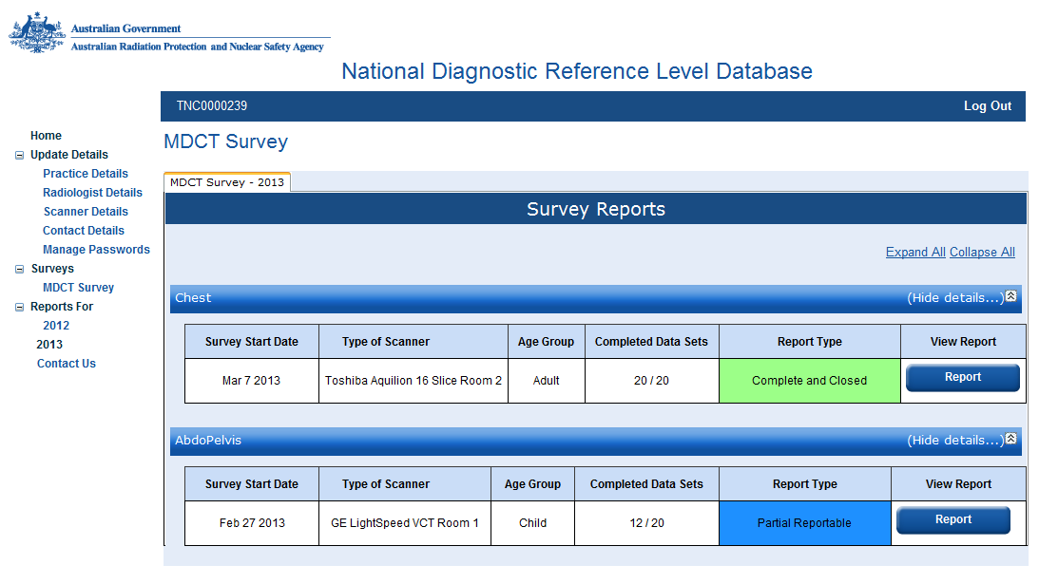
On this page, you will see a list of surveys that you have submitted under the protocol name for these surveys. Protocol names for which you have not submitted any surveys will not be shown.
This list includes the ‘Survey Start Date’, ‘Type of Scanner’ including the ‘Additional Identifier’, the ‘Age Group’, the number of ‘Completed Data Sets’ and the ‘Report Type’.
There are two ‘Report Types’, these are:
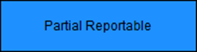 | Indicates that the survey has been submitted with between 10 and 19 patient data sets.
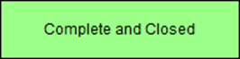 | Indicates that the survey has been submitted with a full 20 patient data sets.
To view a report you should select the appropriate Report button. Each report is in the form of a PDF which you can open and/or save to your computer. You can download the same report multiple times.

A Guide to Your Facility Report
The Australian National Diagnostic Reference Level MDCT Survey report enables each facility to document and record Facility Reference Levels for individual scanners, protocols and age groups.
The Facility Reference Levels (FRLs), can then be compared against established Diagnostic Reference Levels (DRLs), enabling a facility to compare their dose efficiency performance in relation to their peers.
The facility report comprises four pages, provided in an easy to understand format.
The purpose of the report is to provide you with a record of the range of doses submitted for the specific acquisition protocol you used for that group of patients. The principle dose metrics are the Dose Length Product (DLP, mGy.cm) and the volume Computed Tomography Dose Index (CTDI_{vol}, mGy).

A Guide to Page 1 of the Report
This page displays the following information
At the top of the page there is a summary of the following details:
- Facility Name
- Protocol
- CT machine Make, Model and Additional Identifier
- Age Group
- Survey Start and End Date
Below this is a table titled ‘Survey Outcome’.
This table shows the FRLs (in terms of DLP and CTDI_{vol}) for the survey in blue, the corresponding National Australian adult DRLs in red, and a comment comparing the FRL and DRL for both dose metrics.
If your FRL is below the Australian Adult DRL then no comment will be made. If your FRL is above the national DRL then a comment suggesting protocol optimisation will be made.
Note: by definition, 25% of facilities will have an FRL that is above the national DRL.
At the bottom of the page is a table summarising the Australian DRLs for MDCT in terms of DLP and CTDI_{vol}.
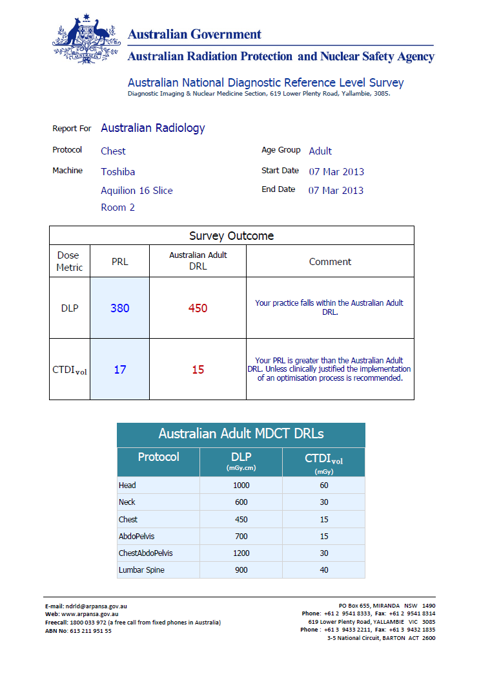

A Guide to Page 2 of the Report
This page shows two graphs, the first graph is a histogram showing the spread of national data in terms of DLP for the relevant protocol, with a dashed red line showing the Australian DRL value.
The second graph is a histogram showing the spread of DLP values recorded in the submitted survey. The red dashed line on the histogram shows the Australian DRL and the solid blue line on the histogram shows your Facility Reference Level (FRL), for the submitted survey. Your FRL is simply the median DLP value for the survey.
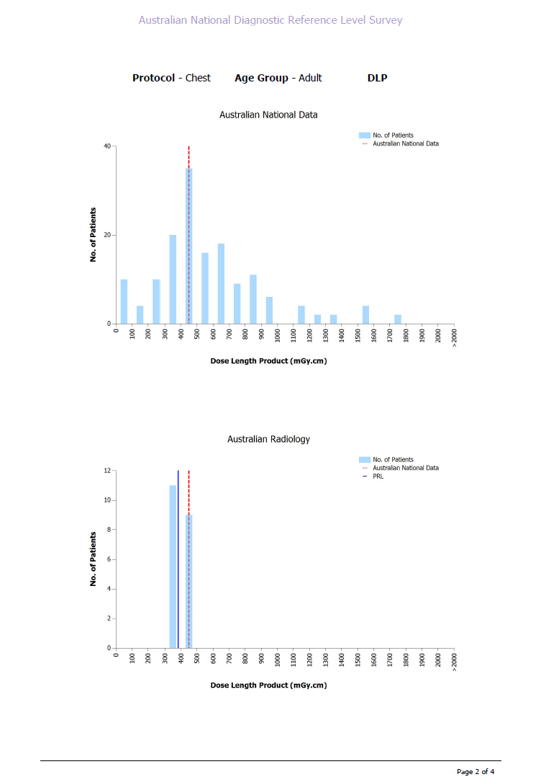

A Guide to Page 3 of the Report
This page also shows two graphs, the first graph is a histogram showing the spread of national data in terms of CTDI_{vol} for the relevant protocol, with a dashed red line showing the Australian DRL value.
The second graph is a histogram showing the spread of CTDI_{vol} values recorded in the submitted survey. The red dashed line on the histogram shows the Australian DRL and the solid blue line on the histogram shows your Facility Reference Level (FRL), for the submitted survey. Your FRL is simply the median CTDI_{vol} value for the survey.
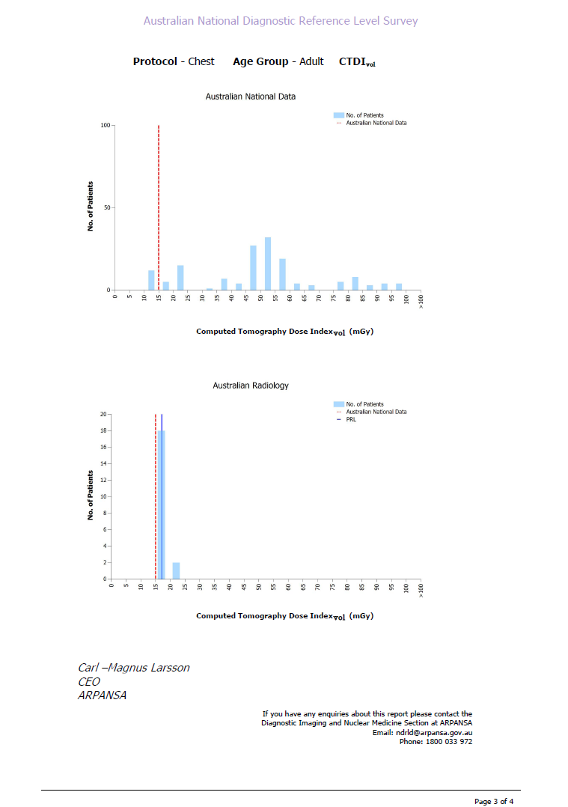

A Guide to Page 4 of the Report
This page shows a record of the technical settings and patient dose data for the submitted survey.
At the top of the page there is a summary of the following:
- Facility Name
- Protocol
- CT Machine Make, Model and Additional Identifier
- Age Group
- Survey Start and End Date
Below this summary is a copy of the technical scan settings entered for the survey as well as the patient data entry table. You can cross reference the patient data with the corresponding histograms on pages two and three.
This page is provided so you can make comparisons between surveys completed for the same protocol over time.
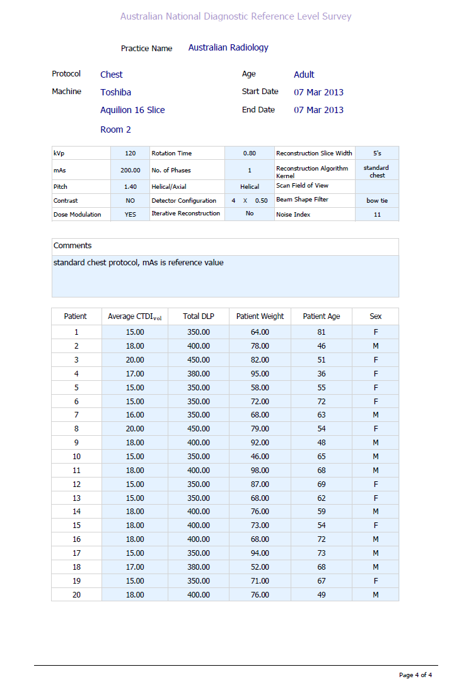

Managing multiple facilities

Introduction
There are some imaging facility networks that have centralised radiation safety officers (RSO), quality managers or medical physicists, who will be referred to as the manager in this section. In such cases, the manager may require easy access to all of the NDRL accounts within their network. To aid this, the NDRL service allows facilities to share their data with trusted users at other facilities.

Registering a new network
Each facility within the network should register using the process described in Section 2. The manager will need to be listed as the contact person or radiologist at one of the facilities, but in the remaining facilities it is recommended (but not essential) that local employees such as the chief radiographer and radiologist are used.
Once all facilities have been registered, the manager can submit share requests to the other members of the network (see Section 7.3.1). The contact or radiologist at each member facility can then authorise the sharing of data (see Section 7.3.2), allowing the manager to access the accounts of all facilities. The manager will have the full suite of privileges available to the local contact and radiologist, for example the ability to update contact information and alter passwords.

Manage Facilities Section

Requesting Access
A user can request access to a facility in the ‘Request Access’ section under the Manage Facilities heading. In the ‘Facility’ field, the user should enter the first two or three letters of the facility that they want to access and then select the facility from the drop down list. In the comment field, the user should write a message to be sent to the contact person and radiologist at the destination facility.
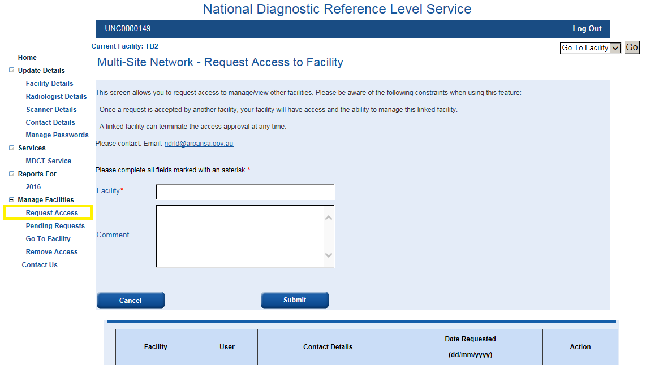
Once the contact person or radiologist has actioned the access request (either accepted or denied) the requesting user will be sent a confirmation email.

Pending Requests
The ‘Pending Requests’ section of the site allows the user to view both incoming and outgoing pending requests.
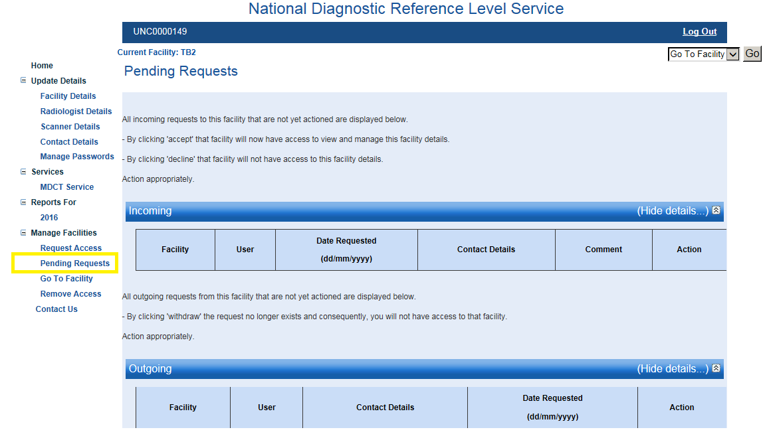
The ‘Incoming’ section lists the requests that other facilities have made for access to the user’s facility. The user can accept or decline the requests. It is important that share requests are only granted to known facilities and personnel; if the user is unsure of the legitimacy of the request, the requester can be contacted directly via the listed ‘Contact Details’. Access can be revoked at a later date (Section 7.3.4).
The ‘Outgoing’ section lists the requests that the user has made for access to other facilities. The user can choose to remove the request if desired.

Go To Facilities
The ‘Go To Facility’ section under the Manage Facilities heading lists the facilities that the user has access to and allows the user to view those facilities. Alternatively, the user can access other facilities using the drop down menu in the upper right-hand corner of all NDRL screens. Once at the other facility, the user has full privileges to not only view reports but to also submit data, change contact details and reset passwords.
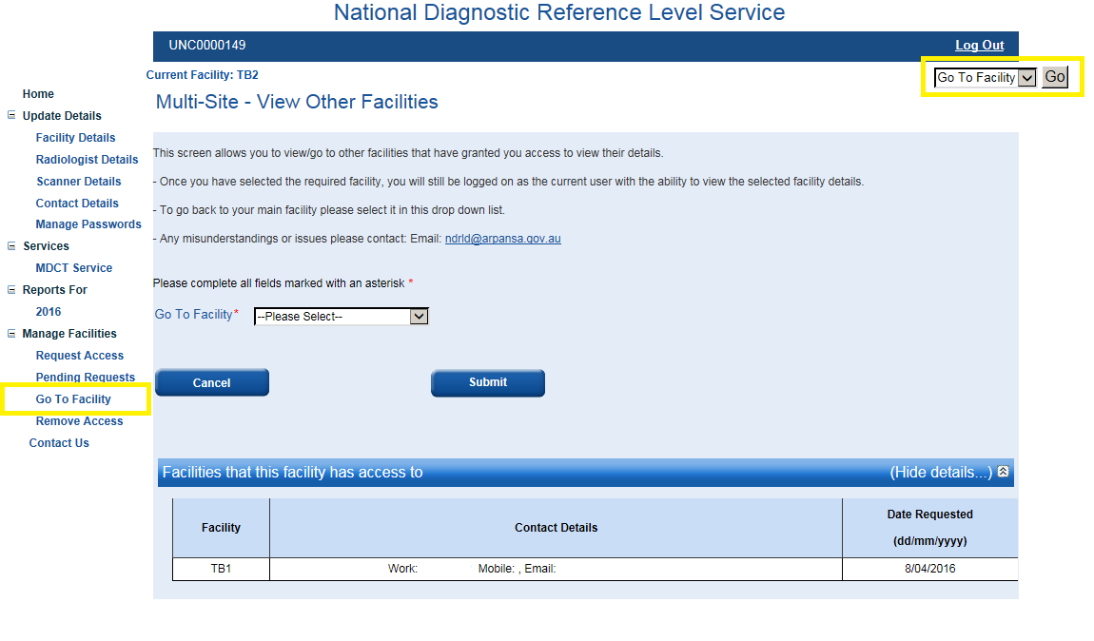

Remove Access
Users can revoke the access previously granted to any facility in the ‘Remove Access’ section under the Manage Facilities heading. Removing access will trigger an email alert to the person who had previously been granted access.
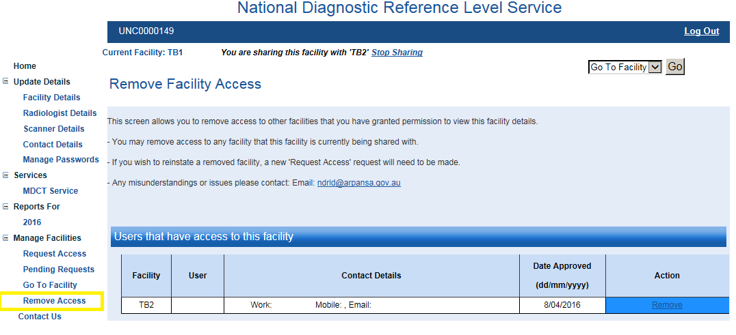
Table of Contents

Contact Us
There are a number of ways you can contact us.
You can write to us at:
Medical Imaging Section
ARPANSA
619 Lower Plenty Road
Yallambie
VIC 3085
Australia
You can call us on:
1800 033 972 (a free call from anywhere in Australia)
(Preferred) You can email us at:
ndrld@arpansa.gov.au

If you are logged in
If you are logged in to the survey you can also use the Contact Us page to send us a message. To do this you should select ‘Contact Us’ from the menu on the left hand side of the screen.
This will take you to the Contact Us page.
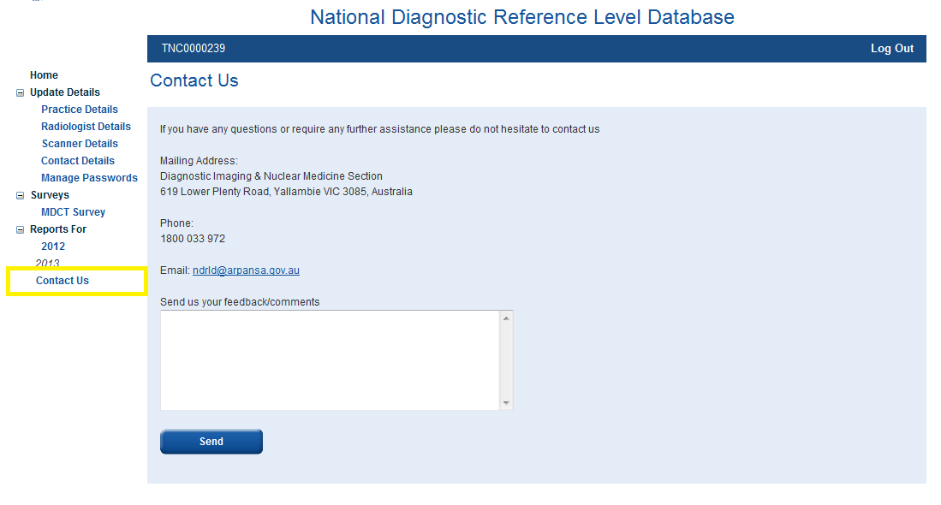
On this page you will find our mailing address, phone number and email address.
There is also an option to type in a message. To use this option you should type your message in the box provided and select Send. This will send your message as an email to the NDRLD mailbox with your username as an identifier. Once your message has been sent you will be notified that ‘Your message successfully sent to ARPANSA’.

If you are not logged in
You can also use the website to send us a message if you are not logged in to the survey. From the Login page you should select ‘Contact Us’ from the bottom of the screen.
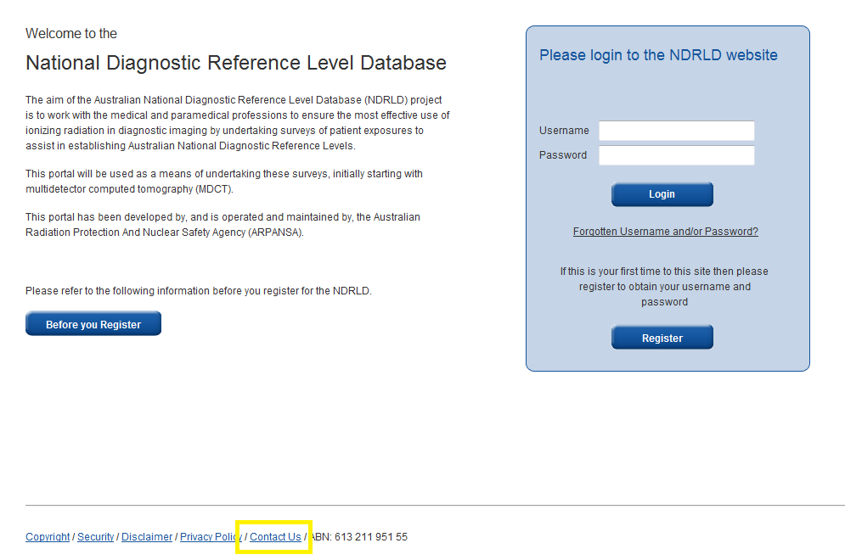
This will take you the Contact NDRL Team page.
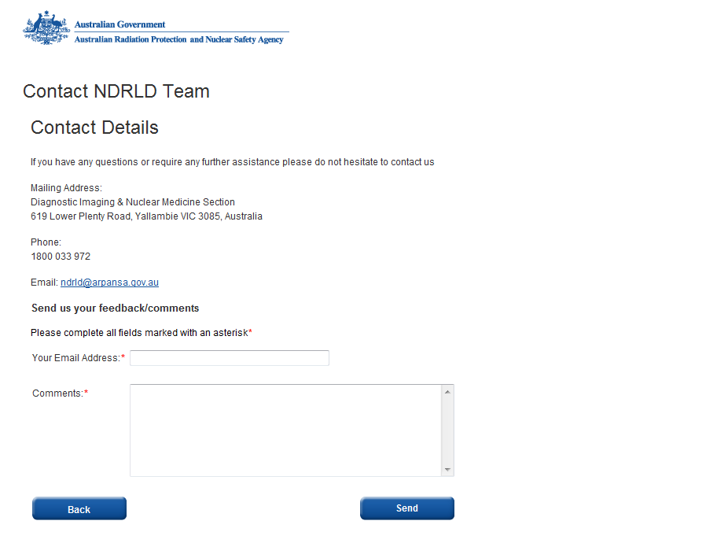
On this page you will find our mailing address, phone number and email address.
There is also an option to type in a message. To use this option you should type your email address in the box provided, type your message in the box below and select Send. It would be appreciated if you include the facility LSPN or your username in your message.
Once your message has been sent you will be notified that ‘Your message successfully sent to ARPANSA’.
Table of Contents
- Protocol Scan Margins
The survey is collecting data on eight common protocols. We have defined scan margins for each protocol with the intention that any scans performed at your facility that fall within the scan margins can be included in the survey. The scans included in a dose comparison do not necessarily have to be for the listed phase/indication; however, the exposure parameters of the included scans must match what would be used for the listed phase/indication.
The red lines on each of the following images represent the limits of each scan range. A verbal description of the scan range is also given.

Head
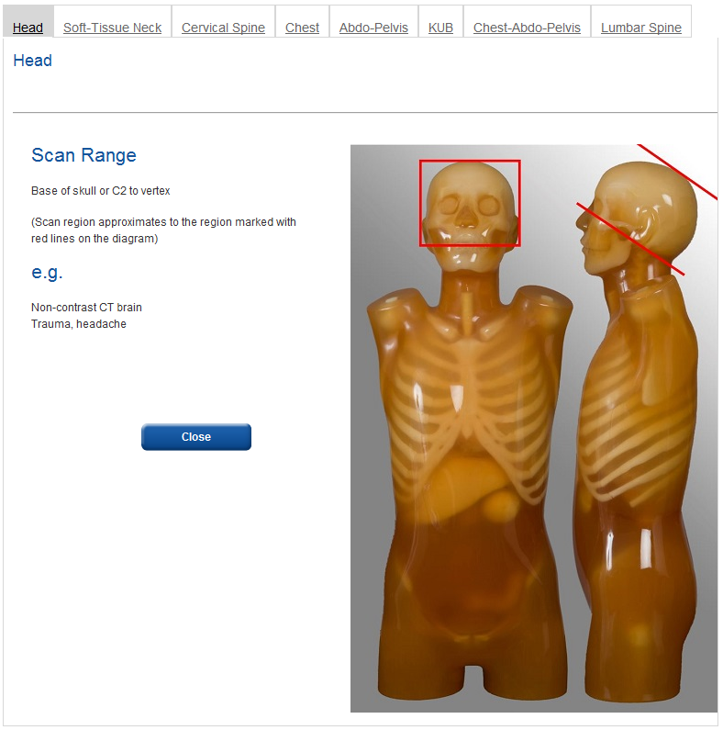
Table of Contents

Soft-Tissue Neck
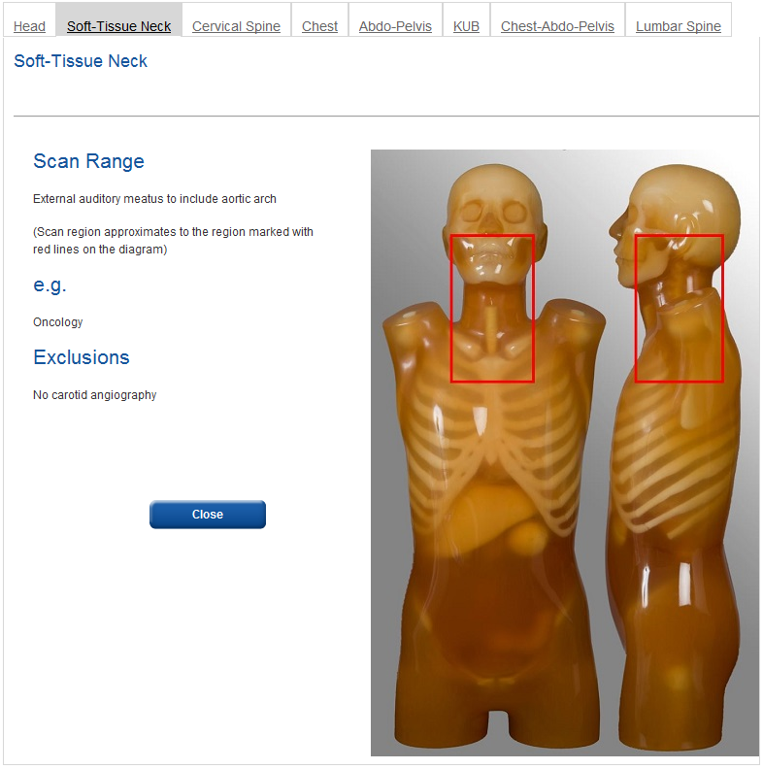
Table of Contents

Cervical Spine
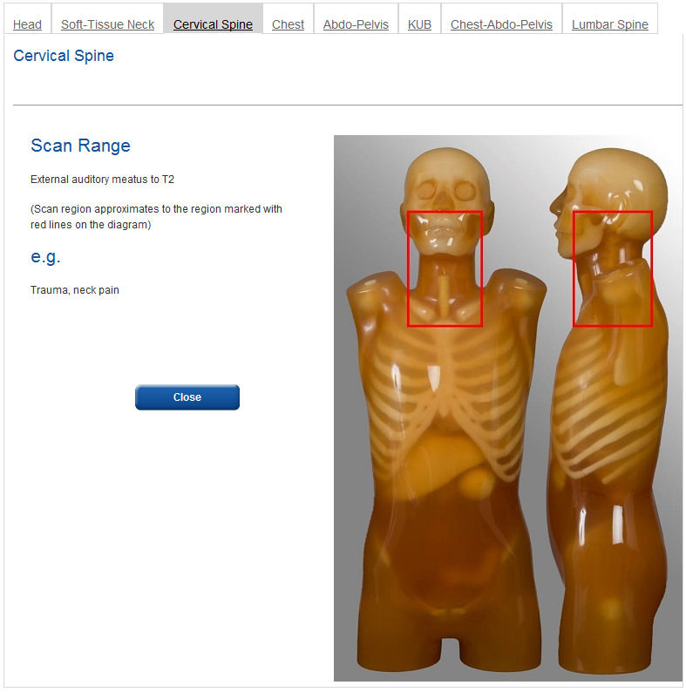
Table of Contents

Chest
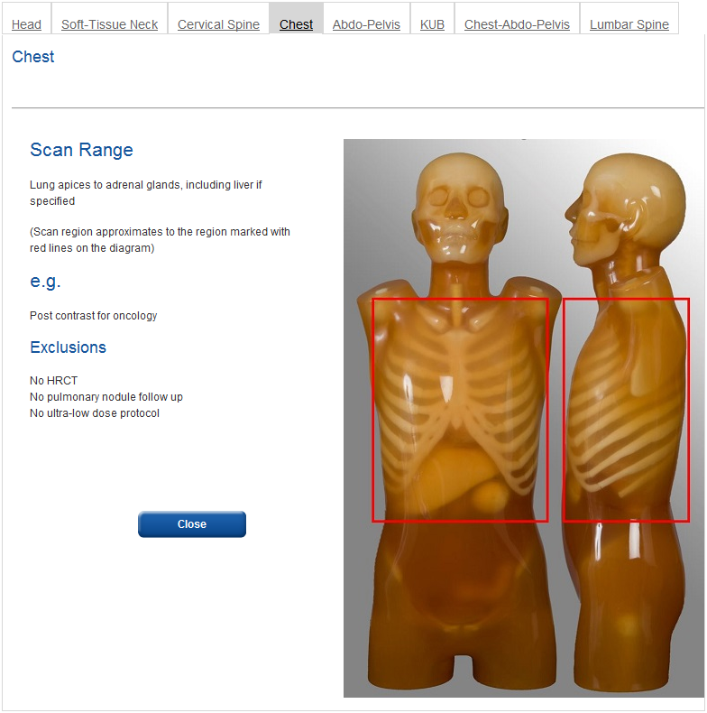
Table of Contents

Abdomen-Pelvis
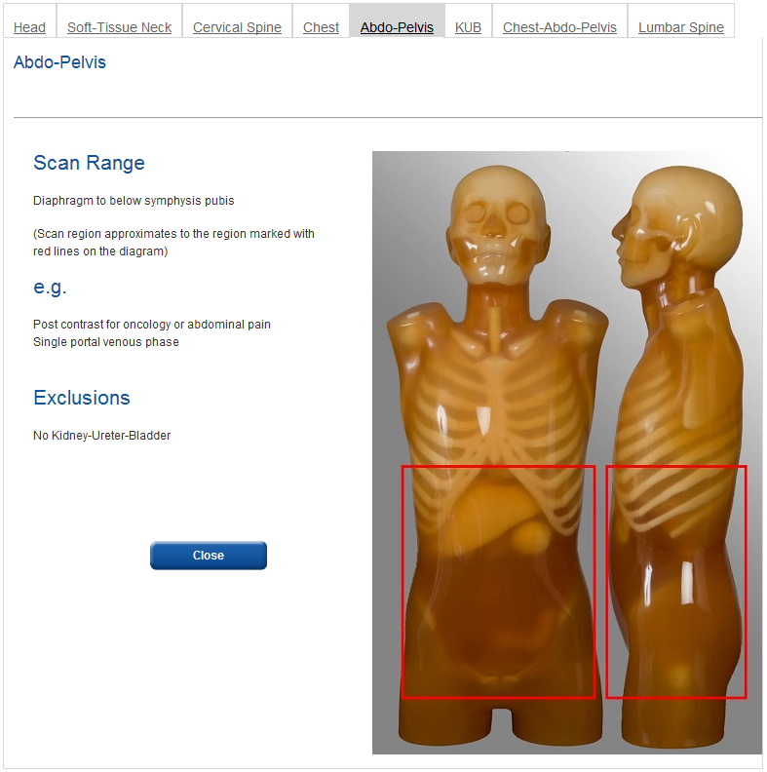
Table of Contents

Kidney-Ureter-Bladder
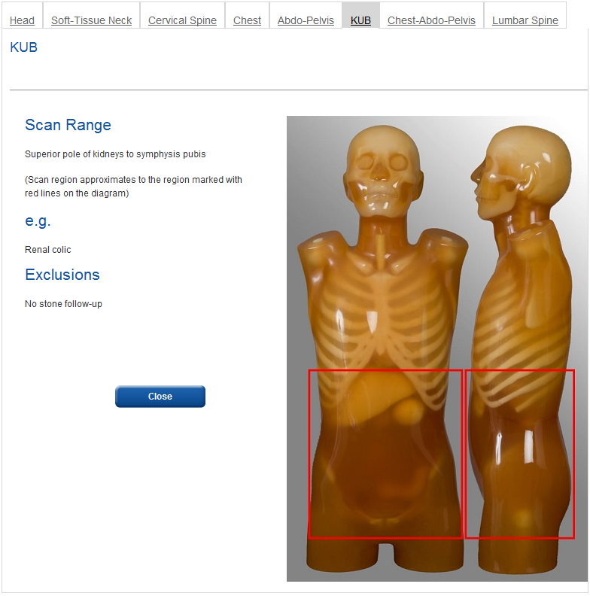
Table of Contents

Chest-Abdomed-Pelvis
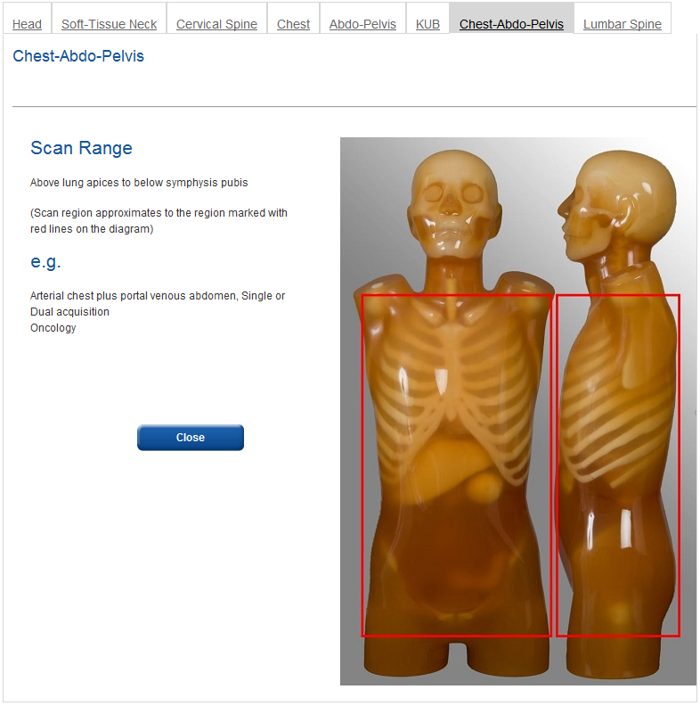
Table of Contents

Lumbar Spine
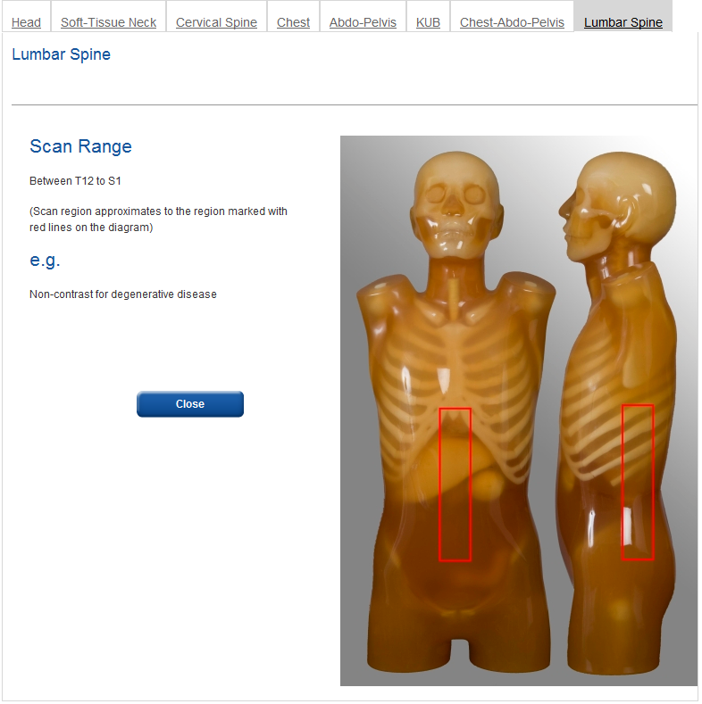
Table of Contents

- Scan Settings Technical Information

Beam Shaping Filter | The filter used to shape the X-ray beam to the body habitus  What filter was used to shape the X-ray beam? e.g. - bow tie, large bow, etc.
Comments | Any additional comments about the survey  To better define the specific protocol (e.g. what mAs value was used, starting, reference etc, if it was a survey of paediatric patients was the 16 or 32 cm reference phantom used for DLP and CTDI_{vol} values) and/or something relevant to you at the facility to help you differentiate between surveys.
Contrast | Contrast used during the image acquisition  Was contrast used during the image acquisition? (YES/NO)
Detector Configuration | The geometrical configuration of detectors used during image acquisition  The first part is the number of detector rows used.  How many rows of detector were used in the image acquisition? (must be a whole number between 0 and 400)  The second part is the width of acquisition slice  What is the width (in mm) of the acquisition slice? (must be a number between 0 and 10 with a maximum of three decimal places)
Dose Modulation | Also known as Automatic Dose Modulation, Automatic Exposure Control and Tube Modulation  The nomenclature of this parameter will be manufacturer dependent and subject to change over time, e.g. Smart-mA, DoseRight, Care Dose, etc.  Was Dose Modulation used during the image acquisition? (YES/NO)
Helical or Axial | The mode of acquiring the image:  Helical (also known as Spiral)  refers to the method of image acquisition in which the gantry is continuously rotating while patients are simultaneously being translated in the z-direction  Axial  refers to the method of image acquisition in which each individual slice is measured at a fixed z-position followed by an appropriate translation in the z-direction  Was the image acquired Helically or Axially? (Helical/Axial)
Iterative Reconstruction | The application of iterative reconstruction algorithm(s).  Was some type of iterative reconstruction used to process the image? (Yes/No)
kVp | kilo Voltage peak  What was the set kVp for the protocol? (must be a whole number between 70 and 150). If conducting dual energy scans enter the average kVp and list the individual kVps in the comments.
LSPN | Location Specific Practice Number  The LSPN is a unique identifier assigned by Medicare which is required to be submitted as part of each Medicare Claim  What is the LSPN for your facility? (must be given as a six digit number with leading zeros)
mAs | Current-time product in milli Ampere second  What is the starting or reference mAs for your image acquisition protocol? (must be a number between 50 and 1000 with a maximum of two decimal places)
Noise Index | The image quality reference parameter for dose modulation  Also known as  - Reference Image (Philips)  - Quality Reference mAs (Siemens)  - Standard deviation (%), low-dose or high quality (Toshiba)  It is expected that the nomenclature of these parameters will change over time  (must be given as a whole number between 0 and 999)
No. of Phases | The number of phases in the image acquisition  How many phases were in the complete scan, not including the scout/topogram view? (1/2/3/4, etc.)
Pitch | The ratio of the table feed per rotation to the total slice collimation, i.e.  Pitch = d/M×S  Where:  d is the table feed per rotation  M is the number of acquisition slices  S is the individual acquisition slice collimation width  M×S is the isocentric beam width  (must be a number between 0 and 3 with a maximum of three decimal places)
Reconstruction Algorithm/Kernel | The Algorithm/Kernel used in the image reconstruction process  What Algorithm/Kernel was used in the image reconstruction process? (e.g. bone, standard, soft, etc.)
Reconstruction Slice Width | The slice width (in mm) of the reconstructed image  What was the slice width (in mm) in the reconstructed image?
Rotation Time | The time (in sec) of one 360° rotation  What is the rotation time (in sec) during image acquisition (must be a number between 0 and 2 with a maximum of two decimal places)
Scan Field of View | The size (in cm) of the field of view used in the image acquisition  What is the scan field of view (in cm) during image acquisition? (can also be non-numeric, e.g. large)
Table of Contents

- Patient Data Information
For each survey 20 patient data sets are required. Each patient data set includes the CTDIvol, the DLP, the Patient Weight, the Patient Age and the Patient Gender.
CTDI_{vol} The CTDI_{vol} should be displayed on the scanner console at either the beginning or end of the scan.

DLP The DLP should be displayed on the scanner console at either the beginning or end of the scan.

Patient Weight This can be obtained by simply asking the patient. Accuracy to within 5 kg is sufficient.

Patient Age The patient age in years (months for the Baby/Infant age group)

Patient Gender Either Male or Female
It may be useful to have a set of scales handy for measuring patient weight.
Acquisitions involving multiple series
For acquisitions that involve multiple series the CTDI_{vol} and DLP that represent the entire procedure should be recorded.
e.g. If you perform a Chest-Abdomen-Pelvis scan as two separate scans, i.e. as a Chest scan then an Abdomen-Pelvis scan, and you obtain a CTDI_{vol} and DLP for each separate scan, then the CTDI_{vol} and DLP recorded on the data entry page should be calculated as follows:

The CTDI_{vol} recorded should be the average of the CTDI_{vol} from each part of the scan
${CTDI}_{vol}=\frac{{\left({CTDI}_{vol}\right)}_{Chest}+ {\left({CTDI}_{vol}\right)}_{AbdoPelvis}}{2}$

The DLP recorded should be the sum of the DLP from each part of the scan
$DLP={\left(DLP\right)}_{Chest}+ {\left(DLP\right)}_{AbdoPelvis}$

e.g. If you perform a two phase Head scan, with and without contrast, and you obtain a CTDI_{vol} and DLP for each phase, then the CTDI_{vol} and DLP recorded on the data entry page should be calculated as such

The CTDI_{vol} recorded should be the average of the CTDI_{vol} from each phase of the scan
${CTDI}_{vol}=\frac{{\left({CTDI}_{vol}\right)}_{Phase 1}+ {\left({CTDI}_{vol}\right)}_{Phase 2}}{2}$

The DLP recorded should be the sum of the DLP from each phase of the scan
$DLP={\left(DLP\right)}_{Phase 1}+ {\left(DLP\right)}_{Phase 2}$
Table of Contents

- Glossary of Terms
AEC | Automatic Exposure Control:  Variation of the nominal tube current selected at the start of the examination.
Additional Identifier | An Additional Identifier for your MDCT Scanner  This is a mandatory free field in which you must enter some words relating to your MDCT Scanner. For example,  • the physical location of the MDCT Scanner, e.g. 2nd Floor, East Wing or Room 210  • the department the MDCT Scanner is used in, e.g. Emergency CT  This is meant as a tool to help you at your facility differentiate between your MDCT Scanners, particularly if you have more than one of the same make and model.
Anatomical Protocol | The specifications of the scan in terms of body region margins and indicators.
ARPANSA | Australian Radiation Protection and Nuclear Safety Agency  http://www.arpansa.gov.au/
Axial | A mode of image acquisition. Conventional method of CT scanning in which each requested slice is acquired at a fixed z-position followed by an appropriate transport of the patient in the z-direction.
Beam Shaping Filter | The filter used to shape the X-ray beam to the body habitus.
Contrast | Contrast used during the image acquisition.
CTDI_{vol} | Volume Computed Tomography Dose Index:  $${CTDI}_{vol}= {{CTDI}_{w}}/{Pitch}$$
CTDI_{w} | Weighted Computed Tomography Dose Index:  $${CTDI}_{w}= 1/3{CTDI}_{c}+ 2/3{CTDI}_{p}$$  Where CTDI_{c} and CTDI_{p} are the doses measured at the centre and periphery of the CTDI phantom respectively.
Detector Configuration | The geometrical configuration of detectors used during image acquisition
Dose Constraint | A prospective and source-related restriction on the individual dose from a source, which provides a basic level of protection for the most highly exposed individuals from a source, and serves as an upper bound on the dose in optimisation of protection for that source. There are no dose constraints for medical procedures.
DLP | Dose Length Product  $$DLP\left(mGy.cm\right)= {CTDI}_{vol}\left(mGy\right)×Scan Length (cm)$$
Dose Modulation | Also known as Automatic Dose Modulation, Automatic Exposure Control, Tube Current Modulation.
DRL | Diagnostic Reference Level:  The 75th percentile value of a range of medians for a population of facilities for a single anatomical protocol and age group.
Helical | A mode of image acquisition. Method of CT scanning with continuous gantry rotation and simultaneous continuous object translation in the z-direction. In contrast to the sequential scanning technique.
Iterative Reconstruction | The application of an error-minimising recursive feedback loop in the reconstruction of an image.
kVp | kilo Voltage peak.
LSPN | Location Specific Practice Number:  Where a facility site provides diagnostic imaging or radiation oncology services, the Health Insurance Amendment (Diagnostic Imaging, Radiation Oncology and Other Measures) Act 2003 requires these sites to be registered with Medicare Australia in order for Medicare benefits to be payable. Registered sites and bases for mobile equipment are allocated a Location Specific Practice Number (LSPN). The LSPN is a unique identifier which is required to be submitted as part of each Medicare claim for diagnostic imaging or radiation oncology services.  Medicare Australia has an online data base of registered LSPNs that  can be searched via their website: http://www.medicareaustralia.gov.au/provider/medicare/lspn.jsp
mAs | Current-time product in milli Ampere seconds.
MDCT | Multi Detector Computed Tomography. Also known as Multi Slice Computed Tomography (MSCT). The vast majority of modern CT scanners can be classified as MDCT.
Noise Index | Image Quality Reference Parameter for AEC.  Also known as Reference Image (Philips), Quality Reference mAs (Siemens) and Standard Deviation (%), or standard, low dose or high quality (Toshiba)  It is expected that the nomenclature of these parameters will change over time.
No. of Phases | The number of phases in the image acquisition.
Pitch | The ratio of table feed per tube rotation and total slice collimation, i.e.  Pitch= d⁄(M×S)  Where:  d is the table feed per rotation,  M is the number of acquisition slices  S is the individual acquisition slice collimation  M×S is the isocentric beam width
FRL | Facility Reference Level:  The median value of the spread of DLP or CTDI_{vol} for a particular CT scanner at a given facility for a single protocol.  A facility reference level is defined by the protocol chosen, the age group and the scanner it was acquired on.
Reconstruction Algorithm/Kernel | The algorithm or kernel used in the image reconstruction process.
Reconstruction Slice Width | The slice width in mm of the reconstructed image.
Rotation Time | The time in seconds of one 360° rotation.
Scan Field of View | The size in cm of the field of view used in the image acquisition.
Table of Contents

